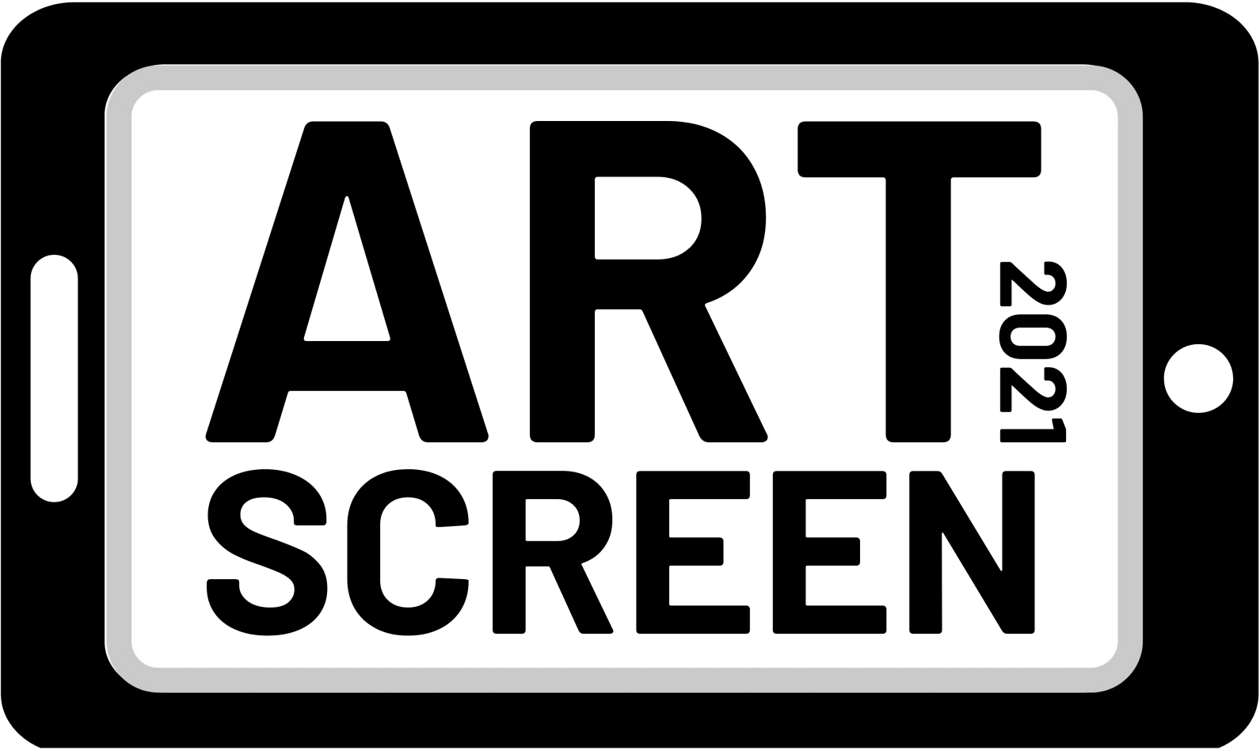

About ArtScreen

ArtScreen 2021 Application

ArtScreen 2021 is a visual art project which seeks to enable three (3) NSW artists with disability to develop their creativity and careers by creating work in the increasingly prevalent format of video art or ‘art of the moving image’.

The successful applicants will be mentored by experienced video artists to create video artworks up to 10 minutes duration which explore identity and social connectedness in specific environments.

If required, the production of each artwork will be supported by a team of students from inclusive screen production school Bus Stop Films, Accessible Film Studies Program and with equipment/facilities from Parramatta’s Information & Cultural Exchange (I.C.E.).

All completed artworks will be premiered at the Museum of Contemporary Art in Sydney in December 2021 to mark the International Day Of People With Disability. The premiere season will include a series of screenings over one week and will feature live Q&As with the respective artists. The Prototype video art streaming platform will also have an option to potentially exhibit the artworks online.

ArtScreen is being funded with grants from Create NSW and the City of Sydney as well as in-kind contributions from Accessible Arts and other project partners. A trial of this initiative was funded by the City of Sydney in 2020.

WHO CAN APPLY

Applicants must identify as being Deaf and/or a person with disability Applicants must be emerging or mid-career visual artists and/or filmmakers Applicants must reside in NSW
Applicants do not need to have prior experience working with video as a creative format

PROJECT REQUIREMENTS

Artworks must explore the theme of identity and social connectedness in specific environments Artworks should engage with experimental video forms and advance visual/cinematic language Artworks must be legible and make sense visually on small screens
Artworks should have a minimum duration of 3 minutes and a maximum duration of 10 minutes
Applicants must demonstrate that they can create and deliver their artwork using the cash and in-kind resources that comprise the project budget
Applicants must be available to commence production of the artwork from March 2021 and deliver the final artwork by October 2021.
Applicants must be open to working with the project mentors and curator
All final artworks must be delivered in multiple formats which include captioning, audio description and Auslan interpretation.

MENTORS & CURATOR

The successful applicant will receive up to 16 hours of support from experienced video artists. These mentors will each choose to work with one artist. They will be available for an initial consultation and then will provide advice and support during pre-production, production and post-production. The mentors are:

Soda_Jerk
Soda_Jerk is a two-person art collective who work exclusively with sampled material and pirated cinema to make experimental documentary films. Following their acclaimed political revenge fable TERROR NULLIUS (2018), Soda_Jerk are currently working on a new feature Hello Dankness. Formed in Sydney in 2002, they’ve been based in NYC since 2012. https://www.sodajerk.com.au/

Amala Groom
Amala is a Wiradyuri conceptual artist whose work presents acute and incisive commentary on contemporary socio-political issues. Articulated across diverse media, Groom’s work often subverts western iconography in order to enunciate Aboriginal stories, experiences and histories and to interrogate the legacy of colonialism. http://amalagroom.com/About

Dr Zanny Begg
Zanny is an artist, curator, theorist and lecturer at UNSW Art and Design. As an artist, Zanny is interested in hidden and contested history/ies. She works with film, drawing and installation to explore ways in which we can live and be in the world differently. https://zannybegg.com/

Lauren Carroll-Harris
The successful applicant will also receive advice and support from Prototype curator Lauren Carroll-Harris. Lauren is a writer, artist, broadcaster, critic and curator with a focus on film and contemporary art. Lauren will provide feedback at selected stages of the production process. https://youaretheprototype.art/

ACCESS

Applicants are welcome to detail if they have any access requirements and how these requirements will be addressed during the production process.

For example, if the applicant requires a camera operator, the cost of this could be met using part of the $7000 cash component. However, if the applicant requires an Auslan interpreter for any part of the production process, the cost of this could potentially be met using NDIS funding.

Please contact us if you have any questions about access requirements.

ArtScreen guidelines and application forms are available in accessible formats upon request. Formats include word documents, audio files, and large print.

SELECTION CRITERIA & PROCESS

Applications will be assessed using the following criteria:

Artistic standing of the applicant Creative merit of the project concept
Benefit of the project to the applicant’s professional development Ability to deliver the project on time and on budget
Suitability of the project for Prototype programming

Applications will be assessed by a panel including the mentors, curator, and staff members from Accessible Arts and Bus Stop Films.

All applicants will be notified of the results by Monday 1 March 2021.

Successful applicants will be required to enter into an agreement which will contain additional terms and conditions in accordance with existing policies of Accessible Arts, MCA, Prototype, Bus Stop Films and I.C.E.

The successful applicant must provide Accessible Arts, MCA and Prototype with permission to screen and/or share the artwork created through the ArtScreen initiative. This will involve MCA screening the artworks on site for 1 week in December 2021 and Prototype presenting the online premiere as well as having exclusive rights to stream the artwork online for two years.

For the purposes of promoting ArtScreen, the successful applicant must also agree to make themselves available for interviews, filming and other social media opportunities.

APPLICATION DEADLINE

Applications close at 5pm on Monday 8 February 2021

ENQUIRES

Please direct any enquiries to:
Liz Martin, Arts Development Manager, Accessible Arts lmartin@aarts.net.au | 02 83793102

About The Applicant

ArtScreen 2021 Application

In this section please provide your personal details.

1. First Name

- 2. Last Name

- 3. Contact Information

Address

Address 2

City/Town

State/Province

ZIP/Postal Code

Country

Email Address

Phone Number

  - 4. Are you over 18 years of age?
Yes No

5. Gender
Female Male
Other

6. Do you identify as being Deaf and/or as a person with disability?
Yes No

7. Do you have any access requirements? Please list your needs, eg wheelchair accessible accommodation, extra accommodation for support worker, etc. Please be very detailed and specific in your response.

- 8. Artist Bio/CV

Should include information about:
- Your creative practice
- Your qualifications
- Relevant artworks, films, exhibitions and/or screenings
- How long you have been a practicing artist and/or filmmaker


- Links to relevant online profiles Attach a file
Choose File
Choose File
No file chosen

* 9. How did you hear about ArtScreen?
Accessible Arts e-news Accessible Arts website Facebook
Instagram

Deaf Herald Word of Mouth Other

Your Project

ArtScreen 2021 Application

In this section please provide details of your project

10. Project Title

- 11. Creative Concept (max 500 words)

Please ensure your concept details the following:

- Your idea for the artwork
- How your proposal explores and responds to the theme of identity and social connectedness in specific environments.
- How you envisage working with the mentor

- 12. What artistic outcomes are you hoping to achieve with this project? (max. 200 words)

- 13. How do you think this project will advance your career as a professional artist? (max 200 words)

Your Budget

ArtScreen 2021 Application
In this section please provide a basic breakdown of how you will use the available budget and in- kind resources to produce your artwork.

The production budget that’s available is as follows:

  - Artist Fee: $3000 (cash)
  - Production expenses: $7000 (cash)
  - Production equipment and post-production facilities: $7000 (in-kind from I.C.E)
  - Production assistants: $2000 (in-kind from Bus Stop Films)
  - Artwork access costs (e.g. captioning, audio description, Auslan): $1500 (cash)

Applicants are welcome to use the project’s cash component to cover any relevant project expenses (e.g. cast, crew, production design, equipment, travel, access, etc).

I.C.E equipment includes video cameras, stills cameras, lighting kits, microphones, audio recorders and tripods. I.C.E post-production facilities include video editing suites, audio recording studios and a green screen room.

Below is an I.C.E price guide to assist with budgeting. Please contact I.C.E directly to make any specific enquiries about equipment and facilities.

Category | Rate
Editing Suite (Mac Pro | Final Cut | Premiere) | $140/day
Audio Suite (Mac Pro | Logic Pro | Ableton) | $140/day
Canon 5D (stills camera) | $130
Sony Ex3 (video camera) | $150
Zoom H6N (audio recorder) | $30
Dedo Lights (big lights) | $60
Redhead (medium lights) | $40
Litepanel (small lights) | $40

Two (2) students from Bus Stop Films’ Accessible Film Studies Program will be engaged to work alongside the artist and provide up to 12 hours of general assistance during the pre-production and production phases of the project. If necessary, support workers for the students may be supplied with costs met by the project.

Applicants are welcome to augment their budget with other sources of funding (e.g. cash or in-kind support from individuals or businesses, NDIS funding for relevant access requirements, etc).
These sources must be detailed in the final budget.

All final artworks must be delivered in multiple formats which include captioning, audio description and Auslan interpretation. There is $1500 in the production budget to cover these costs.

Budget Template & Sample Budget
You can access a budget template and sample budget here: www.aarts.net.au/artscreen2021

- 14. Production Budget Attach a file

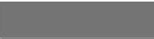
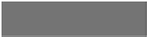
No file chosen
Choose File
Choose File

Production budget notes (max 200 words)

Supporting Materials

ArtScreen 2021 Application
In this section please include information which supports the creative concept for your project specifically or for your application generally.

Supporting materials may include:

- Up to 5 images of artwork (pictures, drawings, sketches, photographs, etc)
- Up to 5 minutes of videography, film or visual story
- Up to 5 minutes of audio recording (music, voiceover, etc)

Supporting Materials - notes and links to digital files



- Supporting Materials - one of up to ten files Attach a file
Choose File
Choose File
No file chosen

Supporting Materials - two of up to ten files



No file chosen
Choose File
Choose File

Supporting Materials - three of up to ten files

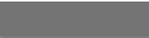
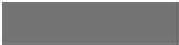
No file chosen
Choose File
Choose File

Supporting Materials - four of up to ten files

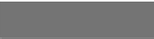
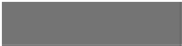
No file chosen
Choose File
Choose File

Supporting Materials - five of up to ten files

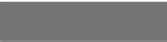
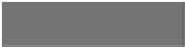
No file chosen
Choose File
Choose File

Supporting Materials - six of up to ten files



No file chosen
Choose File
Choose File

Supporting Materials - seven of up to ten files



No file chosen
Choose File
Choose File

Supporting Materials - eight of up to ten files



No file chosen
Choose File
Choose File

Supporting Materials - nine of up to ten files

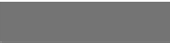
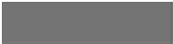
No file chosen
Choose File
Choose File

Supporting Materials - ten of up to ten files

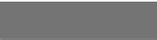
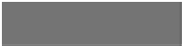
No file chosen
Choose File
Choose File

