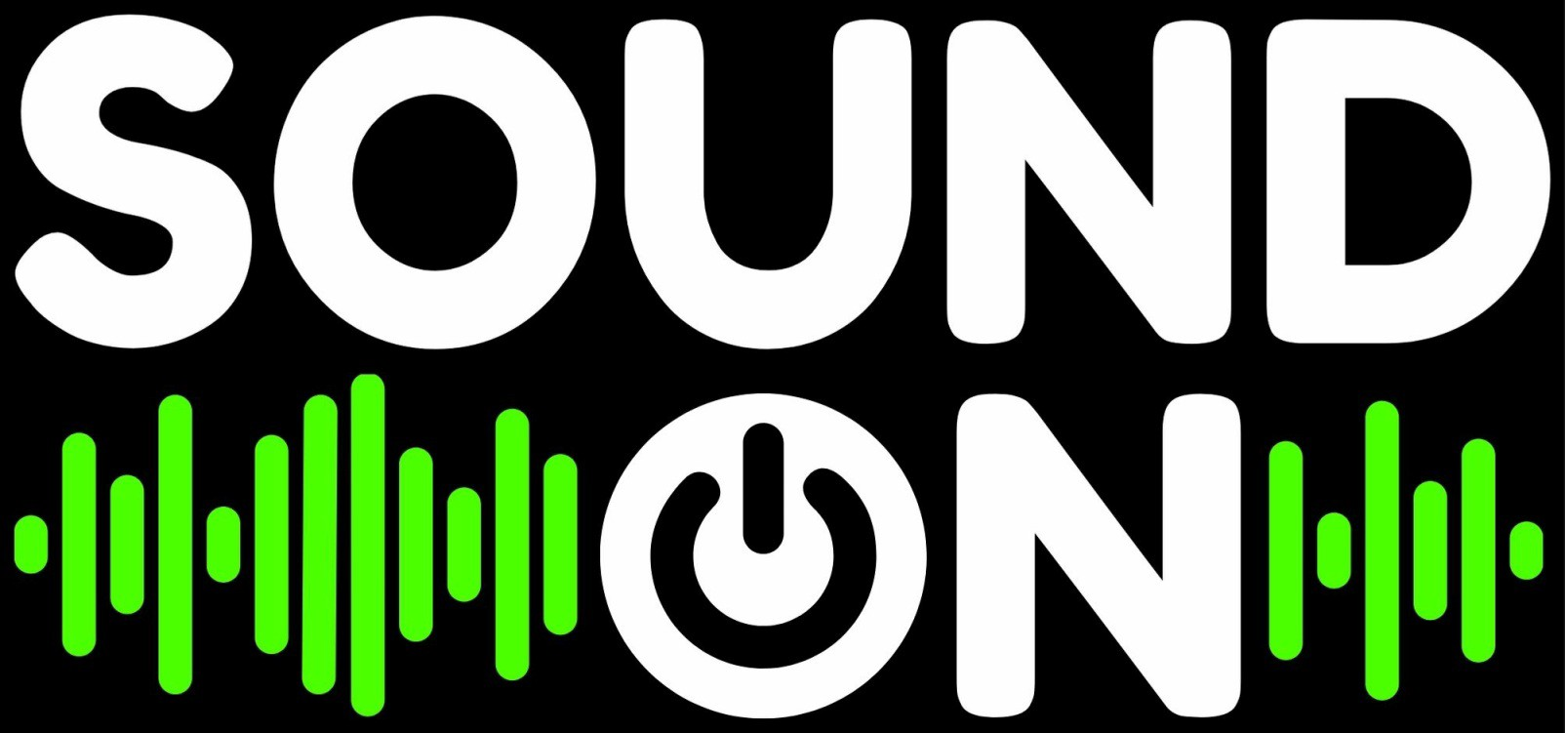

Sound On Application

About Sound On
Sound On is a funding opportunity to support musicians who identify as d/Deaf or disabled, or who have a chronic illness or mental health condition, in the development of new work/s, to undertake a NSW-based mentorship, or to tour throughout NSW.

Original music projects may include, but are not limited to:

Album, EP, or single song recording
Album, EP, or single song release, PR and marketing Composition of new work
Exploring new collaborations in the creation of new work
Undertaking NSW based mentorship with an established NSW musician City based musicians touring regional NSW
Regional musicians performing in metropolitan areas

Applicants are able to apply for up to $6000 per project. Projects are to be completed between 1 April and 30 June 2021.
Sound On is delivered by Accessible Arts and funded by Create NSW.

WHO CAN APPLY

Applicants may apply as individuals, groups or organisations.
Projects outlined must be led by musicians who identify as d/Deaf or disabled, or having a chronic illness or mental health condition.
Applicants must reside in NSW.
Applicants may be emerging, mid-career, or established.

PROJECT REQUIREMENTS

Applicants must demonstrate that they can create and deliver their project within the project budget.
Applicants must be able to complete their projects between 1 April and 30 June 2021.

ACCESS

Applicants are welcome to detail if they have any access requirements and how these requirements will be addressed during their project.

Please contact us if you have any questions about access requirements.

Sound On guidelines and application forms are available in accessible formats upon request. Formats include word documents, audio ﬁles, and large print.

SELECTION CRITERIA & PROCESS

Applications will be assessed using the following criteria:

Artistic standing of the applicant/s Creative merit of the project concept
Beneﬁt of the project to the applicants’ professional development Ability to deliver the project on time and on budget

Applications will be assessed by an advisory panel of musicians who are d/Deaf or disabled, or who have a chronic illness or mental health condition, along with music industry leaders and staﬀ members from Accessible Arts.

All applicants will be notiﬁed of the results by Monday 29 March 2021.

Successful applicants will be required to enter into an agreement, which will contain additional terms and conditions in accordance with existing policies of Accessible Arts.

For the purposes of promoting Sound On, the successful applicants must agree to make themselves available for interviews, ﬁlming and other social media opportunities.

APPLICATION DUE DATE

Applications close at 5pm on Monday 15 March 2021.

HOW TO APPLY

Applicants must provide the following: Creative Concept (max. 500 words)
Your idea for your project and what you hope to achieve.
Where your project will be carried out.
The names of everyone involved in your project. Why your project is important to do now.
How your project will advance your music career.

Project Budget

A basic breakdown of how you will use the available budget to produce your project.

Supporting Materials (any of the below)

- Up to 5 tracks of music recordings
- Up to 5 pages of written composition
- Up to 5 letters of support from participants Artist Bio
- Your creative practice
- Your qualiﬁcations
- Previous music releases and performances
- How long you have been a practicing musician
- Links to relevant online proﬁles
- Up to 5 examples of previous original music created

If applicants cannot access the Survey Monkey application form, please note that applications will be accepted in other formats that are accessible to the applicant including Auslan, audio, video, printed, dictated, electronic and handwritten formats.

ENQUIRES

Please direct any enquiries to:
Liz Martin, Arts Development Manager, Accessible Arts
Email: lmartin@aarts.net.au | Telephone: +61 2 8379 3102 | Mobile: +61 409 836 634

Sound On Application

About The Applicant

In this section please provide your personal details.

- 1. First Name

2. Last Name

- 3. Organisation Name (if applicable)

4. Contact Information

Address Address 2 City/Town State/Province ZIP/Postal Code Country

Email Address Phone Number

5. Are you over 18 years of age?

Yes No

6. Gender

Female Male Other

7. Do you identify as a/Deaf or Disabled, or who have a chronic illness or mental health condition

Yes No

8. Do you have any access requirements?

- 9. Artist Bio and CV for all artists involved.

Should include information about:
- Your creative practice

Your qualiﬁcations
- Previous music releases and performances

How long you have been a practicing musician
- Links to relevant online proﬁles

Up to 5 examples of previous original music created

Attach a ﬁle



No ﬁle chosen
Choose File
Choose File

* 10. How did you hear about Sound On?

Accessible Arts e-news Accessible Arts website Facebook
Instagram
Deaf Herald Word of Mouth Other

Sound On Application

Your Project

In this section please provide details of your project

- 11. Project Title

12. Creative Concept (max 500 words)

Please ensure your concept details the following:

Your idea for your project and what you hope to achieve.
- Where your project will be carried out.

The names of anyone involved in your project.
- Why your project is important to do now.
- How your project will advance your music career.

Sound On Application

Your Budget

In this section please provide a basic breakdown of how you will use the available budget and in-kind resources to produce your project.

Up to $6000 is available for each project.

Please indicate clearly the amount of money you're applying for, whether GST is required, and a breakdown of how the money will be spent.

Applicants are welcome to augment their budget with other sources of funding (e.g. cash or in-kind support from individuals or businesses, NDIS funding for relevant access requirements, etc).

These sources must be detailed in the ﬁnal budget. Budget Sample
Expense | Notes | Amount
Audio Engineer | 2 days recording at XXX Studio $XXX per hour/day | $XXXX
Session musicians | 2 days recording at XXX Studio $XXX per day, each | $XXXX
Mixing tracks | Mixing over 2 days by XXX
Mastering tracks | Mastering 1 day by XXX | $XXXX
TOTAL |  | $XXXX

13. Budget

Attach a ﬁle



No ﬁle chosen
Choose File
Choose File

- Budget notes (max 200 words)

Sound On Application

Supporting Materials

In this section please include information which supports the creative concept for your project speciﬁcally or for your application generally.

Supporting materials may include:

- Up to 5 tracks of music recordings
- Up to 5 pages of written composition
- Up to 5 letters of support from participants

Supporting Materials - notes and links to digital ﬁles

- Supporting Materials - one of up to 15 ﬁles

Attach a ﬁle



No ﬁle chosen
Choose File
Choose File

Supporting Materials - two of up to 15 ﬁles



No ﬁle chosen
Choose File
Choose File

Supporting Materials - three of up to 15 ﬁles



No ﬁle chosen
Choose File
Choose File

Supporting Materials - four of up to 15 ﬁles



No ﬁle chosen
Choose File
Choose File

Supporting Materials - ﬁve of up to 15 ﬁles



No ﬁle chosen
Choose File
Choose File

Supporting Materials - six of up to 15 ﬁles



No ﬁle chosen
Choose File
Choose File

Supporting Materials - seven of up to 15 ﬁles



No ﬁle chosen
Choose File
Choose File

Supporting Materials - eight of up to 15 ﬁles



No ﬁle chosen
Choose File
Choose File

Supporting Materials - nine of up to 15 ﬁles



No ﬁle chosen
Choose File
Choose File

Supporting Materials - ten of up to 15 ﬁles



No ﬁle chosen
Choose File
Choose File

Supporting Materials - eleven of up to 15 ﬁles



No ﬁle chosen
Choose File
Choose File

Supporting Materials - Twelve of up to 15 ﬁles



No ﬁle chosen
Choose File
Choose File

Supporting Materials - Thirteen of up to 15 ﬁles



No ﬁle chosen
Choose File
Choose File

Supporting Materials - Fourteen of up to 15 ﬁles



No ﬁle chosen
Choose File
Choose File

Supporting Materials - Fifteenth of up to 15 ﬁles

No ﬁle chosen
Choose File
Choose File

