Program Outline The Accessible Arts and Bundanon Artists-In-Residence Program, 13 - 19 September 2021, is a 6-night residency for research and development or for the creation of new work.

Application selection criteria includes:

- Potential of the artist – artistic standing of applicant and artistic merit of the proposal

- Impact on career – benefit of the residency to the applicant’s professional development or the successful realisation of the proposal

Please note, for the purposes of promoting the residency, artists agree to make themselves available for interviews, filming and other social media opportunities. Where mutually agreed, artists provide Accessible Arts with permission to reproduce and/or share the art created during the residency.

About the application

Who can apply:

The Accessible Arts and Bundanon Trust Artist-In-Residence Program is a 6-night residency open to emerging or mid-career professional writer (all media), visual artist, or musician. Applicants must be living and/or working in NSW or the ACT and identify as being Deaf or as a person with disability.

To download a Word doc of this application please visit the Accessible Arts website: https://www.aarts.net.au/news/accessible-arts-bundanon-trust-artist-residency/

Due date:

Applications close at 5pm on Monday 12 July 2021.

Results:

Applicants will be notified by Tuesday 3 August 2021 via email.

We will accept applications via this SurveyMonkey form as well as other accessible formats including Auslan, audio, video, printed, dictated, electronic and handwritten formats. Please contact Liz Martin on 02 83793102 or lmartin@aarts.net.au to discuss your specific requirements.

About Bundanon

Arthur Boyd opened the Bundanon Artist in Residence complex designed by Sydney architect Tonkin Zulakha, in 1998. As a gift to the Australian people, Arthur Boyd’s vision for Bundanon was to provide an inspirational haven for artists of every discipline and at all stages in their careers.

Bundanon advances contemporary art practice through fostering artists, producers/directors, as well as curators and educators engaged in research and development. Residencies under this program do not necessarily involve production-based outcomes. The residency supports artists’ new work, research and collaboration. Australian and international artists are hosted in purpose-built studios located at the Bundanon properties on the Shoalhaven River in NSW. As such, there is high prestige attached to having undergone a residency at Bundanon.

The Bundanon Trust Artist-in-Residence program is the largest program of its kind in Australia. The program welcomes around 350 artists each year from all disciplines and levels of experience, making it highly sought after by artists nationally. A residency experience at the Bundanon Trust provides artists with the opportunity to develop their art forms in the beautiful surroundings of the residency complex.

About the artist

- 1. Title - Mr/Ms/Mx/Miss/Mrs/Dr/Cr/Prof/Judge/Justice/Sr

- 2. First Name

- 3. Last Name

  - 4. Are you over 18 years of age?
Yes No

  - 5. Gender
Female Male
Other

  - 6. Do you identify as being Deaf and/or as a person with disability?
Yes No

- 7. Do you have any access requirements? Please list your needs, eg wheelchair accessible accommodation, extra accommodation for support worker, etc. Please be very detailed and specific in your response.

  - 8. How did you hear about the residency?
Accessible Arts e-news Accessible Arts website Facebook
Instagram

Deaf Herald Word of Mouth Other

- 9. Contact Information

Address

Address 2

City/Town

State/Province

ZIP/Postal Code

Country

Email Address

Phone Number

Submission

An Artist Bio (equivalent of 1 page written) including:

- details of your creative practice

- your qualifications

- relevant exhibitions, performances, publications

- how long you have been a practicing/active artist

- links to an online profile

Supporting materials including up to either:

- 10 images of artwork, photography

- 10 minutes of audio recording (eg. selection of original music)

- 10 pages of written material (eg. excerpts of literary writing)

- 10 minutes of videography, film or visual story Artist Bio
Supporting Materials

- 10. Artist Bio Attach a file

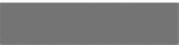
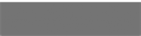
No file chosen
Choose File
Choose File

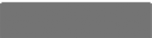
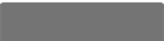
- 11. Supporting Materials - one of up to ten files Attach a file
Choose File
Choose File
No file chosen

- Supporting Materials - two of up to ten files

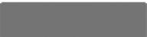
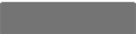
No file chosen
Choose File
Choose File

- Supporting Materials - three of up to ten files

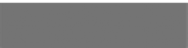
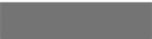
No file chosen
Choose File
Choose File

- Supporting Materials - four of up to ten files

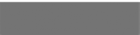
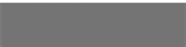
No file chosen
Choose File
Choose File

- Supporting Materials - five of up to ten files

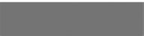
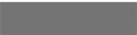
No file chosen
Choose File
Choose File

- Supporting Materials - six of up to ten files

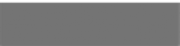
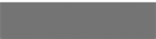
No file chosen
Choose File
Choose File

- Supporting Materials - seven of up to ten files

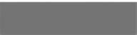
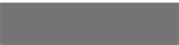
No file chosen
Choose File
Choose File

- Supporting Materials - eight of up to ten files

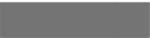
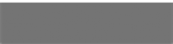
No file chosen
Choose File
Choose File

- Supporting Materials - nine of up to ten files

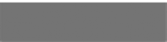
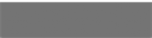
No file chosen
Choose File
Choose File

- Supporting Materials - ten of up to ten files

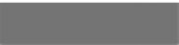
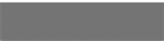
No file chosen
Choose File
Choose File

Your Project

- 21. Project Title (max 10 words)

- 22. Project Summary (max 100 words)

- 23. What will you do in your residency? (max 300 words)

- 24. What artistic outcomes are you hoping to achieve during your residency? (max 300 words)

- 25. What professional development goals will you work towards during your residency? (max 300 words)

- 26. How will you contribute to an artistic community at Bundanon? (max 300 words)

Your Practice

- 27. Please outline your working requirements, such as studio space, access to piano, writing space, etc. Please provide as much detail as possible.

Other Information

Supplies

Accessible Arts and Bundanon:

As part of this residency, the successful applicants will be provided with self-catering accommodation and a bursary to cover food and travel.
Artists in residence will each have one bedroom, a studio space and kitchen access. The Residency will take place across the Musicians’ Cottage, Gonski Apartment, Freedman Apartment, Fern Apartment, Sherman Apartment and The Barn Studios at Bundanon Trust. Further information is available here. https://bundanon.com.au/residencies/studios/
Please note: Fern Apartment is fully accessible for a wheelchair user. Please clearly indicate if this an access requirement within your application.

Artists:

Artists will be responsible for arranging their own transport to Bundanon and any supports that may be required. The property is a 2.5 hour drive from Sydney. Follow this link for location and maps. https://bundanon.com.au
There is a train to Nowra but no direct transport from the station to the Property. As part of this residency, the successful applicants will be provided with a bursary to cover travel.

All artists are responsible for their own food ie. 14 breakfasts, lunches and dinners, as well as beverages. The buildings will have their own kitchenette, with dining section for artists to prepare their own meals. Nowra has supermarkets. More information is available here. As part of this residency, the successful applicants will be provided with a bursary to cover food.
Artists are expected to bring their own art/creative materials.

Artists will need to sign a contract which commits them to attending both residency weeks in their entirety. Artists are expected to arrive between 2pm and 4pm on Monday 13 September 2021 for induction of the site by Bundanon staff.

Enquiries

Liz Martin, Arts Development Manager, Accessible Arts Email: lmartin@aarts.net.au
02 8379 3102

Thank-you for your applying!

If you are successful in your application, there will be additional Terms and Conditions on acceptance in accordance with existing policies of both the Bundanon Trust and Accessible Arts.

