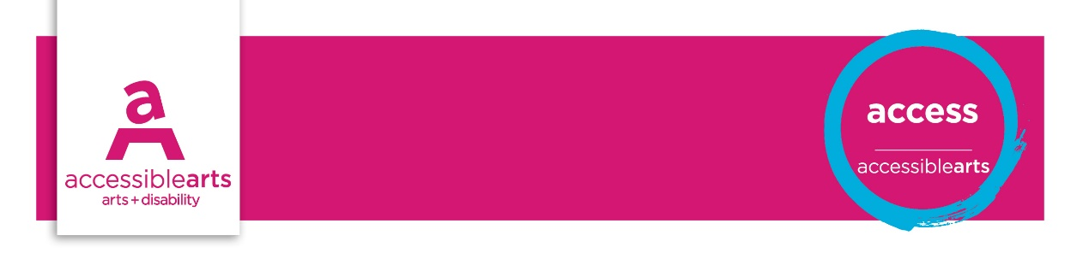

Accessibility Starter Kit
Accessible Arts’ Starter kit is a tool to be used for an initial venue and organisation access appraisal. It is a simple audit for disability access to venue and events and may provide the basis for public information that can go onto the website, marketing material or an access information sheet. This will also inform your organisation’s Disability Action Planning.
Some practices are legislated, yet many of the guiding principles for increased accessibility make good sense as well as being good business practice.
Aspects of disability access to consider include:
- Consultation – committees, forums, surveys, social media, formal and informal feedback
- Parking, public transport and accessible paths of travel
- Physical access: ramps, handrails, door handles and doorways, lifts, amenities
- Services – accessibility of event program, customer service and flexibility
- Attitude – disability awareness, equitability, respect, inclusion, diversity
- Affordability – companion card affiliate, comparable costs and opportunities
- Information – how to get there, disability facilities and services, signage
- Access to information – accessible website, alternate formats, options for communication
- Capacity building and partnership – mainstream and disability sector promotion

Thinking about access at the very earliest planning stages of your event means thinking about the access requirements of staff, public and artists or performers who may have a disability.
Inclusive practices remove the disadvantages and enable everyone to have a choice to participate equally.

Venue details
Venue Name: [enter venue name]
Address: [enter street address]
Phone: [enter phone]
Email: [enter email]
Website: [enter website address]

Venue | Yes | Part | No | Action
Wheelchair access is available at the main entrance; booking office; performance venue
Public spaces in the venue are accessible to people using a wheelchair or mobility aid
There are clear and considerate paths of travel in the venue for people using a wheelchair
Hearing augmentation is present and maintained in public address spaces
Noise levels in venue are moderated to aid hearing at conversational level
Pathways and general public areas are well lit for people with low vision or who lip read
Tactile Ground Surface Indicators are used to mark possible hazards ie. stairs, ramps
There are well maintained, accessible amenities
Public transport to the venue is accessible for people in wheelchairs and limited mobility
Transport drop-off / pick-up points are close to main entrance
There are clear, accessible pathways from drop off points or carpark to venue entrance
The drop off zone has kerb cuts in the footpath for wheelchair access
There is accessible parking at or near to the venue
Doors and doorways support people in wheelchairs to open/ close, manoeuvre, enter/ exit
Door handles and bathroom fittings are designed to aid people with limited dexterity
Service counter heights comply with standards that allow access for a people in a wheelchair
Reserved seating with considerate sightlines exists for disability access initiatives
Seating for people in wheelchairs is flexible enough to allow for companions to sit together
Directional signage in the venue includes disability access with access symbols
Program, goods & service information is in alternate formats ie. web, audio, print, braille
Making enquires or booking tickets is through a range of communication channels
People with disability are represented in media in an inclusive and respectful way
Language in marketing, media and customer service is inclusive and person-centred
Accessible performances have been promoted in main stream and in disability media
Contact numbers and email are available for queries about the disability services provided
Employees have undertaken disability awareness training
Employees are available to provide assistance to people with disability
Emergency exits are clearly marked and are wheelchair accessible
There are both audio and visual warning signals in the event of an emergency
Evacuation procedures support people with disability who may require assistance

Organisational | Yes | Part | No | Action
Policies on accessibility are clearly stated and implemented
There is an active disability action plan

Consultation on accessibility is on-going with people with disability
Targeted disability community have been consulted when programming access initiatives
There is a budget line for accessibility initiatives in each department or area or work
There are people with disability on staff
There is regular training in disability awareness and equity for employees
Website complies with W3C’s Web Content Accessibility Guidelines (WCAG 2.0)

Assessment of Results

Priority Action and Goals
- [enter text]

References and Links
Summary of the main Australian Standards referenced in the Access Code
Disability (Access to Premises – Buildings) Standards, 2010
Public transport re: accessible transport
National Arts and Disability Strategy
Disability Discrimination Act (1992), Regulations and Amendments
Australian Human Rights Commission
Accessible Arts

