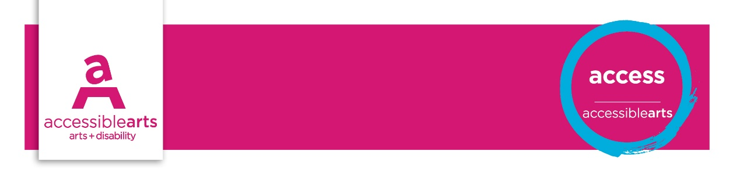

Venue Checklist

2. Building Maintenance and Access
The following statements are best addressed by the Venue Manager, and checked on a regular basis. These statements aim to identify opportunities for reviewing access and increasing inclusive practices.
Further information and explanation of some terms are on the Venue Information sheet. Compliance for access in public buildings are detailed in Disability (Access to Premises – Buildings) Standards 2010 and Australian Standards.

Venue details
Venue Name: [enter venue name]
Address: [enter street address]
Phone: [enter phone]
Email: [enter email]
Website: [enter website address]

General access | Yes | Part | No | Action
There is wheelchair access via the main entrance
If no wheelchair access via main entrance, access entrance is a respectable alternative
There is a clear pathway to the main entrance of the venue free from obstructions
Hazards are marked ie: overhead or overhanging, trips or protruding objects
All public spaces in the venue are wheelchair accessible. If no, note the restrictions
Noise levels in venue are moderated to aid hearing at conversational level
There are quiet areas for people to sit/rest or recharge electric wheelchair
All glass windows and doors are clearly marked
Hazard marking Tactile Ground Surface Indicators are in use for people with vision impairment
Hearing augmentation system is fully functioning, checked and maintained annually
The hearing augmentation system’s coverage is between 80-95% of the designated space
Pathways and ramps allow for a person in a wheelchair to travel next to a companion
Ramps have building standard grading and landings: standard 1:20; minimum 1:14
Step ramps have a minimum standard grading of 1:8
Ramps have building standard handrails
Outdoor areas are accessible and provide shelter and rest areas
There is an area for assistance animals to be toileted

Doors and doorways | Yes | Part | No | Action
Automatic doors are provided at venue
Manual doors are wide enough to allow wheelchair access: minimum 850mm
Manual doors are weighted to enable ease of use in opening and closing
Door handles are at a height that is within reached of people in wheelchairs
Door handles are of universal design for ease of use for people with limited dexterity
Manual doors have space to enable people in a wheelchair to enter/ exit and manoeuvre

Floor surfaces | Yes | Part | No | Action
Floor surfaces are even and non-slip
Floor surfaces are stable and low friction for ease of travel in a wheelchair
Colour contrast is utilised to indicate changes in floor surfaces

Lighting | Yes | Part | No | Action
Lighting is even and enough for activities as appropriate to areas of the venue
Lighting is enough for activities as appropriate to areas of the venue
Transitions between dramatic lighting changes are moderated
Pathways and general areas are well lit for people that are low vision or who lip read

Stairs / escalators / lifts | Yes | Part | No | Action
Stairs comply with building standards for height and consistency
Stairs and escalators have safety measures installed ie: handrails, slip resistant surfaces
Stairs have non slip surfaces
Stairs and escalators have tactile ground surface indicators at the top and bottom
Escalators/ stairs / lifts are clearly and consistently sign posted
Escalator speed allows for people with limited or slow mobility
Lift is large enough to allow a person in a wheelchair to manoeuvre 360 degrees
Lift buttons are at a height that can be reached by a person in wheelchair
Lift has relevant signage including braille on the buttons
Lift has aural and visual cues to indicate floor levels and other information

Public amenities/ toilets & bathrooms | Yes | Part | No | Action
Venue provides accessible toilets at a ratio of 1:25 for women and men (unisex)
Directional signs for public amenities incorporate the universal symbol for access
Toilet signs includes raised tactile and braille information
Accessible toilets comply with Australian Building standards
Accessible toilets are clear and free from hazards or unsuitable items
If no accessible toilets are available, a suitable alternative is arranged

Emergency exits | Yes | Part | No | Action
Emergency exits are clearly marked and accessible for wheelchair
Luminous indicators are used in the venue ie: Fire exit signs
There are both audio and visual warning signals in the event of an emergency
Evacuation procedures support people with disability who may require assistance

Staff | Yes | Part | No | Action
Employees have undertaken disability awareness training
Employees are available to provide assistance to the public with disability
Employees are suitably prepared to assist the public with a range of disabilities

Assessment of Results

Priority Action and Goals
- [enter text]

References and Links
Summary of Australian Standards: 1428 Design for Access and Mobility
Disability (Access to Premises – Buildings) Standards, 2010
Accessible Arts

