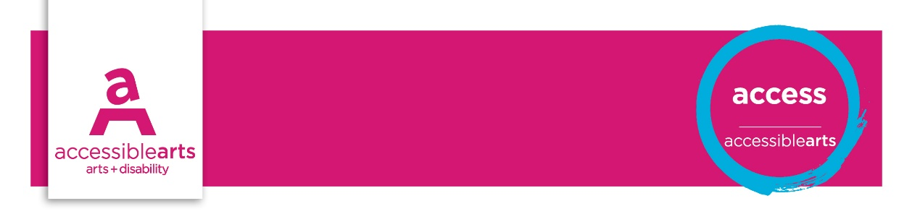

Marketing and communications checklist

The following statements should be addressed by Marketing Manager in conjunction with media and communications manager and checked on a regular basis. These statements aim to identify improved services for people with disability.

Further information and explanation of some terms are on the Marketing and Communications Information sheet.

Marketing and communications | Yes | Part | No | Action
Accessibility is embedded in the marketing strategy
Identify and establish relationships with local disability and community groups
Identify programs / services that would benefit from collaboration with disability organisations
Develop a disability media contact list that reflects the marketing programme
Develop partnership programs with disability organisations
People with disability are included in research or community / customer consultative processes
Marketing staff have undertaken disability awareness training
There is a marketing budget for both supporting and promoting accessibility

Access information | Yes | Part | No | Action
Information includes services provided for people with disability
Access information and symbols are included on all marketing and promotional material
Times, availability, costs and booking process of access services are promoted early
Times, availability and costs of access services are promoted in alternative formats
A range of contact options are available for people requiring further information
Access guides are available that provide information on accessible services and facilities

Presentation of information | Yes | Part | No | Action
Access symbols are on all promotional materials
Language is inclusive and person-centred eg. person in a wheelchair
Images are inclusive of people with disability
People with disability are represented in an inclusive and respectful way
Images convey the diversity of disability
Mail out information is in an access format for the specific disability sector / organisation
Information is available in a range of formats for audiences, as per below formats:
Braille
Large print (minimum size 18 font)
Audio
Easy English
Electronic Word document, plain text
Print version of audio material
Captioning of audio-visual material
Audio description of audio-visual material
Auslan interpretation of key text and audio

Media | Yes | Part | No | Action
Disability media and organisations are included in all aspects of publicity and promotional plans
Promotion to disability media for both mainstream interests and disability/ access
Liaise with disability media representatives in an inclusive and respectful way
Press releases are sent to disability media
Access is promoted in mainstream media
There are opportunities for people with disability to give feedback on use of services

Print and publications | Yes | Part | No | Action
Text size is 12 points or greater
Text uses fonts and are clear and easy to read ie. sans serif
Text minimises use of italics
Text uses standard mixed cases rather than all capitals
Text and graphics are kept separate
Tags or captions in use to describe visual images on electronic material
Text conveys a distinct level of contrast between background and foreground ie: 70% luminance
Print materials are on midweight paper to eliminate bleed
Print materials are on matt or low gloss paper
Information and publications are made available in alternative formats ie easy English; Braille
Large print documents have a minimum font of 18 points
Publications use affirmative language to describe people with disability
Text size is 12 points or greater
Text uses fonts and are clear and easy to read i.e., sans serif

Assessment of Results

Priority Action and Goals
- [enter text]

References and Links
Guidelines for Producing Readable Text
Accessible Arts

