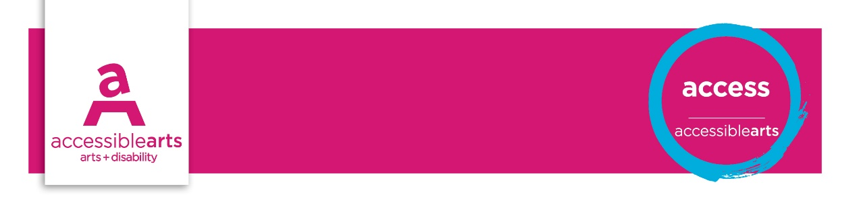

Venue Checklist

5. Exhibition Environments
The following statements are best addressed by Curator or Production Manager in conjunction with heads of departments. These statements aim to identify opportunities for reviewing access and increasing inclusive practices.
Further information and explanation of some terms are on the Accessibility Starter Kit information sheet.

Venue details
Venue Name: [enter venue name]
Address: [enter street address]
Exhibition environment | Yes | Part | No | Action
The exhibition space is accessible to people using a wheelchair or mobility aid
Service counters heights comply with standards that allow access by a person in a wheelchair
There are clear, considerate paths of travel in the exhibition for a person in a wheelchair or people who are blind or have low vision
Noise level management considers people who are hard of hearing
Lighting is even and appropriate to the activities ie: reading text, moving around, lip reading
Changes to lighting levels are clearly identified with signage
There is a variety of seating available in the exhibition space for people to rest
Some seating has back support and arm rests both in the exhibition space and rest area
There are rest and wheelchair recharge areas outside and within the exhibition space
Theatrettes and auditoriums have a range of accessible seating for wheelchairs
Accessible seating is flexible and allows people in wheelchairs to sit with their companions and service animals
Theatrettes and auditoriums have a hearing augmentation system in place for hearing aids
A notice of fresh wall paint and other recent building works has been provided on the website and at the venue
Quiet or quieter spaces have been identified and communicated on maps and the web

Display of objects and media | Yes | Part | No | Action
Wall mounted work is hung at a height comfortable for viewing from a seated position
Display cases and tables are at a height comfortable for viewing from a wheelchair
There is knee room below the display case to allow a person in a wheelchair to get close to the display ie 750mm high x 900mm wide
Glass used in display case and framed artwork is non-reflective
There is colour contrast between the work displayed and the background
There are tactile samples evoking artwork that may not be touched
Hazards are indicated through warning notices and announcements
Content warnings are clearly indicated by signage that follows accessible guidelines
Video content is captioned with transcripts available

Print and publication guidelines | Yes | Part | No | Action
Display labels are at a comfortable height to be read from a sitting or standing position
Labels are in alternate formats including Braille, large print, audio or Auslan
There is adequate lighting to read labels
Labels convey a distinct level contrast between text and background ie 70%
Label text is large enough to be read easily by people who require Large Print
Printed catalogues meet print guidelines for accessibility
Printed materials and publications are available in alternate formats ie Braille, large print, audio
Publications use affirmative, person-centred language to describe people with disability
Promotional material is inclusive of people with disability
Access facilities and services are promoted in all marketing and information materials
People with disability are represented in an inclusive and respectful way
Signage uses access symbols to indicate access facilities
Maps of the venue and/or exhibition spaces are provided in a range of formats, eg tactile, high contrast, web and at the venue

Access services | Yes | Part | No | Action
Public address areas have a hearing augmentation system
Auslan Interpreters are included in any public presentations or speeches
Public tours or guides of the exhibition are available in Auslan
Public tours or guides of the exhibition are available as Audio Description
There are opportunities for tactile experiences of the artwork for people who have low vision or are blind
Public programs cater for people with disability
Access to the exhibition considers multi-sensory experience ie scent; tactile, audio, visual
There are several options for booking access ie in person; online; telephone
There is a specific contact person to coordinate disability access and booking enquiries
Staff have undertaken disability awareness training

Assessment of Results

Priority Action and Goals
- [enter text]

References and Links
Disability (Access to Premises – Buildings) Standards, 2010
Exhibition display guidelines
Auslan interpreters – NSW
Access service providers
Guidelines for Producing Readable Text
Accessible Arts

