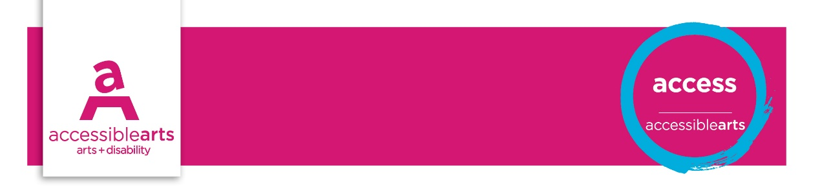

Venue Checklist

3. Signage and Communications
The following statements are best addressed by Customer Service Manager in conjunction with the Venue Manager and checked on a regular basis. These statements aim to identify opportunities for reviewing access and increasing inclusive practices.
Further information and explanation of some terms are on the Venue Information sheet.

Venue details
Venue Name: [enter venue name]
Address: [enter street address]
Communication | Yes | Part | No | Action
Venue access information is available in a range of formats ie web, audio, print, braille
Goods and services information is in a range of formats ie web, audio, print, braille
Venue / organisation offers a range of communication options for booking tickets
People with disability can make enquires using a range of communication channels
Venue/ organisation utilises National Relay Service to receive or make calls
Communication points have accessible systems ie. Braille; visual cues at intercom
People with disability are represented in media in an inclusive and respectful way
Language is inclusive and person-centred
Images are inclusive of people with disability
Universal access symbols are used on all signage and promotional formats
Auditory and visual information is provided for performance warnings ie: explosive sounds
Staff have undertaken disability awareness training
Staff are aware of the access facilities and services and able to advise the public

Signage | Yes | Part | No | Action
There are wayfinding and directional signage for access facilities ie. entrances, lifts, toilets
Wayfinding signage uses accessible formats for communicating information ie audio, Braille
There are clear wayfinding indicators and information signage in the main reception
Signage and wayfinding indicators are provided at ‘points of decision-making’
Information signage are displayed at a height to be read by a person in a seated position
Characters and letters are sized so easy to read, according to viewing distance
Characters and symbols contrast with their background
Universal access symbols are used on signage
Signage used to direct the public at night is illuminated

Assessment of Results

Priority Action and Goals
- [enter text]

References and Links
National Relay Service - A free service to assist telephone communication with people who are deaf or have a hearing or speech impairment
Guidelines for Producing Readable Text
Accessible Arts

