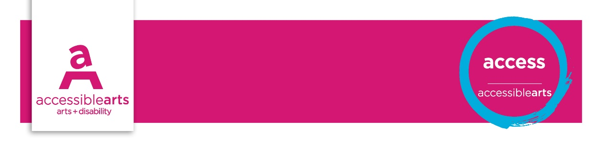

Venue Checklist

4. Ticketing, Seating and Services
The following statements should be addressed by Customer Service Manager and the Venue Manager and checked on a regular basis. These statements aim to identify opportunities for reviewing access and increasing inclusive practices.
Further information and explanation of some terms are on the Venue Information sheet

Venue details
Venue Name: [enter venue name]
Address: [enter street address]
Access facilities and services | Yes | Part | No | Action
There is customer service assistance at reception or central information point
Venue staff are knowledgeable and able to assist regarding access facilities and initiatives
Hearing augmentation system is available in the venue. Note the type of system
There are signs with access symbols indicating the availability of the augmentation system
There is information available regarding augmentation system and procedures for use
Staff are aware of the augmentation system and are able to assist in its usage
There is reserved seating with good sightlines to both performance and Auslan Interpreters and captions
There are captioned performances
There are clear procedures for booking audio description and collection of headsets
Staff are aware of the audio description service and are able to assist in its usage
Accessible performances have been promoted in mainstream and disability media
Accessible performance promotional material is in appropriate format for the disability service
Venue provides a policy on provisions for assistance animals
Staff are aware of the policy regarding assistance animals in the venue
Wheelchair and other assistance equipment is available for loan/hire
Access equipment that is available/ for hire is advertised
People who use motorised wheelchairs are able recharge their wheelchairs at the venue
Transport is available for people with limited mobility at events with multiple, widely spaced venues
Staff are trained in disability awareness

Seating | Yes | Part | No | Action
There are rest areas throughout venue with available seating
There are accessible pathways to seating areas ie: with ramps, lifts and clear path of travel
Some seating considers ease of use for sitting in and rising out
Some seating has back support and armrests in both rest areas and event space
In the venue seating is provided for people who use wheelchairs and their carers
In the venue signs indicate the seats covered by the hearing augmentation system
Wheelchair accessible seating is evenly dispersed throughout the venue
There is circulation space within the venue for a person to transfer from a wheelchair to a chair
Seating with good sightlines is reserved for access initiatives
Seating for people with wheelchairs is flexible enough to allow for companions to sit together
Some seating allows room for an assistance animal to sit beneath or beside their companion
Seating can be booked to meet the needs of people with disability ie: near to stage; or aisles
Reserved seating is coordinated between the ticketing outlets and in the venue
Audiences can store their mobility aids in available storage during performances

Ticketing | Yes | Part | No | Action
Ticketing and seating information for people with disability is available in a range of formats
Ticket prices are equitable if seating choice is restricted ie. suitable seating is A reserve only
Ticketing and Box Office staff are trained in disability awareness and access considerations
Ticketing and Box Office staff are aware of the venue disability services and facilities available
Ticketing staff are aware of the event services and facilities available for people with disability
Booking office is accessible for people with a wheelchair or limited mobility
Ticketing counters are at a suitable height for people in wheelchairs to carry out transactions
Booking office is accessible for people with a sensory disability ie: use of Braille; hearing loop
Accessible seating spaces are clearly identified on venue seating maps
Staff are familiar with National Relay Service to facilitate communication
Carers receive free or discounted tickets as part of the Companion Card scheme
Booking services online are fully accessible for people with a vision impairment
Contact number and email are available for queries about the disability services provided
Warnings and hazards have been communicated at point-of-sale ie: smoke; explosive sounds
People with disability are not disadvantaged when booking access on multiple ticket deals
At point-of-sale customers are asked if they have access requirements, and staff are trained in how to respond to requests
There are opportunities for giving feedback on the ticketing process

Food, beverage service  (If offered as part of the service) | Yes | Part | No | Action
Menus are available in an accessible formats ie: website in plain text; large print
Counters are at a height suitable for transactions with people in wheelchairs
People can pre-order food/ drinks
Food and beverages can be delivered to people with disability in the performance or rest area

Assessment of Results

Priority Action and Goals
- [enter text]

References and Links
Companion Card, NSW
National Relay Service
Disability (Access to Premises – Buildings) Standards, 2010
Exhibition display guidelines
Auslan interpreters – NSW
Access service providers
Guidelines for Producing Readable Text
Accessible Arts

