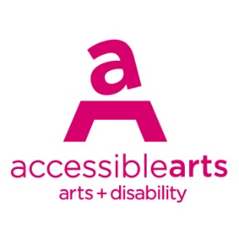

Access Ideas & Insights Podcast

Image Description Guide

Introduction: Episode 1 – Accessible Curation
This document contains written Image Descriptions for the images featured in the Auslan version of the Accessible Arts: Access Ideas & Insights podcast video Accessible Curation. Each episode of the podcast includes the following accessible features: an Auslan video, a transcript, and an Image Description guide. Where available, time stamps are included to assist with navigation. Auslan users may find it helpful to use this guide alongside the video.

Table of Contents
Introduction: Episode 1 – Accessible Curation 1
Table of Contents 1
Image Descriptions 2
Image 1: Access Ideas & Insights Podcast Logo Graphic 2
Image 2: Headshot Bedelia Lowrenčev 3
Image 3: Access Ideas & Insights Podcast Logo Graphic 3
Image 4: Artwork Jellybean 4
Image 5: Bailee Lobb Performing 4
Image 6: Bailee Performing with Glass Beaded Blanket 5
Image 7: Artwork Hugging Pea 5
Image 8: Glass Blanket 6
Image 9: Bailee performing behind yellow transparent curtain 6
Image 10: Bailee waking up during her performance 7
Image 11: Bailee Sleeping in the Gallery 7
Image 12: Artwork Big Blue 8
Image 13: Artwork Pineapple Place 8
Image 14: Artwork Jellybean 9
Image 15: Artwork Orange Cathedral 9
Image 16: Audience inside Big Blue 10
Image 17: Bailee sitting inside Orange Cathedral 10
Image 18: Artist talks inside Yellow Bubble 11
Image 19: Access Ideas & Insights Podcast Logo Graphic 11
Image 20: Headshot Amanda Cachia 12
Image 21: Dominic Quagliozzi: Corporis Fabrica exhibition 12
Image 22: Amanda Cachia & Jason Strother 13
Image 23: Entrance view, Crip Ecologies: Vulnerable Bodies in a Toxic Landscape 13
Image 24: Installation view, Crip Ecologies: Vulnerable Bodies in a Toxic Landscape 14
Image 25: Sweet Gongs Vibrating Exhibition 14
Image 26: Installation view, Smoke & Mirrors exhibition 15
Image 27: Smoke & Mirrors exhibition 15
Image 28: Access Ideas & Insights Podcast Logo Graphic 16
Image 29: Access Ideas & Insights Podcast Partnerships 16

Image Descriptions

Image 1: Access Ideas & Insights Podcast Logo Graphic
Video Timestamp: 00:00:00 – 00:44:00
Image Description: A white vintage microphone stands out against a solid black background. To its right, bold text reads: “accessible arts Access Ideas & Insights Podcast.” The words “accessible arts” appear in magenta lowercase, while the rest of the text is white. The word “Podcast” is larger and set below by a thin gradient line shifting from magenta to yellow. Along the bottom edge, a vivid wave of magenta, purple, orange, and yellow adds movement to the design.
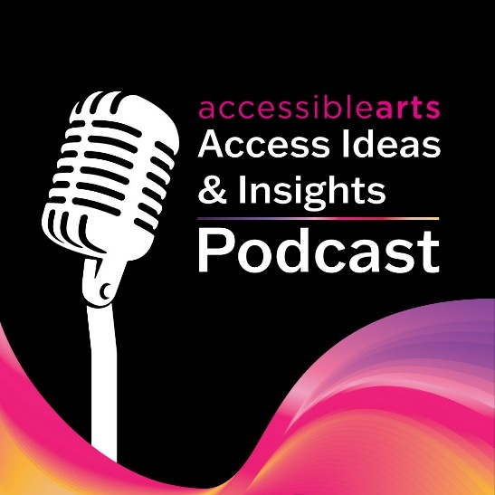

Image 2: Headshot Bedelia Lowrenčev
Video Timestamp: 00:44:00 – 01:22:00
Image Description: A person with long wavy brown hair and hazel eyes smiles at the camera. They are wearing a sheer green long-sleeve top. Their head tilts slightly as their hand rests against her neck. The background is softly blurred, bringing the focus to their face.
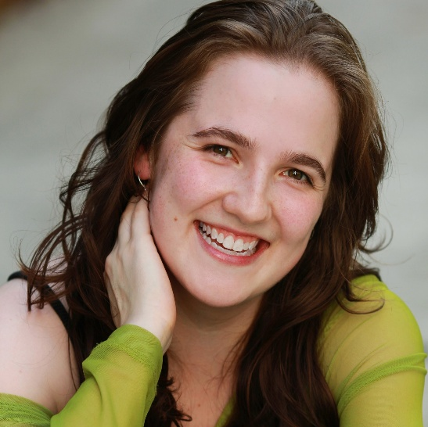

Image 3: Access Ideas & Insights Podcast Logo Graphic
Video Timestamp: 01:22:00 – 02:51:10
Image Description: A white vintage microphone stands out against a solid black background. To its right, bold text reads: “accessible arts Access Ideas & Insights Podcast.” The words “accessible arts” appear in magenta lowercase, while the rest of the text is white. The word “Podcast” is larger and set below by a thin gradient line shifting from magenta to yellow. Along the bottom edge, a vivid wave of magenta, purple, orange, and yellow adds movement to the design.

Image 4: Artwork Jellybean
Video Timestamp: 02:51:10 – 05:04:90
Image Description: Bathed in pink a woman with shoulder-length dark auburn hair sits inside a pink inflatable sculpture. They are smiling and dressed in a long-sleeved top that closely matches the pink hue of the surrounding space. One arm is extended, gently pressing against the curved wall, while the other rests casually on their knee. The semi-translucent fabric of the structure diffuses light, enveloping the entire scene in a soft pink glow. Behind the woman, curved seam lines in the fabric show where different pattern pieces have been stitched together to form the sculpture.
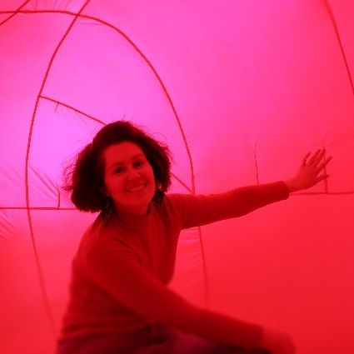

Image 5: Bailee Lobb Performing
Video Timestamp: 05:04:90 – 07:25:40
Image Description: A woman with curly auburn hair wearing a bright red shirt is pictured in profile, standing in a softly lit room. They are gently pressing a large, green, padded sculptural against a white wall. The object has a soft, upholstered texture and is mounted on wooden brackets. The woman appears focused, with both hands extended to steady the sculpture. Light filters in from the upper left corner, casting a diffused light across the room.
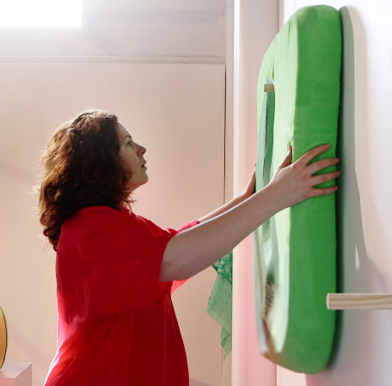

Image 6: Bailee Performing with Glass Beaded Blanket
Video Timestamp: 07:25:40 – 08:29:00
Image Description: A woman with shoulder-length auburn hair stands next to a white gallery wall, shown in profile. Only the top half of her body is visible. She is wrapped in a knitted glass-beaded blanket that has a soft iridescent glow. The blanket design is made up of abstract shapes in various shades of green, with a light peach stripe curving around the edge of the shapes. Her hands hold a peach-coloured oval sculpture, suspended from a wooden bracket. The woman looks straight ahead, her gaze is level, rather than down at the object she holds.
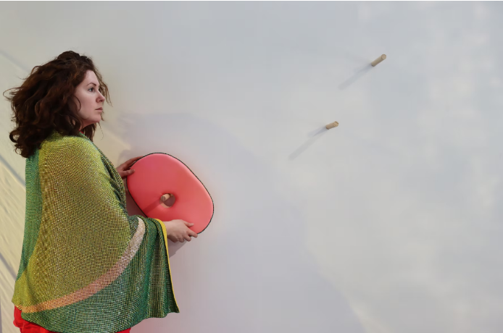

Image 7: Artwork Hugging Pea
Video Timestamp: 08:29:00 – 08:40:90
Image Description: A bright chartreuse circular sculpture sits on a white plinth in the centre of a white-walled gallery. The piece is made from soft velvet fabric and outlined with darker green piping that defines its rounded shape. Near the top of the sculpture, slightly off-centre, a cluster of dark green beads forms an irregular patch against the smooth surface. The gallery is evenly lit, with a ray of light coming across the back wall behind the sculpture.
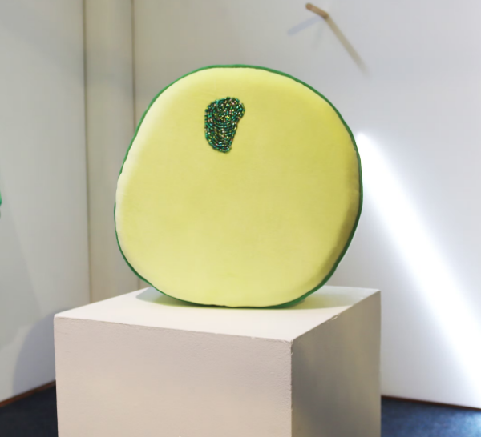

Image 8: Glass Blanket
Video Timestamp: 08:40:90 – 08:51:00
Image Description: A glittering blanket made from 75,000 knitted glass beads stretches across the frame. Designed to provide deep pressure and support temperature regulation. Green shapes in varying shades form a subtle pattern, while beads closest to the viewer are softly out of focus. The blanket dips at the centre and rises in a gentle curve, resembling rolling hills. Light reflects off the surface, giving the beads a shimmering, iridescent quality.

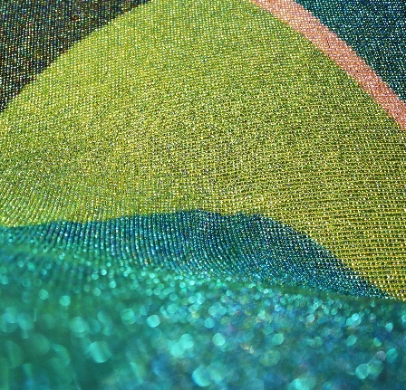

Image 9: Bailee performing behind yellow transparent curtain
Video Timestamp: 08:51:00 – 09:22:70
Image Description: A woman with shoulder-length, curly auburn hair stands in a softly lit room, partially obscured by transparent panels of yellow PCV fabric that hang in the foreground. They wear headphones and a matching red shirt and pants. Draped over their shoulders is a blanket made of glass beads in varying shades of green. Their gaze is lowered in concentration as they hold the blanket in place. Light highlights and reflections are scattered across the panels, giving the scene a diffused, dreamlike quality.
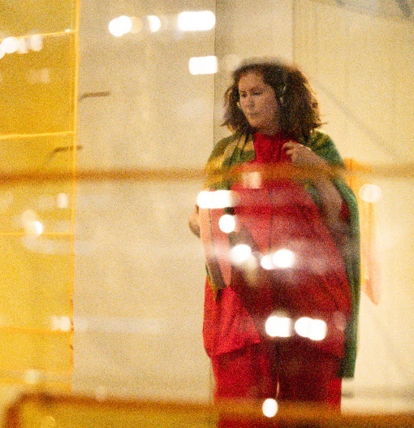

Image 10: Bailee waking up during her performance
Video Timestamp: 09:22:70 – 09:42:60
Image Description: A woman sits on a large, soft green cushion placed on a blue carpeted floor. They wear a loose red shirt, and an iridescent glass-beaded blanket is wrapped around their legs. Captured in motion, their head is turned away, causing their auburn hair to fan out. Beside them is an orange fabric turban and a sleep mask. In the background, semi-transparent yellow PVC fabric hangs on the wall, and a plain white plinth stands to the right.
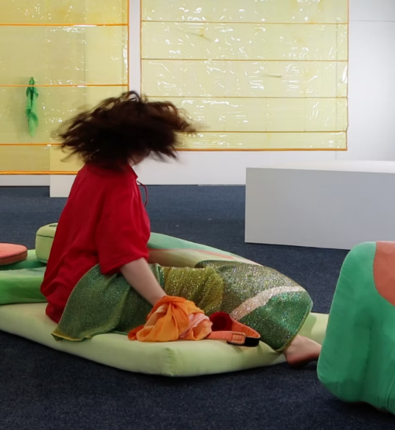

Image 11: Bailee Sleeping in the Gallery
Video Timestamp: 09:42:60 – 11:20:80
Image Description: A woman lies on her side across several large, plush cushions in varying shapes and shades of green. She is covered in an iridescent green blanket made from glass beads. The woman’s head rests on a peach-coloured cushion, and their hair is wrapped in an orange fabric turban. Their eyes are covered with an orange sleep mask featuring a circular red patch in the centre. One arm extends upwards, while the other rests on a pale green circular cushion positioned in front of their chest.
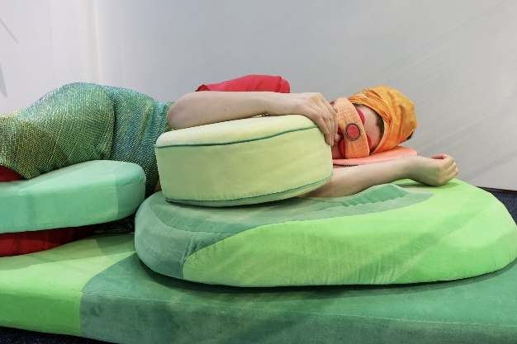

Image 12: Artwork Big Blue
Video Timestamp: 11:20:80 – 12:45:60
Image Description: Inside a deep blue inflatable sculpture, a person reclines with legs extended and arms braced behind them, gazing upward. The interior is made of large, stitched panels, their seams tracing the shape of the sculpture. Soft, even lighting saturates the space in indigo, while a small circular fan sits low on the right wall.
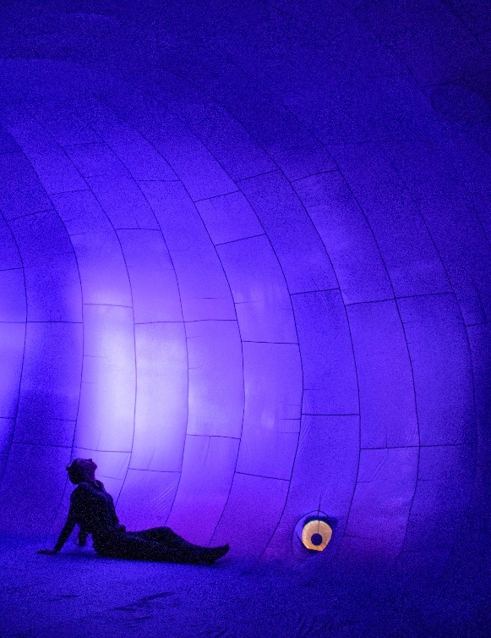

Image 13: Artwork Pineapple Place
Video Timestamp: 12:45:60 – 13:38:20
Image Description: A large yellow inflatable bubble rests against the corner walls of a yellow-painted room. In the foreground, semi-transparent PVC panels stitched into a loose grid hang between floor and ceiling, dividing the space without obstructing it. The polished concrete floor reflects the yellow tones, intensifying the ambient glow.
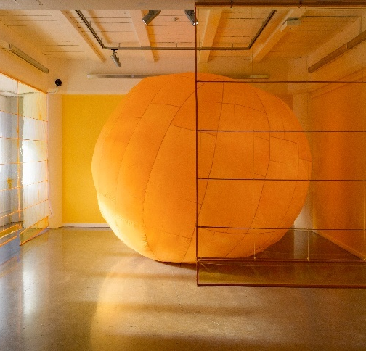

Image 14: Artwork Jellybean
Video Timestamp: 13:38:20 – 14:38:40
Image Description: Bathed in pink a woman with shoulder-length dark auburn hair sits inside a pink inflatable sculpture. They are smiling and dressed in a long-sleeved top that closely matches the pink hue of the surrounding space. One arm is extended, gently pressing against the curved wall, while the other rests casually on their knee. The semi-translucent fabric of the structure diffuses light, enveloping the entire scene in a soft pink glow. Behind the woman, curved seam lines in the fabric show where different pattern pieces have been stitched together to form the sculpture.

Image 15: Artwork Orange Cathedral
Video Timestamp: 14:38:40 – 14:57:00
Image Description: A close-up view of the inside of an orange inflatable sculpture. The textured surface is composed of stitched fabric panels. The semi-transparent material allows soft light to pass through, giving the interior a warm glow. The seams curve and intersect at irregular angles, forming an abstract pattern, and the fabric shows small creases and variations in texture giving more detail to the inflatable sculpture.
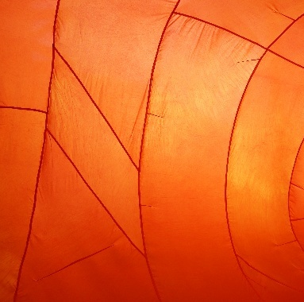

Image 16: Audience inside Big Blue
Video Timestamp: 14:57:00 – 16:40:00
Image Description: Five people move through a large, deep blue inflatable sculpture. The curved walls and floor are made from different pattern pieces of fabric stitched together. The people are mostly in shadow, silhouetted by the light, which intensifies toward the back where an opening or entrance. Two people appear mid-step, one facing away and the other partially turned. Further back, one figure leans into the opening, their body bent forward as if in mid-motion, while others stand nearby waiting to follow.
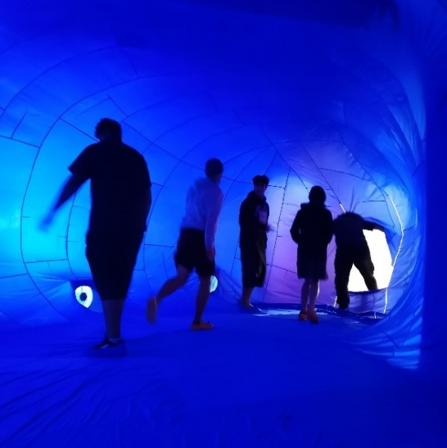

Image 17: Bailee sitting inside Orange Cathedral
Video Timestamp: 16:40:00 – 19:38:00
Image Description: A woman with dark, shoulder-length hair sits inside an inflatable sculpture, entirely enclosed in vivid orange fabric. The interior curves around them in a spiral of stitched fabric pattern pieces, giving the space a tunnel like feel. They are seated with one leg bent and the other extended, wearing a sleeveless dark dress and brown flat shoes. Their expression is contemplative as they look slightly upward, bathed in the warm orange light that fills the space.
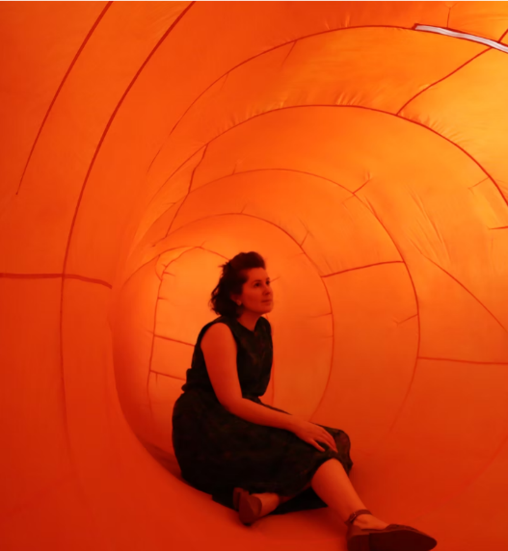

Image 18: Artist talks inside Yellow Bubble
Video Timestamp: 19:38:00 – 21:27:70
Image Description: Inside a softly lit, inflatable sculpture glowing in vibrant orange and yellow hues, a group of people sit closely together on the floor. The group is enclosed by the curved walls of an inflatable sculpture. At the centre, a woman gestures with her arm outstretched as she speaks to the group. The members of the group sit attentively some cross-legged, some leaning in to listen.
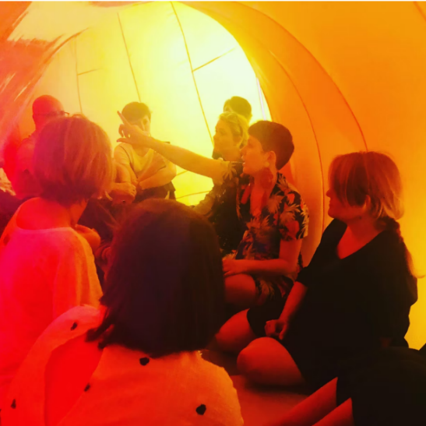

Image 19: Access Ideas & Insights Podcast Logo Graphic
Video Timestamp: 21:27:70 – 21:40:60
Image Description: A white vintage microphone stands out against a solid black background. To its right, bold text reads: “accessible arts Access Ideas & Insights Podcast.” The words “accessible arts” appear in magenta lowercase, while the rest of the text is white. The word “Podcast” is larger and set below by a thin gradient line shifting from magenta to yellow. Along the bottom edge, a vivid wave of magenta, purple, orange, and yellow adds movement to the design.

Image 20: Headshot of Amanda Cachia
Video Timestamp: 21:40:60 – 23:10:03
Image Description: A white woman with curly brown hair and brown eyes is smiling. They are wearing red lipstick and a patterned top with maroon, orange, and cream geometric shapes. The background is softly blurred, with greenery and terracotta bricks faintly visible. The lighting is bright and even, highlighting the person's face.


Image 21: Dominic Quagliozzi: Corporis Fabrica exhibition
Video Timestamp: 23:10:03 – 24:31:80
Image Description: An art exhibition with white walls and wooden floors and a ramp with a metal handrail leads into the space. On the left, a flatscreen shows a video of a hand moving against a bright blue background, with a wall label below. Nearby, artworks on the wall include paper arms showing anatomical details and pink fabric lungs with brown and gold accents. On the right, two sculptural garments stand on dress forms near a window. One made of brown stuffed toys, the other of bright blue fabric. The gallery is lit by both natural light and ceiling track lights.
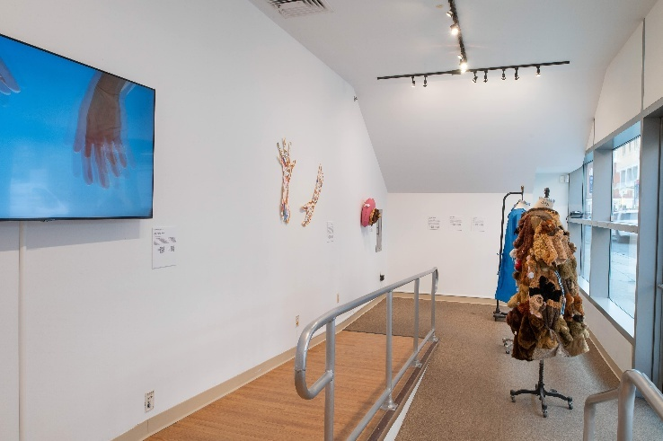

Image 22: Amanda Cachia & Jason Strother
Video Timestamp: 24:31:80 – 27:07:70
Image Description: Two people stand in front of a table inside an art gallery with wooden floors and white walls. The woman, in a green jacket and cream blouse, smiles while engaging with textile pieces. The man beside her, in a light blue sweater, looks down at a crocheted work in his hands. More textiles are spread across the table. In the background, a patterned artwork wall displays repeated bright geometric shapes in pink, green, black, and white.
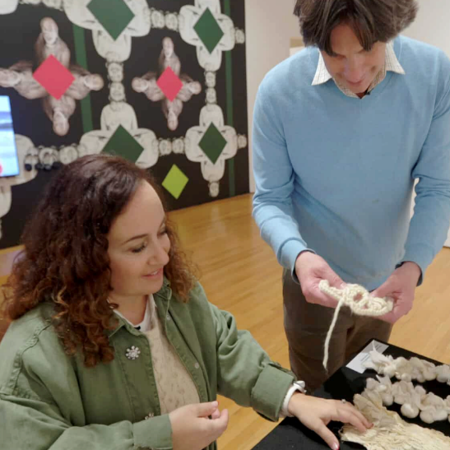

Image 23: Entrance view, Crip Ecologies: Vulnerable Bodies in a Toxic Landscape
Video Timestamp: 27:07:70 – 28:18:80
Image Description: A wide view of the exhibition Crip Ecologies: Vulnerable Bodies in a Toxic Landscape, curated by Amanda Cachia. The entrance leads into a large gallery with polished concrete floors. Sculptural, textile, and video works are spaced throughout the room. In the front, three white plinths hold small sculptures. In the back, a bright orange video is projected on a screen. Nearby, a patchwork textile and a graphic drawing of antlers with the word “SONIC” on the side hang on the wall.
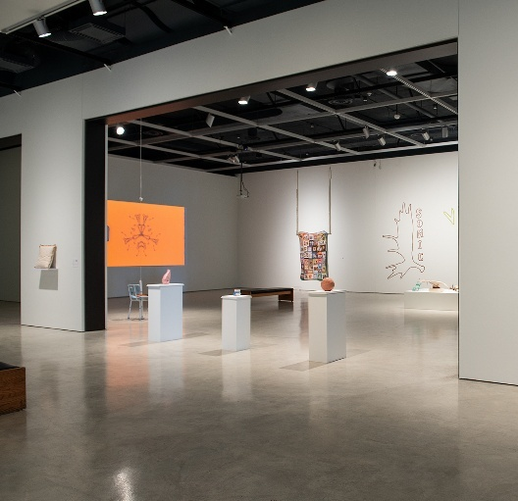

Image 24: Installation view, Crip Ecologies: Vulnerable Bodies in a Toxic Landscape
Video Timestamp: 28:18:80 – 30:10:30
Image Description: A gallery with white walls and polished concrete floors showing a mix of artworks. On the left wall, a video projection shows a person with long braids in a sculptural pose, arched backward, reaching behind to hold their ankles, with a mobility aid helping to stabilise their position. A wooden bench is placed in front. In the centre, a white plinth displays antlers, a brown hat, green gloves, and small wooden objects. On the right wall, a patchwork textile artwork is hanging.
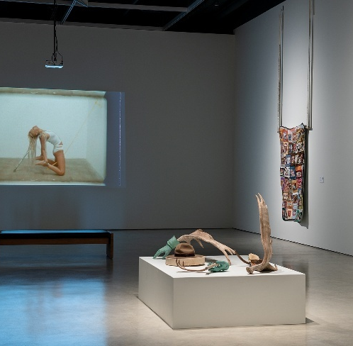

Image 25: Sweet Gongs Vibrating Exhibition
Video Timestamp: 30:10:30 – 36:07:10
Image Description: Curator Amanda Cachia stands at the centre of a gallery, wearing black pants and a white and gold shirt. She looks upward with a smile, holding a mallet up to a suspended metallic, shell-like sculpture with holes. Around her hang other objects, including a teddy bear sculpture. Behind her to the right is a black staircase and to her left is a wall-mounted screen with headphones.
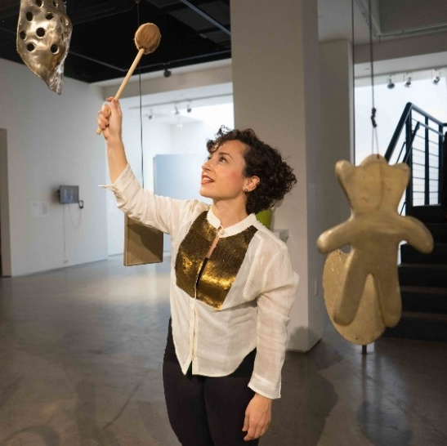

Image 26: Installation view, Smoke & Mirrors exhibition
Video Timestamp: 36:07:10 – 38:23:50
Image Description: A spacious gallery with light wooden floors and white walls features an art exhibition. At its centre, a dark blue massage chair sits within three yellow concentric circles on the floor. Behind it, a chair is placed against a wall scattered with small paper artworks. In the foreground, a white plinth holds framed works, opposite sits a rectangular floor piece, made up of rows of stones in shades of brown, white and grey. Bright, even lighting enhances the open feel of the space.
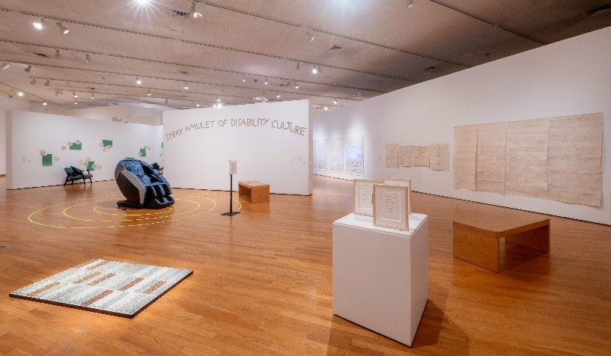

Image 27: Smoke & Mirrors exhibition
Video Timestamp: 38:23:50 – 41:05:70
Image Description: The exhibition space has seating arranged in a circle, including cushioned chairs and a deep green chaise lounge. Embroidered cushions decorate the seats. Yellow coffee tables between the chairs hold books and tactile objects. Around the room, green A4 paper works, and circular, flower-like cutouts are grouped on the white walls. The polished wooden floor and gentle overhead lighting create a warm, bright atmosphere.
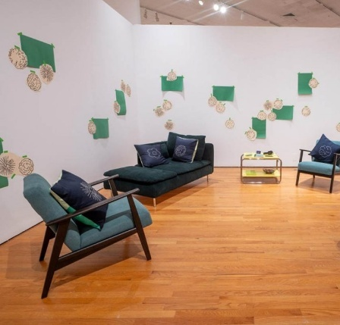

Image 28: Access Ideas & Insights Podcast Logo Graphic
Video Timestamp: 41:05:70 – 41:43:10
Image Description: A white vintage microphone stands out against a solid black background. To its right, bold text reads: “accessible arts Access Ideas & Insights Podcast.” The words “accessible arts” appear in magenta lowercase, while the rest of the text is white. The word “Podcast” is larger and set below by a thin gradient line shifting from magenta to yellow. Along the bottom edge, a vivid wave of magenta, purple, orange, and yellow adds movement to the design.

Image 29: Access Ideas & Insights Podcast Partnerships
Video Timestamp: 41:43:10 – 41:52:70
Image Description: A black background with white text and three logos at the bottom. The text reads: "This podcast was proudly produced by Accessible Arts and Kiera Brew Kurec, with sound design by Tralala Blip. Access consulting was provided by Macro Impact Consulting and our Advisory Group. Special thanks to our Auslan interpreters from Sweeney Interpreting. This podcast series is proudly supported by the City of Sydney and Create NSW, the principal funding partner of Accessible Arts."
At the bottom are three logos: On the left: A black circle with a white outline of a hand in Auslan signing, with the text "MACRO Impact Consulting." In the centre: The words "CITY OF SYDNEY" in bold white capital letters, with a small circular anchor emblem beside it. On the right: A white waratah flower symbol above the words "NSW GOVERNMENT."
