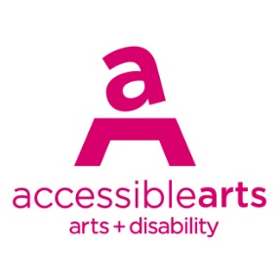

Access Ideas & Insights Podcast

Image Description Guide

Introduction: Episode 2 – The Future of Disability Storytelling
This document contains written image descriptions for the images featured in the Auslan version of the Accessible Arts, Access Ideas & Insights podcast video: The Future of Disability Storytelling. Each episode of the podcast includes the following accessible features: an Auslan video, a transcript, and an image description guide. Where available, time stamps are included to assist with navigation. Auslan users may find it helpful to use this guide alongside the video.

Table of Contents
Introduction: Episode 2 – The Future of Disability Storytelling 1
Table of Contents 1
Image 1: Access Ideas & Insights Podcast Logo Graphic 2
Image 2: Headshot Bedelia Lowrenčev 2
Image 3: Access Ideas & Insights Podcast Logo Graphic 3
Image 4: Headshot Christopher Bryant 3
Image 5: 'New Balance' by Christopher Bryant & Emma Palackic. 4
Image 6: Performance Image 1. ‘New Balance’ 4
Image 7: Performance Image 2. ‘New Balance’ 5
Image 8: Creative Team behind ‘New Balance’ 5
Image 9: ‘Intoxication’ by Christopher Bryant 6
Image 10: 'State of Play' by Christopher Bryant and Emma Palackic. 6
Image 11: Performance Image ‘State of Play’ 7
Image 12: Christopher Bryant and Emma Palackic 7
Image 13: Podcast host Bedelia Lowrenčev and guest Christopher Bryant. 8
Image 14: Access Ideas & Insights Podcast Logo Graphic 8
Image 15: Headshot Bria McCarthy 9
Image 16: 'Dragon Dreams' Experimental shadow puppet show 9
Image 17: Interactive shadow puppet books 10
Image 18: ‘Dragon Hearts’ by Bria McCarthy 10
Image 19: 'Shadow House' by Bria McCarthy 11
Image 20: Inside Shadow House 11
Image 21: ‘Dragon Hearts’ at Sydney Fringe Festival 12
Image 22: 'Animal Dreams’ by Bria McCarthy 12
Video Image 23: Development video of ‘Animal Dreams’ 13
Image 24: Podcast host Bedelia Lowrenčev and guest Bria McCarthy. 13
Image 25: Access Ideas & Insights Podcast Logo Graphic 14
Image 26: Access Ideas & Insights Podcast Partnerships 14

Image Descriptions

Image 1: Access Ideas & Insights Podcast Logo Graphic
Video Timestamp: 00:01:0 – 00:44:0
Image Description: A white vintage microphone stands out against a solid black background. To its right, bold text reads: “accessible arts Access Ideas & Insights Podcast.” The words “accessible arts” appear in magenta lowercase, while the rest of the text is white. The word “Podcast” is larger and set below by a thin gradient line shifting from magenta to yellow. Along the bottom edge, a vivid wave of magenta, purple, orange, and yellow adds movement to the design.
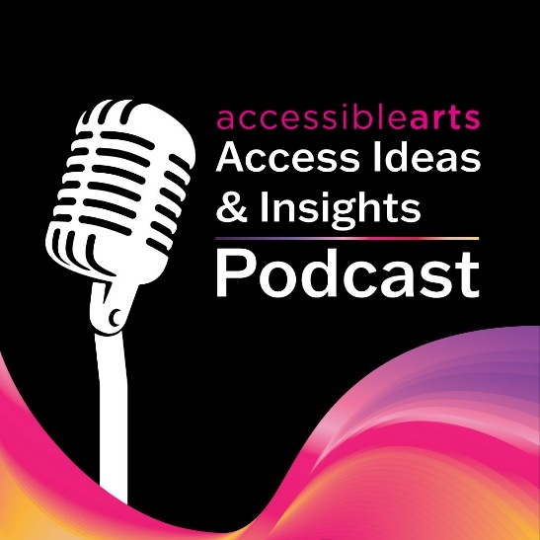

Image 2: Headshot Bedelia Lowrenčev
Video Timestamp: 00:44:0 – 01:22:0
Image Description: A person with long wavy brown hair and hazel eyes smiles at the camera. They are wearing a sheer green long-sleeve top. Their head tilts slightly as their hand rests against her neck. The background is softly blurred, bringing the focus to their face.
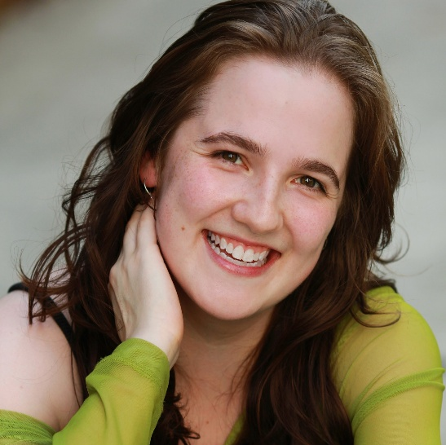

Image 3: Access Ideas & Insights Podcast Logo Graphic
Video Timestamp: 01:22:0 – 02:45:5
Image Description: A white vintage microphone stands out against a solid black background. To its right, bold text reads: “accessible arts Access Ideas & Insights Podcast.” The words “accessible arts” appear in magenta lowercase, while the rest of the text is white. The word “Podcast” is larger and set below by a thin gradient line shifting from magenta to yellow. Along the bottom edge, a vivid wave of magenta, purple, orange, and yellow adds movement to the design.

Image 4: Headshot Christopher Bryant
Video Timestamp: 02:45:5 – 03:48:0
Image Description: Christopher Bryant, a white man with blonde hair, stands against a dark wall, looking directly at the camera with a calm, relaxed expression. He wears a sheer black mesh top that reveals tattoos across his chest and arms, featuring birds, skulls, and various symbols. The lighting is low, focusing solely on him and accentuating the textures of his skin and clothing.
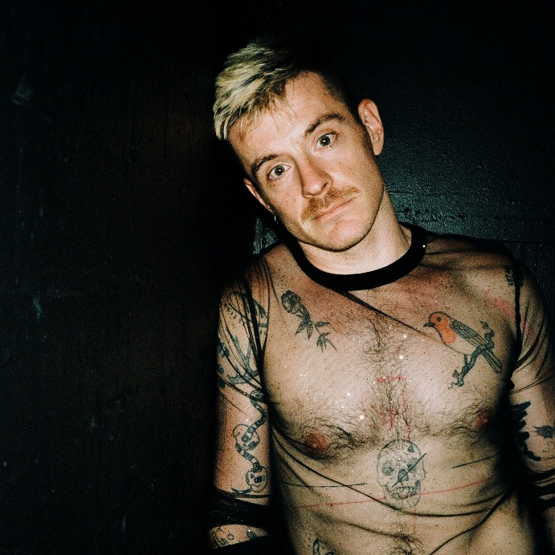

Image 5: 'New Balance' by Christopher Bryant & Emma Palackic.
Video Timestamp: 03:48:0 – 06:04:0
Image Description: Christopher Bryant stands on stage wearing a brightly coloured tracksuit of purple, pink and black. He has one arm extended in gesture. Behind them, a large projected image shows a close-up of two women kissing, a scene from the film: ‘Cruel Intentions’. The lighting casts soft pink tones across Chistopher, highlighting their expression and stance.
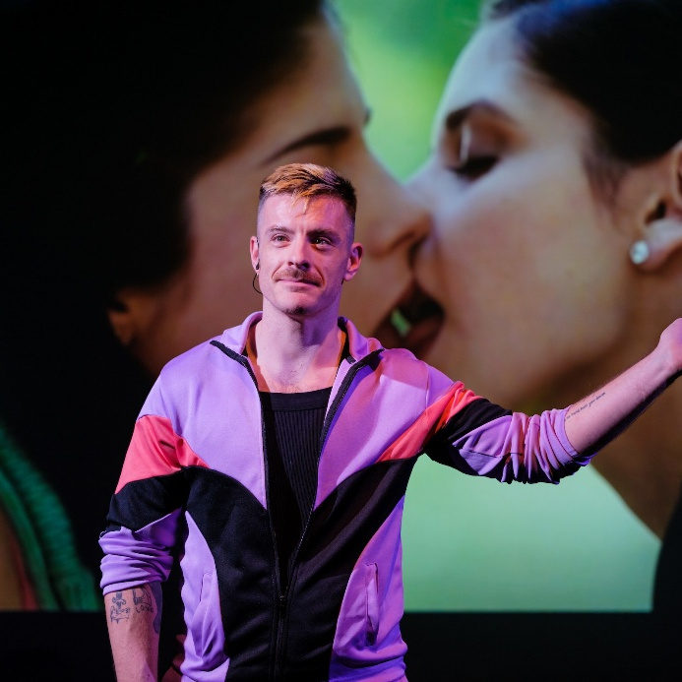

Image 6: Performance Image 1. ‘New Balance’
Video Timestamp: 06:04:0 – 09:24:00
Image Description: Christopher Bryant stands against a projected background, wearing a black tank top and black shorts. The projection’s light casts across his body, blending him with the image behind. The projection features a lime-yellow background with aqua and light blue 3D-style text that reads: “How do you act as the person you would’ve needed in this situation”
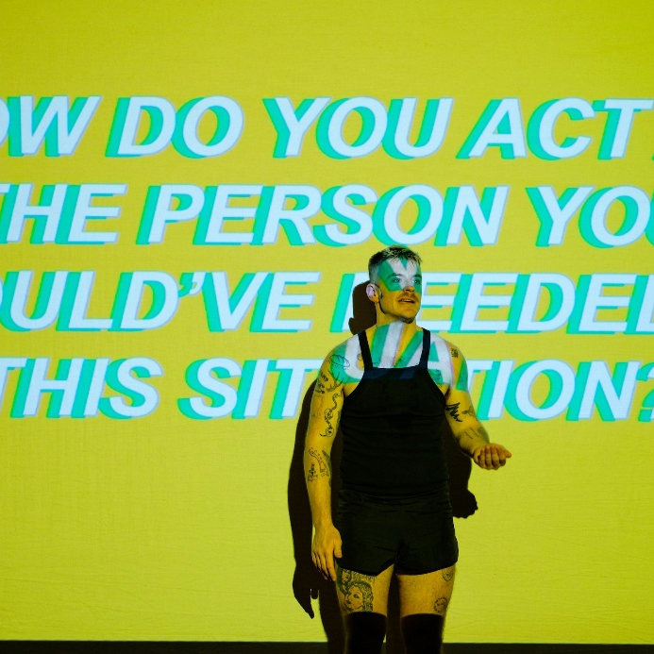

Image 7: Performance Image 2. ‘New Balance’
Video Timestamp: 09:24:00 – 11:08:0
Image Description: Christopher Bryant stands against a projected background, wearing a black tank top and black shorts. The aqua light from the projection washes over his body, merging him with the colour behind. The projection features an aqua background with yellow and purple 3D-style capitalised text that reads: “Where are you left in a text, in a body, when control breaks down?”
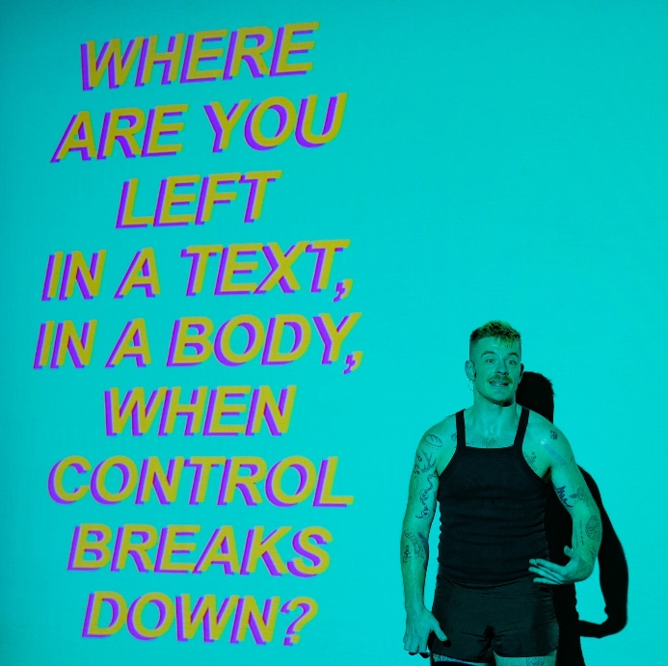

Image 8: Creative Team behind ‘New Balance’
Video Timestamp: 11:08:0 – 14:21:5
Image Description: Four people stand side by side with their arms around each other, smiling warmly. They are members of the production crew from ‘New Balance’, pictured from left to right: Maddy Picard, Emma Palackic, Christopher Bryant, and Chris Milburn. All are dressed in dark clothing. Behind them, a projection displays the ‘New Balance’ title in bold, 3D-style text in purple and light blue. The lighting casts a soft purple glow across the crew.
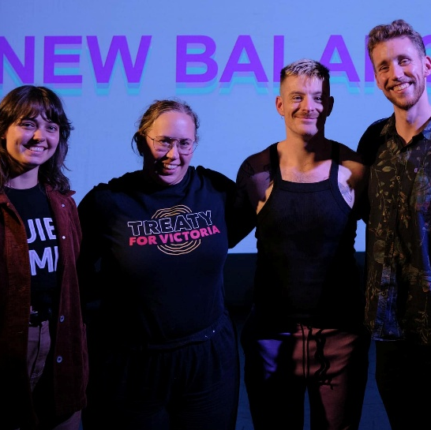

Image 9: ‘Intoxication’ by Christopher Bryant
Video Timestamp: 14:21:5 – 16:04:0
Image Description: Christopher Bryant stands in a warmly lit room, bathed in a soft yellow glow from fairy lights draped across a piano behind him. He has his head slightly tilted down and his hands tucked into the pockets of his black jacket, which features gold sequined sleeves. The room has a red wall behind the piano, and to the left, a wooden door frame with an stained glass windows.
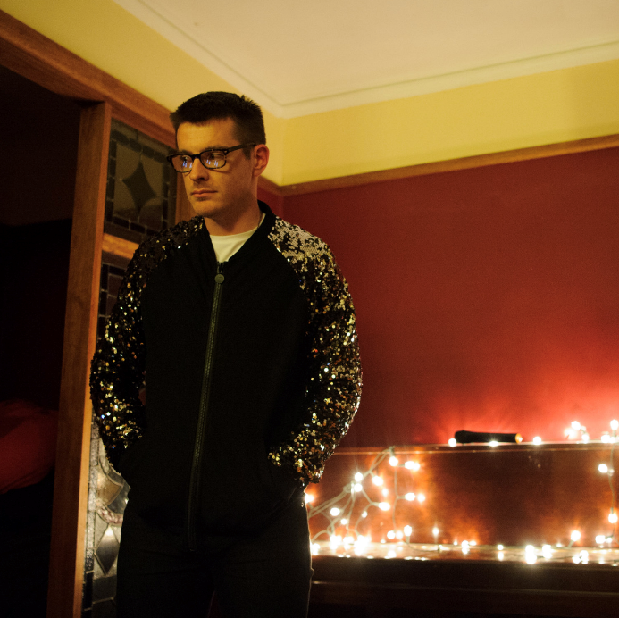

Image 10: 'State of Play' by Christopher Bryant and Emma Palackic.
Video Timestamp: 16:04:0 – 18:49:0
Image Description: Christopher Bryant squats on a grey plastic chair with the chair back facing the audience. He wears a black tank top and black shorts, with a gold plastic crown perched on his head. His hands are clasped in front of him, one on top of the other, as if pressing down, and his facial expression conveys anger.
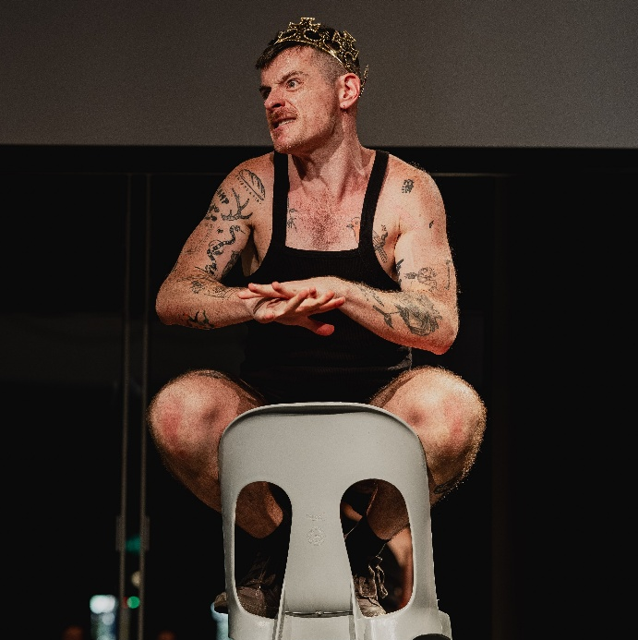

Image 11: Performance Image ‘State of Play’
Video Timestamp: 18:49:0 – 21:31:0
Image Description: Christopher Bryant sits on a grey plastic chair in the centre of the stage. He wears a black tank top and black shorts, with one arm resting across his knees while the other holds a microphone up to his mouth. Behind him, a projection shows what appears to be a school class photo of a young boy in a blazer and tie, with the image cropped just below the eyes. A mirror behind Christopher reflects his back to the audience, adding depth to the scene.
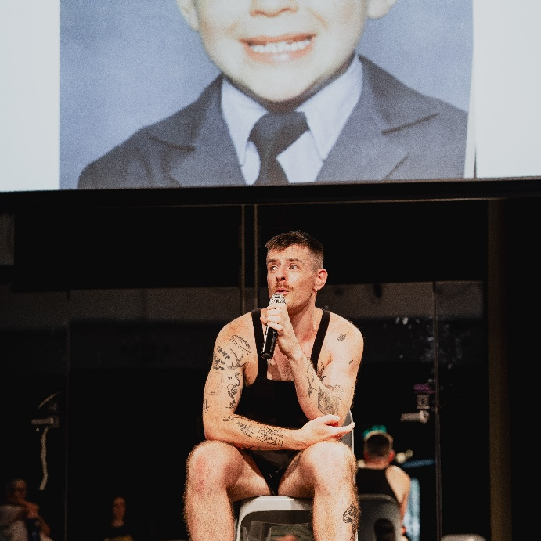

Image 12: Christopher Bryant and Emma Palackic
Video Timestamp: 21:31:0 - 22:30:3
Image Description: Christopher Bryant and Emma Palackic stand close together, with Emma resting her chin on Christopher’s right shoulder. Both are smiling and wearing glasses. They are bathed in a soft pink light that surrounds them, creating a warm and intimate atmosphere.
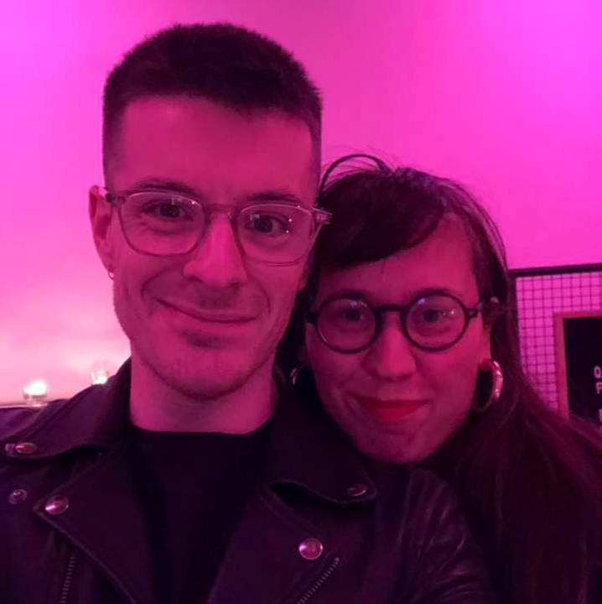

Image 13: Podcast host Bedelia Lowrenčev and guest Christopher Bryant.
Video Timestamp: 22:30:3 – 23:32:0
Image Description: Podcast host Bedelia Lowrenčev and guest Christopher Bryant sit side by side on a black piano stool. Christopher wears a blue short-sleeve shirt over a white tank top and black shorts; he has short blonde hair, glasses, hoop earrings, and a moustache. Bedelia wears a black graphic tee and black pants and has curly brown hair. They are surrounded by a yellow recording studio, with a microphone stand positioned to the right of Bedelia.
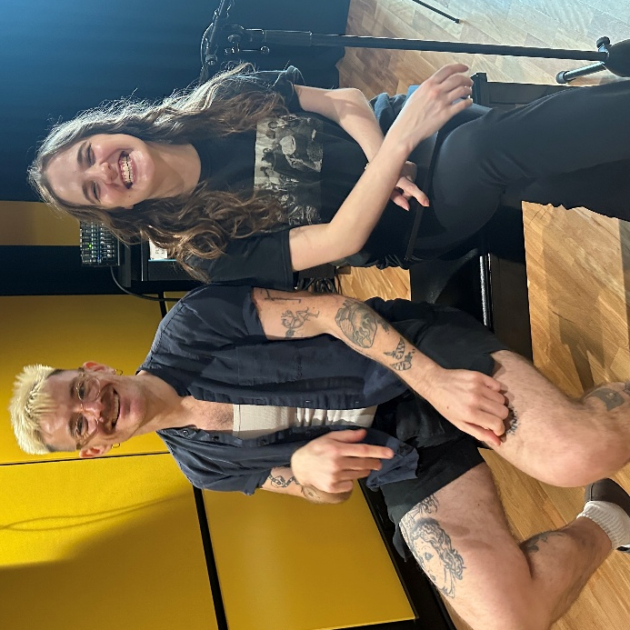

Image 14: Access Ideas & Insights Podcast Logo Graphic
Video Timestamp: 23:32:0 – 23:49:0
Image Description: A white vintage microphone stands out against a solid black background. To its right, bold text reads: “accessible arts Access Ideas & Insights Podcast.” The words “accessible arts” appear in magenta lowercase, while the rest of the text is white. The word “Podcast” is larger and set below by a thin gradient line shifting from magenta to yellow. Along the bottom edge, a vivid wave of magenta, purple, orange, and yellow adds movement to the design.
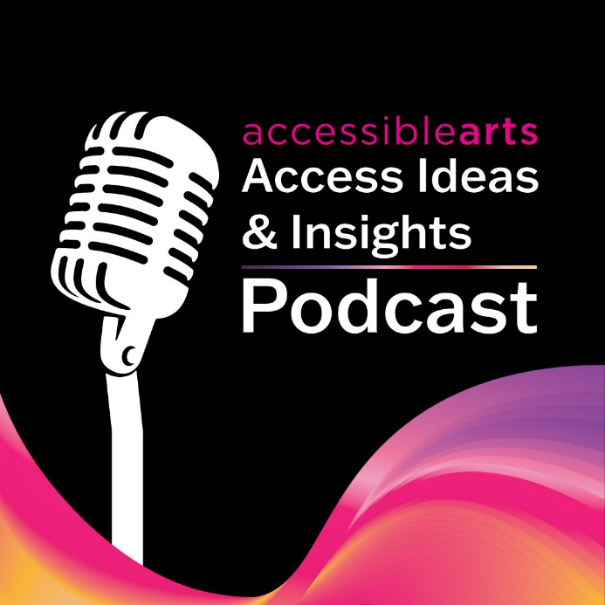

Image 15: Headshot Bria McCarthy
Video Timestamp: 23:49:0 – 24:39:08
Image Description: Bria McCarthy sits in a dark room beside an overhead projector. Her head is tilted upward, as if looking toward the projection. On the projector’s glass surface, Bria’s hands hold down a hand-drawn slide. The bright light from the projector partially illuminates her face and arms, while the rest of the scene remains in shadow.
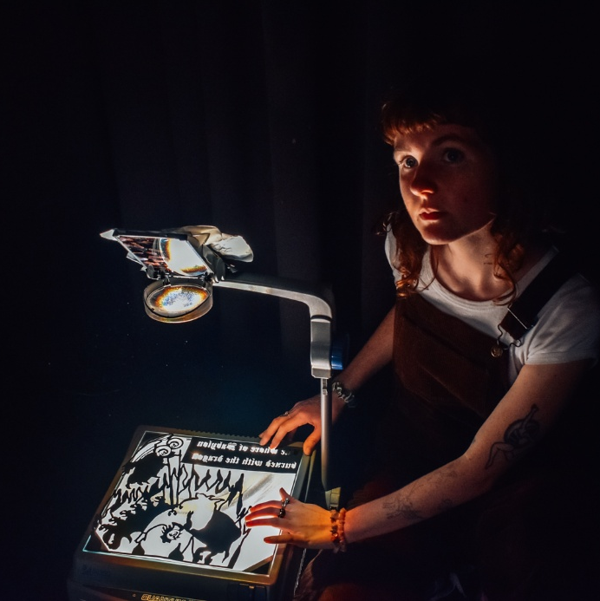

Image 16: 'Dragon Dreams' Experimental shadow puppet show
Video Timestamp: 24:39:08 – 25:42:0
Image Description: Bria McCarthy kneels at the centre of the stage in front of a projector during a performance. The projector casts their silhouette onto a white backdrop, where it’s encircled next to the shadow puppet of a dragon. Text on the projection reads, “We follow the river until we reach the cave.” Blue light washes across the stage, and pillows are arranged off to the side, adding depth to the scene.
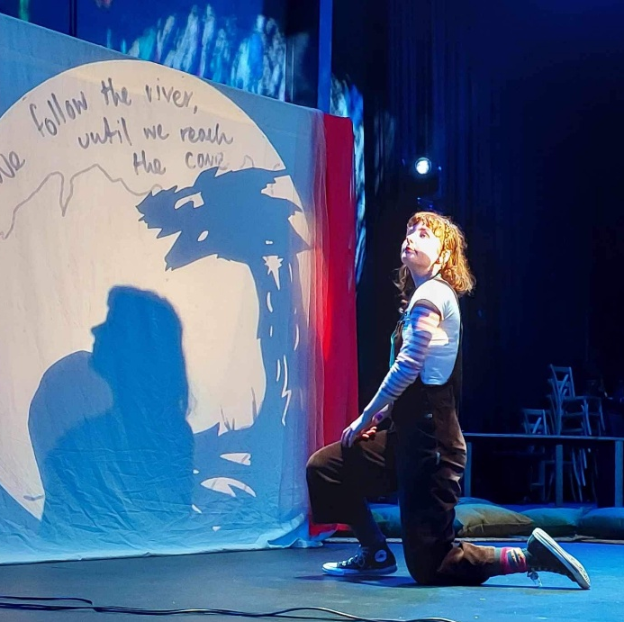

Image 17: Interactive shadow puppet books
Video Timestamp: 25:42:0 – 27:35:0
Image Description: A hand holds a small shadow puppet book against a purple background. The light casts a silhouette on to the wall which depicts a scene of trees arching over a Yowie, who reaches down to hold the hand of a small girl.
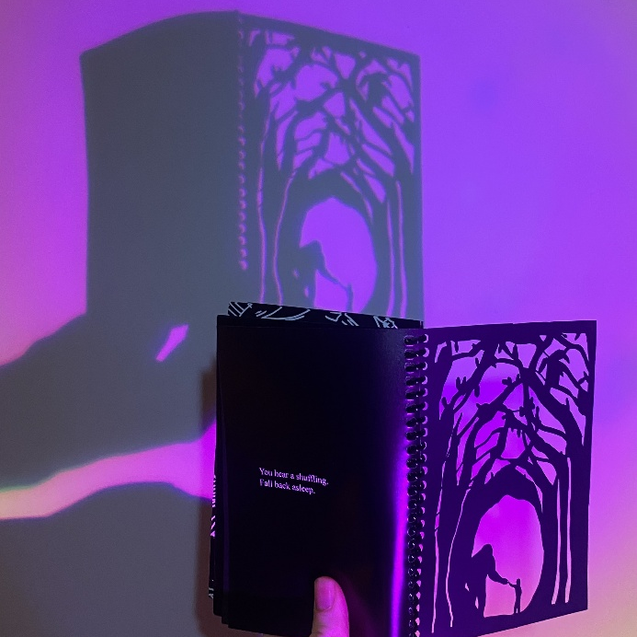

Image 18: ‘Dragon Hearts’ by Bria McCarthy
Video Timestamp: 27:35:0 – 28:30:0
Image Description: A black silhouette on a bright white sheet depicting a woman's head with snakes reaching across the frame. There's a single tear under her eye.
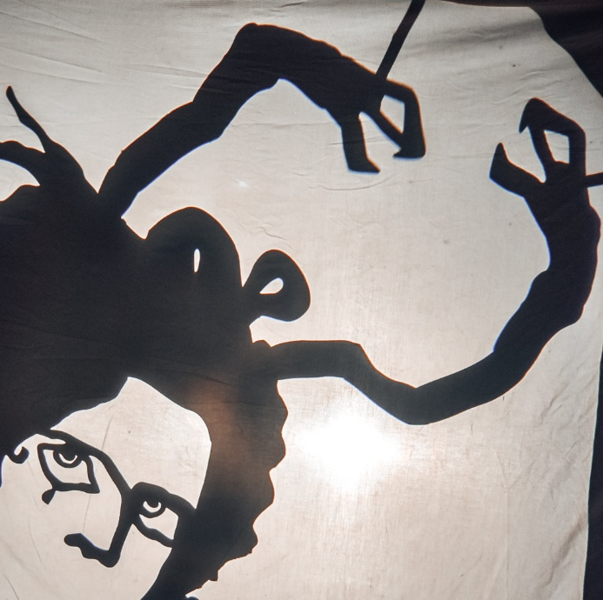

Image 19: 'Shadow House' by Bria McCarthy
Video Timestamp: 28:30:0 - 31:46:4
Image Description: A large patchwork tent, made from a variety of colourful fabrics and laces, stands under a dark night sky. The tent is decorated with bunting, fairy lights, potted plants, and a record player. Just inside the entrance, two people sit on chairs, partially visible within the cosy, illuminated space.
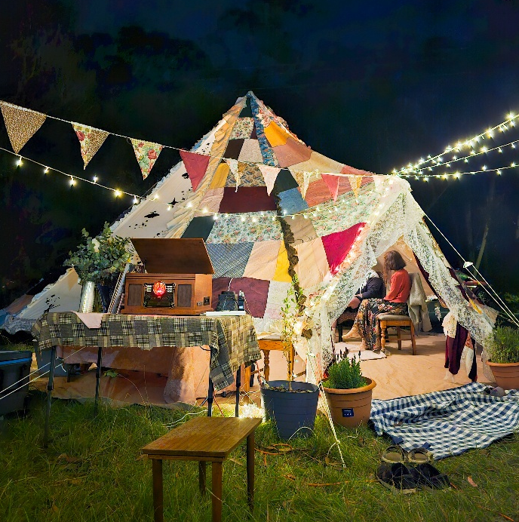

Image 20: Inside Shadow House
Video Timestamp: 31:46:4 – 32:50:0
Image Description: Bria sits in the centre of her patchwork tent, ‘Shadow House’. A central pole supports the tent, and the colourful patchwork is visible through its various panels. The floor is covered with striped and gingham mats. Bria works with a projector, casting an image onto the side of the tent that reads: “Today I feel a little enchanted, a little magical. Maybe a little.”
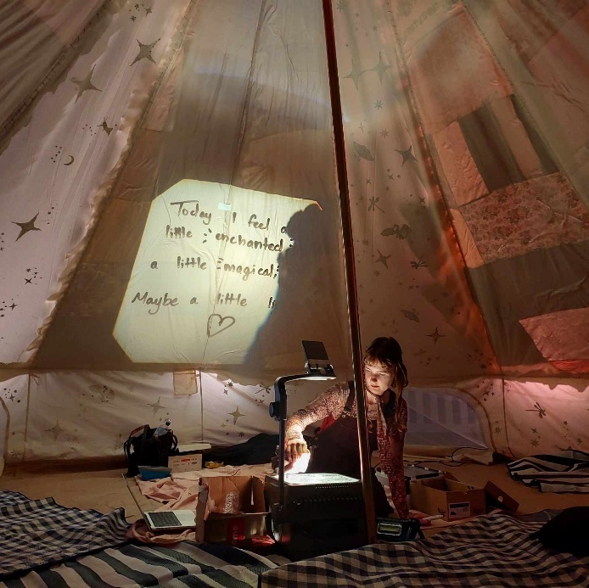

Image 21: ‘Dragon Hearts’ at Sydney Fringe Festival
Video Timestamp: 32:50:0 – 36:23:0
Image Description: A black silhouette of Bria shows her dancing, with her right arm reaching just above her head and her left arm curving across her body. The silhouette is set against a bright orange background textured with movement, crumpled lines, and cracks.
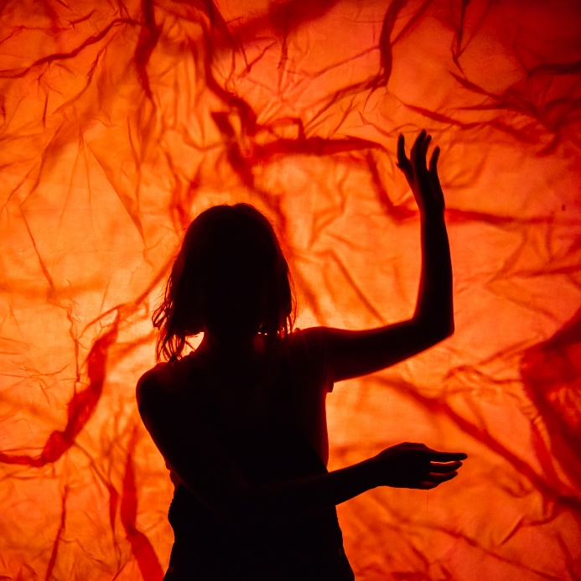

Image 22: 'Animal Dreams’ by Bria McCarthy
Video Timestamp: 36:23:0 – 38:29:0
Image Description: A hand-drawn emu is projected among stars in the night sky onto fabric illuminated with blue and indigo light. Stars are depicted inside the emu’s body. This projection depicts The Emu in the Sky, an Aboriginal constellation formed by the dark areas and dust lanes within the Milky Way.
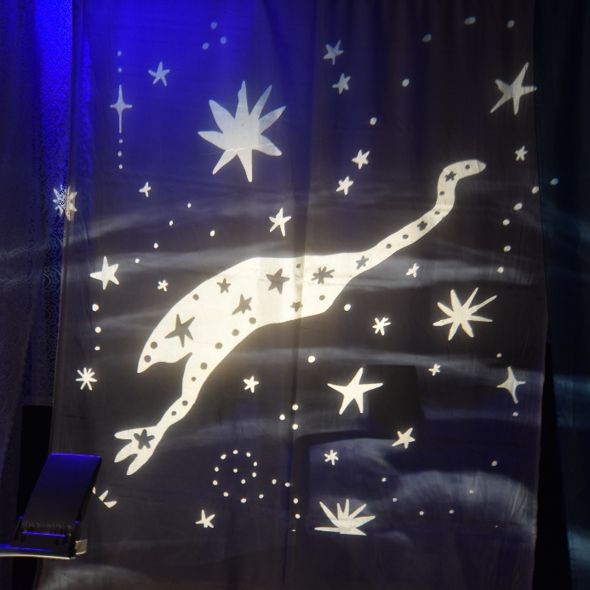

Video Image 23: Development video of ‘Animal Dreams’
Video Timestamp: 38:29:0 – 41:13:5
Image Description: The video shows Bria McCarthy performing with a light projector that casts organic shapes and swirls onto the wall. The scene is bathed in deep blue light. Bria moves through the space, manipulating whale shadow puppets that appear to float through the projector, evoking the feeling of being deep underwater. The video plays on a loop, with Bria moving continuously through the immersive scenes.
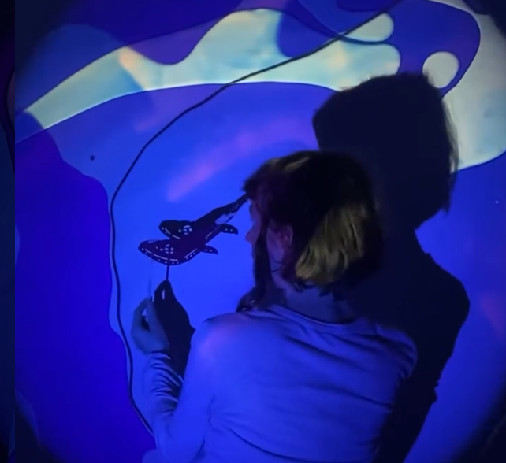

Image 24: Podcast host Bedelia Lowrenčev and guest Bria McCarthy.
Video Timestamp: 41:13:5 - 41:49:9
Image Description: Podcast host Bedelia Lowrenčev and guest Bria McCarthy together on a black piano stool. Bria wears a green tank top over a green-and-white striped top and black jeans, with a brown bob hairstyle and long plaits on either side of her head. Bedelia wears a black graphic tee and black pants, with curly brown hair. They are surrounded by the yellow interior of a recording studio.
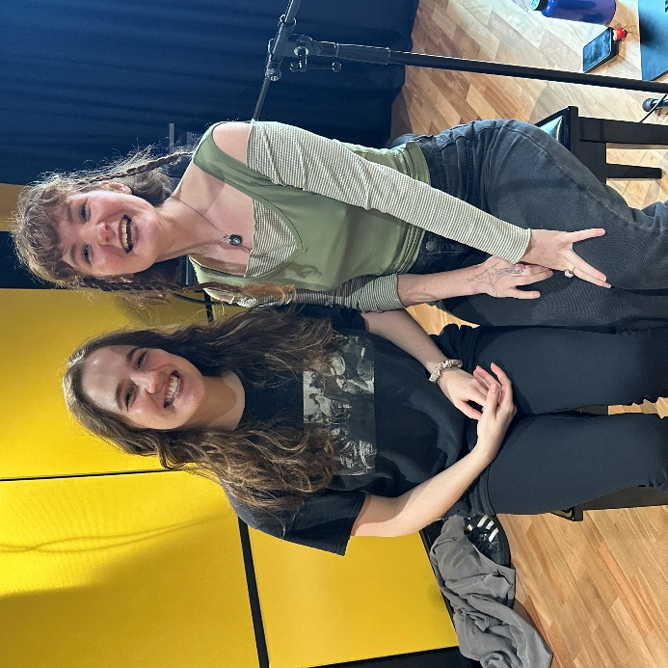

Image 25: Access Ideas & Insights Podcast Logo Graphic
Video Timestamp: 41:49:9 - 42:24:08
Image Description: A white vintage microphone stands out against a solid black background. To its right, bold text reads: “accessible arts Access Ideas & Insights Podcast.” The words “accessible arts” appear in magenta lowercase, while the rest of the text is white. The word “Podcast” is larger and set below by a thin gradient line shifting from magenta to yellow. Along the bottom edge, a vivid wave of magenta, purple, orange, and yellow adds movement to the design.

Image 26: Access Ideas & Insights Podcast Partnerships
Video Timestamp: 42:24:0 - 42:37:8
Image Description: A black background with white text and three logos at the bottom. The text reads: "This podcast was proudly produced by Accessible Arts and Kiera Brew Kurec, with sound design by Tralala Blip. Access consulting was provided by Macro Impact Consulting and our Advisory Group. Special thanks to our Auslan interpreters from Sweeney Interpreting. This podcast series is proudly supported by the City of Sydney and Create NSW, the principal funding partner of Accessible Arts."
At the bottom are three logos: On the left: A black circle with a white outline of a hand in Auslan signing, with the text "MACRO Impact Consulting." In the centre: The words "CITY OF SYDNEY" in bold white capital letters, with a small circular anchor emblem beside it. On the right: A white waratah flower symbol above the words "NSW GOVERNMENT."
