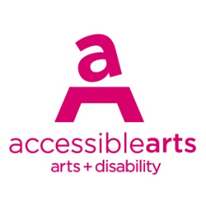

Access Ideas & Insights Podcast

Image Description Guide

Introduction: Episode 3 – The Neurodiversity Paradigm in Theatre
This document contains written Image Descriptions for the images featured in the Auslan version of the Accessible Arts: Access Ideas & Insights podcast video The Neurodiversity Paradigm in Theatre. Each episode of the podcast includes the following accessible features: Auslan video, transcript, and an image description guide. Where available, time stamps are included to assist with navigation. Auslan users may find it helpful to use this guide alongside the video.

Table of Contents
Introduction: Episode 3 – The Neurodiversity Paradigm in Theatre 1
Table of Contents 1
Image 1: Access Ideas & Insights Podcast Logo Graphic 2
Image 2: Headshot Bedelia Lowrenčev 3
Image 3: Access Ideas & Insights Podcast Logo Graphic 3
Image 4: Headshot Joanna Erskine 4
Image 5: Headshot Pollyanna Nowicki 4
Image 6: Creative Team on Method in Madness 5
Image 7: Headshot of Director Dan Graham 5
Image 8: Access Ideas and Insights - The Neurodiversity Paradigm in Theatre 6
Image 9: Pollyanna Nowicki & Marissa Saroca 6
Image 10: Second Creative Development of Method in Madness 7
Image 11: Creative Development Team 7
Image 12: Method in Madness Showcase 8
Image 13: Access Ideas & Insights panel 8
Image 14: Presentation of Method in Madness 9
Image 15: Method in Madness actors 9
Image 16: Access Ideas & Insights Podcast Logo Graphic 10
Image 17: Jules Orcullo Headshot 10
Image 18: Musical song from ‘Forgetting Tim Minchin’ 11
Image 19: Access Ideas & Insights Panel 11
Image 20: Jules Orcullo in ‘Forgetting Tim Minchin’ 12
Image 21: Jules Orcullo performing on stage 12
Image 22: Behind the scenes recording the podcast 13
Image 23: Scene from ‘Forgetting Tim Minchin’ 13
Image 24: Dancing scene from ‘Forgetting Tim Minchin’ 14
Image 25: Singing scene from ‘Forgetting Tim Minchin’ 14
Image 26: Jules Orcullo performing a live reading 15
Image 27: Jules and Bedelia in studio 15
Image 28: Access Ideas & Insights Podcast Logo Graphic 16
Image 29: Access Ideas & Insights Podcast Partnerships 16

Image Descriptions

Image 1: Access Ideas & Insights Podcast Logo Graphic
Video Timestamp: 00:00:0 – 00:44:0
Image Description: A white vintage microphone stands out against a solid black background. To its right, bold text reads: “accessible arts Access Ideas & Insights Podcast.” The words “accessible arts” appear in magenta lowercase, while the rest of the text is white. The word “Podcast” is larger and set below by a thin gradient line shifting from magenta to yellow. Along the bottom edge, a vivid wave of magenta, purple, orange, and yellow adds movement to the design.
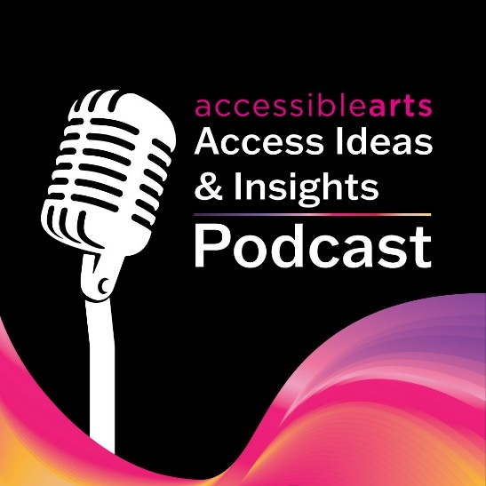

Image 2: Headshot Bedelia Lowrenčev
Video Timestamp: 00:44:0 – 01:22:0
Image Description: A person with long wavy brown hair and hazel eyes smiles at the camera. They are wearing a sheer green long-sleeve top. Their head tilts slightly as their hand rests against her neck. The background is softly blurred, bringing the focus to their face.


Image 3: Access Ideas & Insights Podcast Logo Graphic
Video Timestamp: 01:22:0 – 02:36:1
Image Description: A white vintage microphone stands out against a solid black background. To its right, bold text reads: “accessible arts Access Ideas & Insights Podcast.” The words “accessible arts” appear in magenta lowercase, while the rest of the text is white. The word “Podcast” is larger and set below by a thin gradient line shifting from magenta to yellow. Along the bottom edge, a vivid wave of magenta, purple, orange, and yellow adds movement to the design.

Image 4: Headshot Joanna Erskine
Video Timestamp: 02:36:1 – 02:44:6
Image Description: Joanna Erskine stands outdoors in front of a backdrop of green foliage. She is wearing glasses with a tortoiseshell pattern, a light blue denim jacket over a black top. Her long, straight, dark brown hair falls over one shoulder. They have one hand resting on their hip and natural light softly illuminates their smiling face.
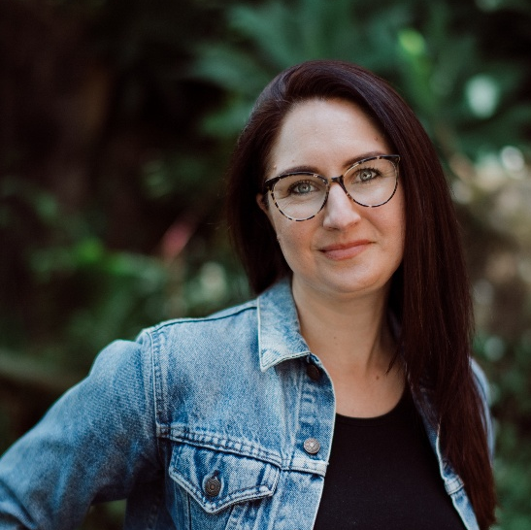

Image 5: Headshot Pollyanna Nowicki
Video Timestamp: 02:44:6 – 02:59:3
Image Description: Pollyanna Nowicki is photographed against a plain, light grey wall. They have medium-length, wavy brown hair parted slightly to the side and are wearing a V-neck, olive-green long-sleeve top. Their expression is neutral with a faint smile, and they are looking slightly toward the camera. The image is well-lit with even, natural lighting.
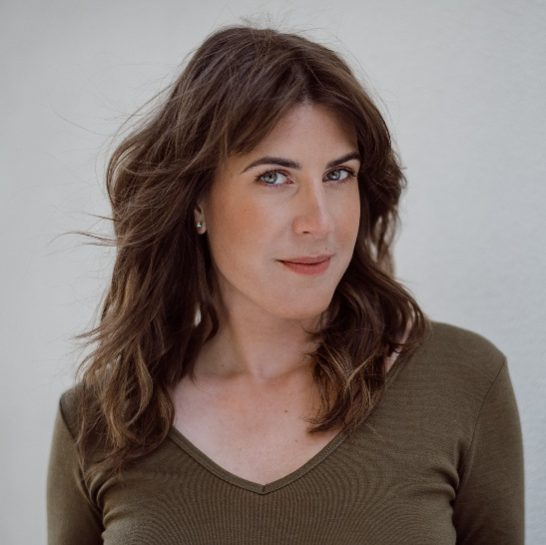

Image 6: Creative Team on Method in Madness
Video Timestamp: 02:59:3 – 03:14:3
Image Description: The Method in Madness create team of ten people is posed indoors against a wooden-panel wall. Dylan Crawford, Pollyanna Nowicki, Ryan Enniss and Liz Martin are standing in the back row, while Joanna Erskine, Amy Claire Mills, Dan Graham, Vitas Varnas, Marissa Saroca and Tiffany Wong are seated or kneeling in the front row. The image is evenly lit, capturing everyone smiling expressions.
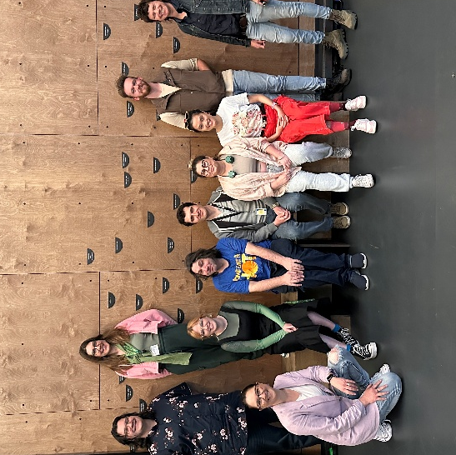

Image 7: Headshot of Director Dan Graham
Video Timestamp: 03:14:3 – 03:45:1
Image Description: Headshot of Dan Graham, he has short, wavy dark hair and fair skin and is photographed sitting beside a blue metal railing. They are wearing a black jacket over a black top and are looking directly at the camera with a warm, subtle smile.
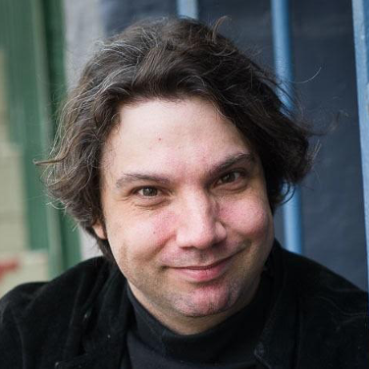

Image 8: Access Ideas and Insights - The Neurodiversity Paradigm in Theatre
Video Timestamp: 03:45:1 – 05:49:9
Image Description: A darken room with stage lights highlighting five people on stage. Four panellists are seated, while an Auslan interpreter stands beside them. Behind them, a large screen displays a presentation slide that reads: The Neurodiversity Paradigm in Theatre, accompanied by a vibrant pink and blue swirl graphic. The faint outlines of the audience are visible in the foreground.
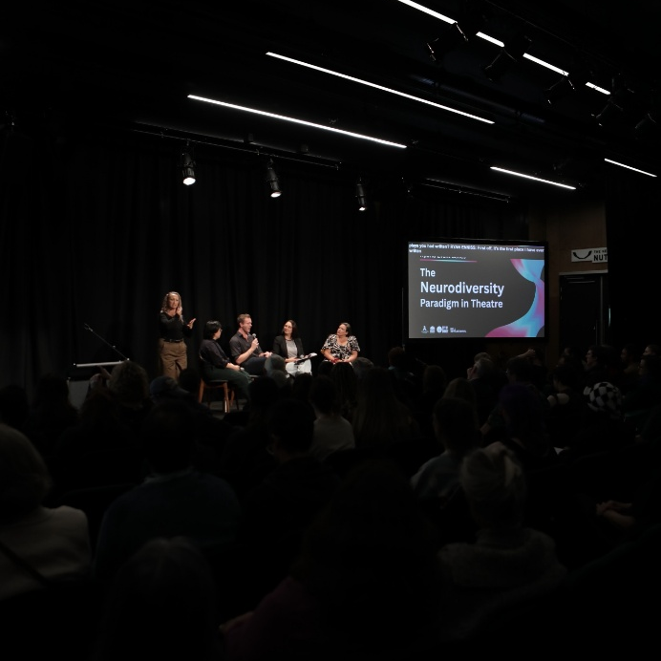

Image 9: Pollyanna Nowicki & Marissa Saroca
Video Timestamp: 05:49:9 – 06:40:8
Image Description: Pollyanna Nowicki & Marissa Saroca sit side by side on a small stage in front of a black curtain, each positioned behind a music stand with papers. Pollyanna is seated on the left and is wearing a grey blazer, with yellow plaid socks pants, and a soft blue blanket covering her legs. Marissa seated on the right wear’s pastel coloured dress and gestures expressively with both hands. A small table between them holds water bottles, tissues, and other personal items.
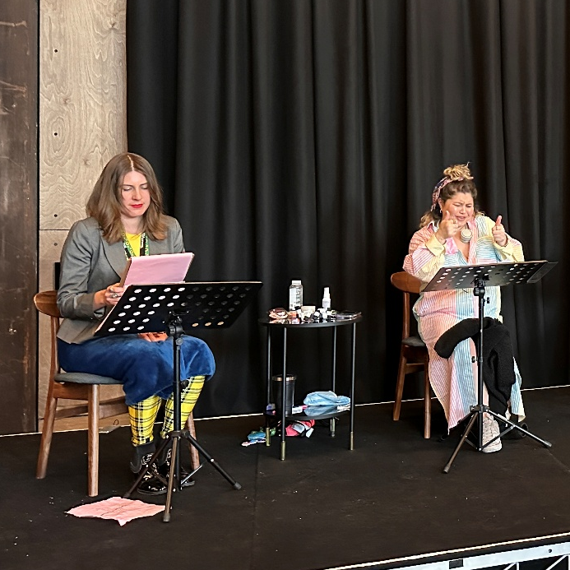

Image 10: Second Creative Development of Method in Madness
Video Timestamp: 06:40:8 – 08:28:9
Image Description: Eight members of the Method in Madness creative team are gathered in a spacious studio with wooden walls and black curtains. Seated in a relaxed circle on chairs and cushions, they surround a large sheet of brown paper covered in colourful handwritten notes and drawings, deep in discussion. Around them, tables, screens, and workshop materials are scattered throughout the room, suggesting an active and collaborative creative session in progress.
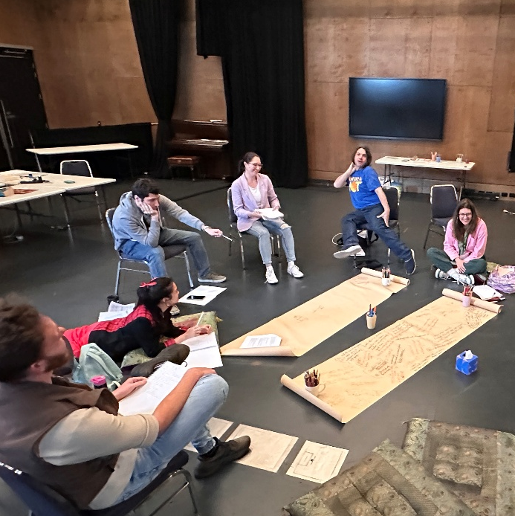

Image 11: Creative Development Team
Video Timestamp: 08:28:9 – 13:25:9
Image Description: The Method in Madness creative team is posed together against a wooden-panel wall. From left to right: Dylan Crawford, Joanna Erskine Pollyanna Nowicki, Amy Claire Mills, Dan Graham, Vitas Varnas, Marissa Saroca, Tiffany Wong and Ryan Enniss.
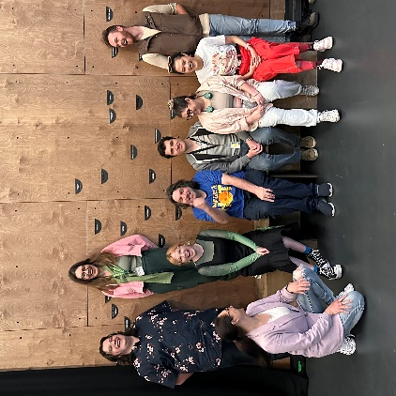

Image 12: Method in Madness Showcase
Video Timestamp: 13:25:9 – 15:28:1
Image Description: Method in Madness actors, Pollyanna Nowicki, Marissa Saroca, Tiffany Wong, Ryan Enniss, and Vitas Varnas, stand on a warmly lit stage in front of a black curtain, each holding scripts as they perform a live reading. Dressed casually, they appear animated in their performance. In the foreground an attentive audience is seated raising their hands and holding pipe cleaners in response to the onstage action.
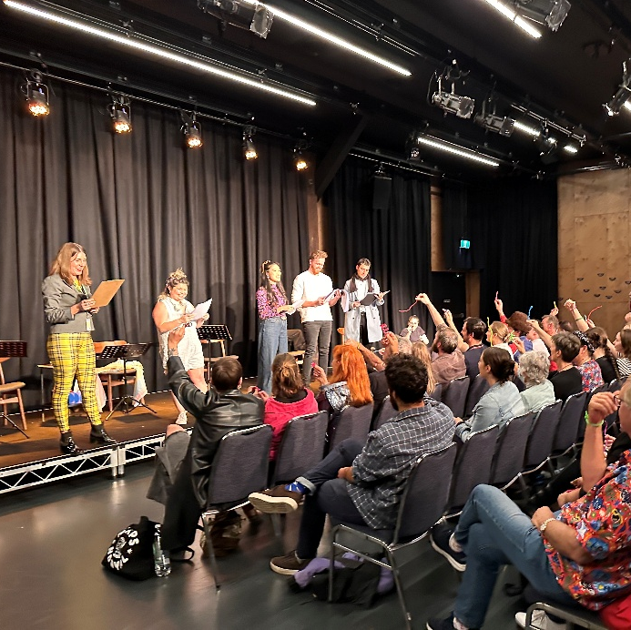

Image 13: Access Ideas & Insights panel
Video Timestamp: 15:28:1 – 17:44:8
Image Description: Ryan Enniss and Joanna Erskine sit on stage in front of a black curtain, engaged in conversation. Ryan, seated on the left and dressed in a dark shirt and jeans, smiles warmly toward Joanna. Joanna on the right, wears glasses, a light grey top, and a black blazer, holding a microphone and papers as she speaks. The setting suggests a live discussion or Q&A event.
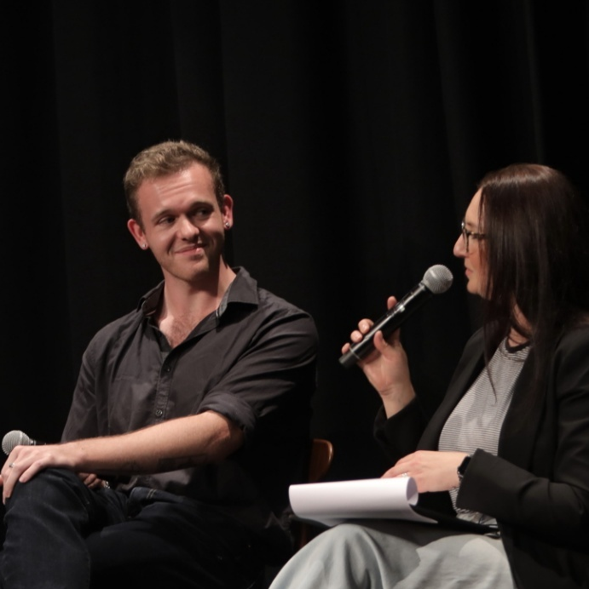

Image 14: Presentation of Method in Madness
Video Timestamp: 17:44:8 – 19:31:1
Image Description: Method in Madness actors stand in a line on stage, scripts in hand, delivering a live reading. Marissa Saroca appears mid-speech, looking up toward the audience as she performs her monologue. In the foreground, the audience sits in rows, seen from behind.
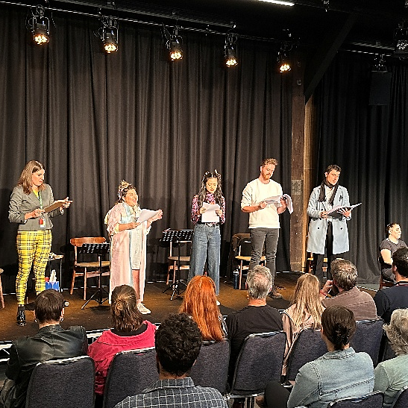

Image 15: Method in Madness actors
Video Timestamp: 19:31:1 – 21:14:2
Image Description: Method in Madness actors stand in a line on stage, scripts in hand, delivering a live reading. At the centre, Tiffany Wong appears mid-speech with her arms outstretched, while the other actors look on with smiles and laughter, some glancing at their scripts or toward the audience. In the foreground, the audience is seated in rows.
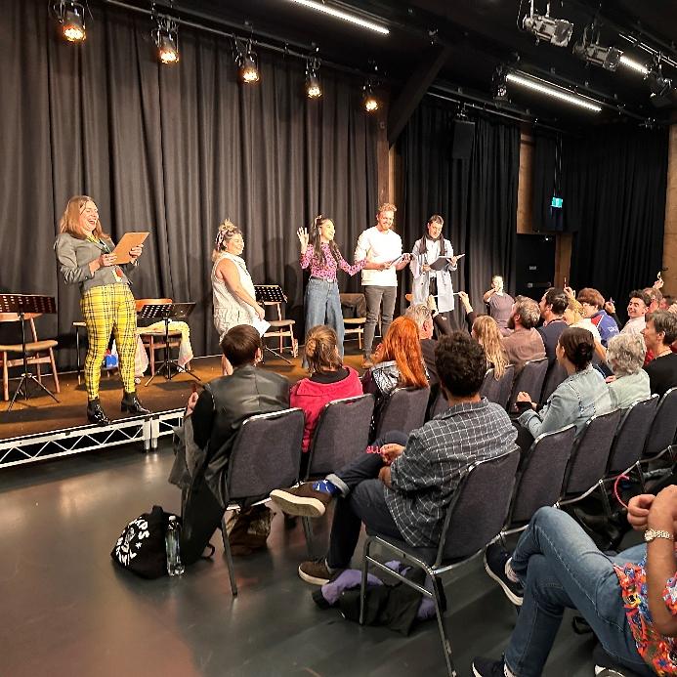

Image 16: Access Ideas & Insights Podcast Logo Graphic
Video Timestamp: 21:14:2 – 21:24:3
Image Description: A white vintage microphone stands out against a solid black background. To its right, bold text reads: “accessible arts Access Ideas & Insights Podcast.” The words “accessible arts” appear in magenta lowercase, while the rest of the text is white. The word “Podcast” is larger and set below by a thin gradient line shifting from magenta to yellow. Along the bottom edge, a vivid wave of magenta, purple, orange, and yellow adds movement to the design.

Image 17: Jules Orcullo Headshot
Video Timestamp: 21:24:3 - 22:01:7
Image Description: Jules Orcullo stands indoors against a softly lit background, framed by a houseplant, a wall clock, and a picture hanging on the wall. They wear a teal button-up shirt and face the camera with a calm, warm expression. Natural, even lighting highlights their features.
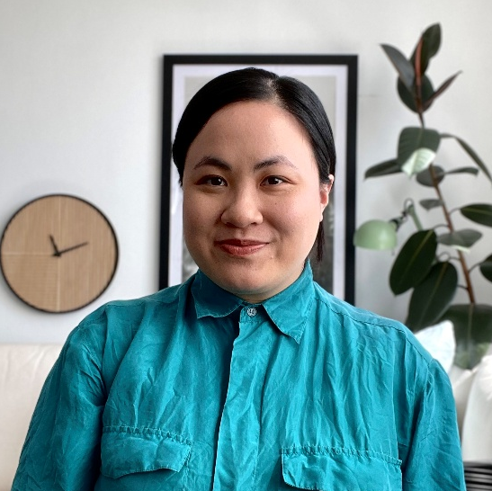

Image 18: Musical song from ‘Forgetting Tim Minchin’
Video Timestamp: 22:01:7 – 23:47:9
Image Description: Warm lighting casts a golden glow over the performer Jules Orcullo as they play the keyboard and sing. Behind them, a portrait of Tim Minchin is framed with fairy lights. On the keyboard rests a potted plant beside a black desk lamp that shines onto the performer. They wear wire-framed glasses, a colourful striped knitted jumper, and have black hair pulled back into a bun.
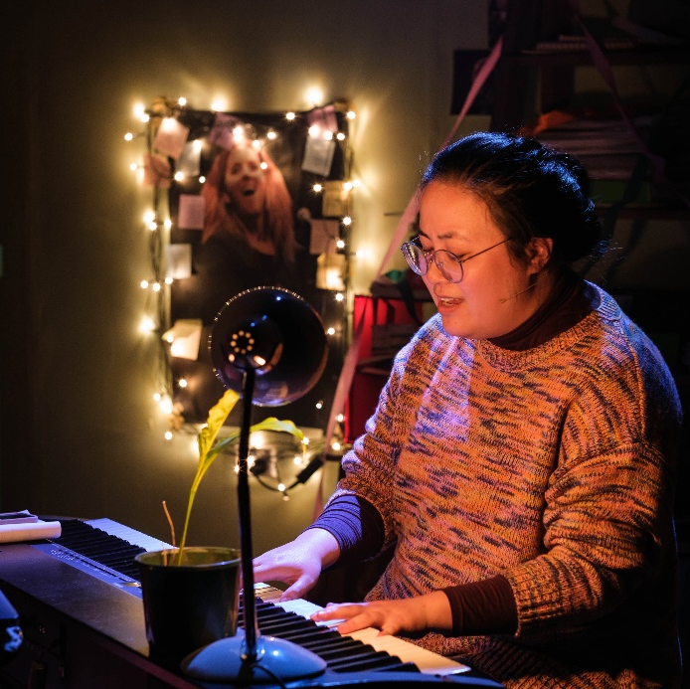

Image 19: Access Ideas & Insights Panel
Video Timestamp: 23:47:9 – 24:41:7
Image Description: Four panellists Jules Orcullo, Ryan Enniss, Joanna Erskine, and Kylie Heart, are seated on wooden chairs against a black curtain at the Access Ideas and Insights panel. Jules, on the far left, holds a microphone and gestures as they speak, while the others listen attentively, turned toward them with notebooks and microphones in hand.
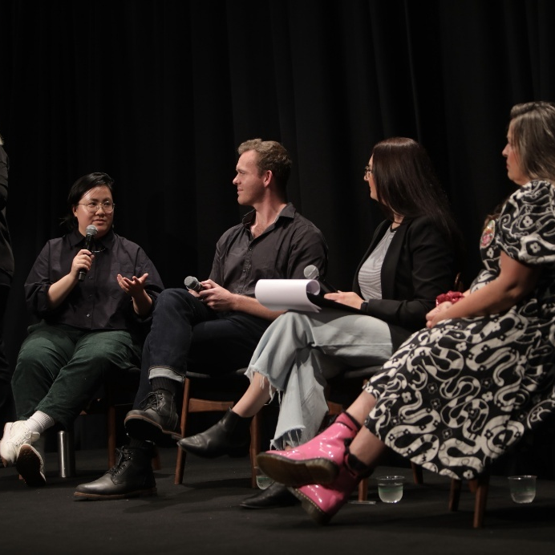

Image 20: Jules Orcullo in ‘Forgetting Tim Minchin’
Video Timestamp: 24:41:7 – 26:48:2
Image Description: Performer Jules Orcullo stands barefoot in a dimly lit bedroom set, illuminated by a spotlight. They wear glasses, a colourful knitted jumper, and loose pants, with their hands clasped in front of them. The unmade bed beside them is covered in dark bedding and scattered clothes, with an orange pillow catching the light. Behind them, clothing hangs against the wall, and a large poster of Tim Minchin is partially visible.
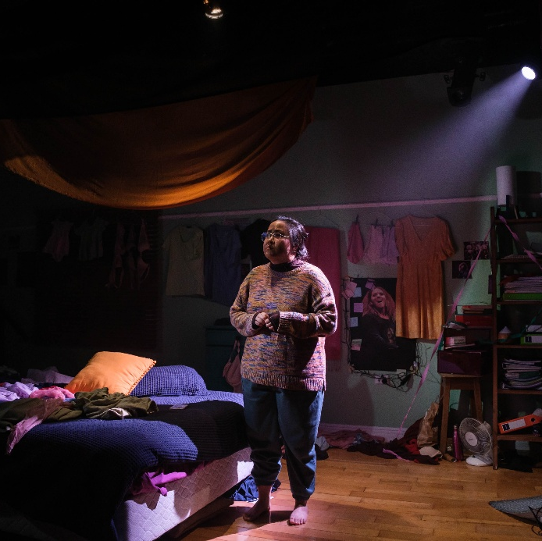

Image 21: Jules Orcullo performing on stage
Video Timestamp: 26:48:2 – 28:49:4
Image Description: Jules Orcullo stands under a spotlight, speaking into a microphone. She holds a sheet of paper in one hand and gesture upward with the other, finger pointed as if making an important statement. They wear round glasses, a brown collared shirt layered over a long-sleeve top, and their hair is tied back in a bun. The background is completely dark, focusing all attention on the performer.
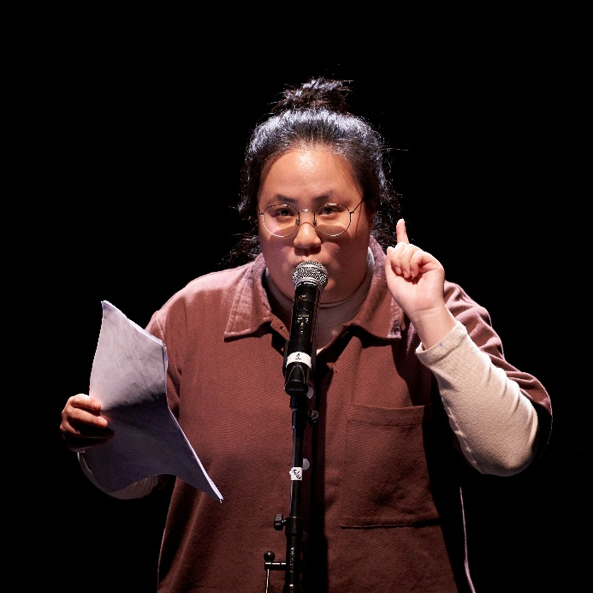

Image 22: Behind the scenes recording the podcast
Video Timestamp: 28:49:4 – 33:01:9
Image Description: Bedelia Lowrenčev and Jules Orcullo sit across from each other in a recording studio, speaking into microphones on stands. Bedelia wears a grey sweater and dark pants, seated on a stool with a laptop and water bottle on a table in front of them. Jules wears a green outfit with white sneakers and gestures with their hand while speaking. The studio has wooden floors, black curtains, and bright yellow walls.
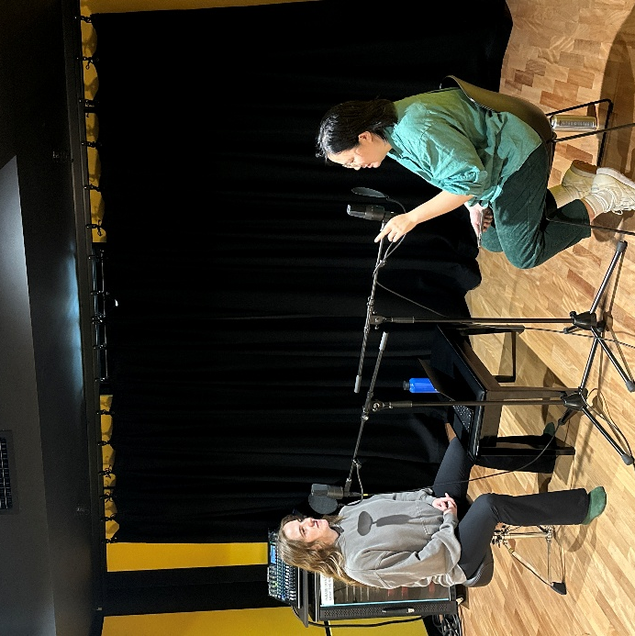

Image 23: Scene from ‘Forgetting Tim Minchin’
Video Timestamp: 33:01:9 – 35:27:3
Image Description: Performer Jules Orcullo sits beneath a window with closed blinds, illuminated by soft pink light. They look down at a glowing phone in their hand, while dresses and bras hang above, silhouetted against the blinds. The scene is dimly lit, with the vivid pink light casting a moody, intimate atmosphere.
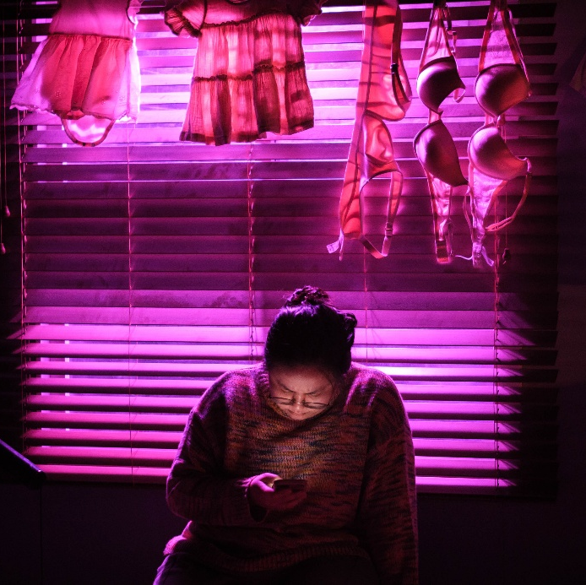

Image 24: Dancing scene from ‘Forgetting Tim Minchin’
Video Timestamp: 35:27:3 – 38:14:7
Image Description: In a warmly lit room, performer Jules Orcullo balances on one leg with arms raised joyfully in the air. They wear glasses, a multicoloured sweater, and loose pants, their expression is animated. Behind them, a bookcase and dresser frame the scene, while clothing and papers scattered across the floor create a sense of a lived-in, creative space. Soft light glows casts shadows on the wall.
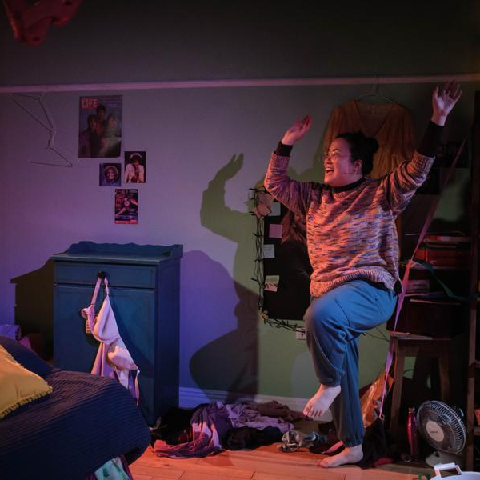

Image 25: Singing scene from ‘Forgetting Tim Minchin’
Video Timestamp: 38:14:7 - 39:14:1
Image Description: Performer Julies Orcullo sits at a keyboard in a dimly lit room, singing with eyes closed. They wear glasses and a multi-coloured jumper. A small desk lamp and potted plant sit on keyboard. Behind, shelves cluttered with books and papers, and coats hanging on the wall. To the left, a glowing portrait surrounded by fairy lights casts a warm yellow glow.
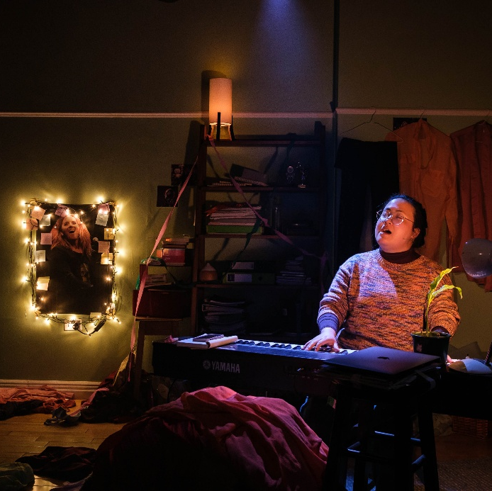

Image 26: Jules Orcullo performing a live reading
Video Timestamp: 39:14:1 - 41:01:4
Image Description: On a dark stage, Jules Orcullo stands at a microphone, illuminated by a bright spotlight. They hold papers in one hand and gesture with the other. Multiple overlapping circles of light spread across the floor, creating a dramatic effect against the black backdrop. Silhouettes of the seated audience are visible in the foreground.
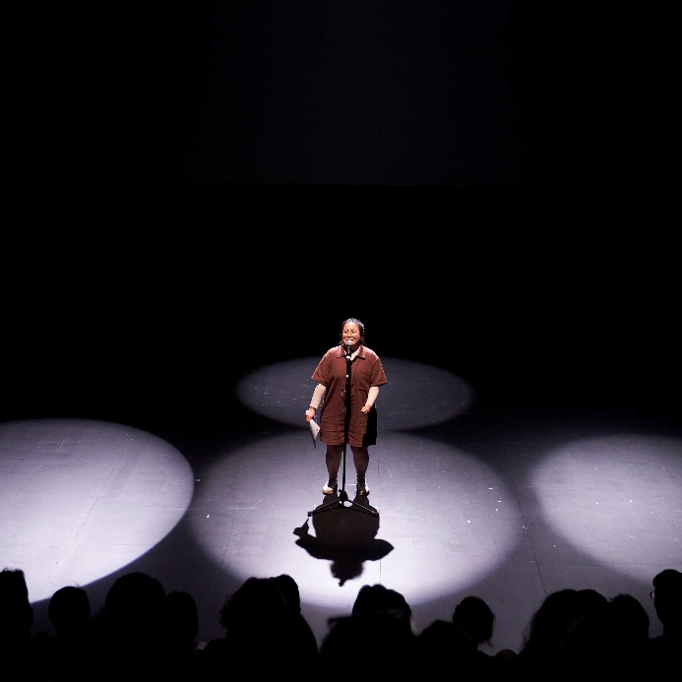

Image 27: Jules and Bedelia in studio
Video Timestamp: 41:01:4 – 41:36:2
Image Description: Jules Orcullo and Bedelia Lowrenčev sit side by side on a black bench in a recording studio. Jules, on the left, wears a loose green shirt, dark green corduroy trousers, and white sneakers, holding a phone in their hands. Bedelia, on the right, sits cross-legged in a grey hoodie and black pants, smiling warmly. A microphone on a stand is positioned in front of them.
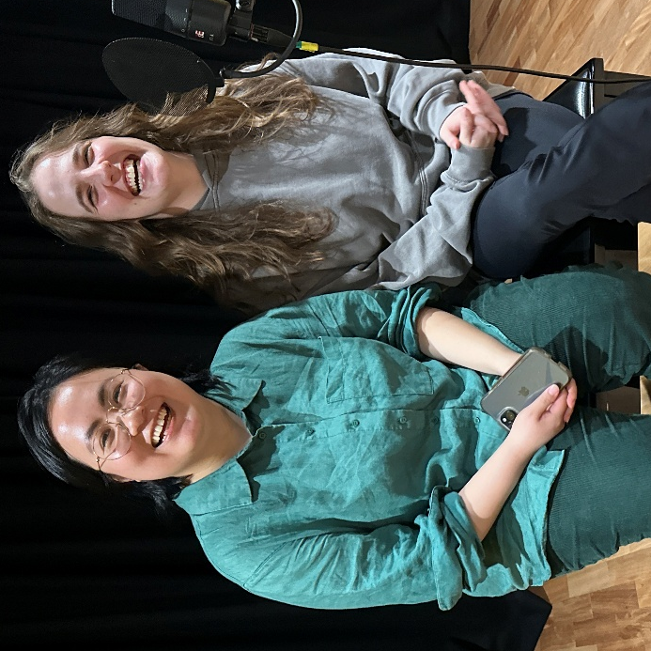

Image 28: Access Ideas & Insights Podcast Logo Graphic
Video Timestamp: 41:36:2 - 42:06:8
Image Description: A white vintage microphone stands out against a solid black background. To its right, bold text reads: “accessible arts Access Ideas & Insights Podcast.” The words “accessible arts” appear in magenta lowercase, while the rest of the text is white. The word “Podcast” is larger and set below by a thin gradient line shifting from magenta to yellow. Along the bottom edge, a vivid wave of magenta, purple, orange, and yellow adds movement to the design.

Image 29: Access Ideas & Insights Podcast Partnerships
Video Timestamp: 42:06:8 – 42:25:6
Image Description: A black background with white text and three logos at the bottom. The text reads: "This podcast was proudly produced by Accessible Arts and Kiera Brew Kurec, with sound design by Tralala Blip. Access consulting was provided by Macro Impact Consulting and our Advisory Group. Special thanks to our Auslan interpreters from Sweeney Interpreting. This podcast series is proudly supported by the City of Sydney and Create NSW, the principal funding partner of Accessible Arts."
At the bottom are three logos. On the left: A black circle with a white outline of a hand in Auslan signing, with the text "MACRO Impact Consulting." In the centre: The words "CITY OF SYDNEY" in bold white capital letters, with a small circular anchor emblem beside it. On the right: A white waratah flower symbol above the words "NSW GOVERNMENT."
