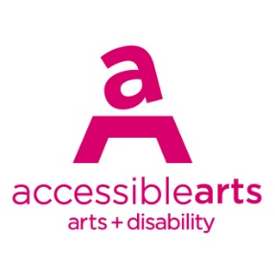

Access Ideas & Insights Podcast

Image Description Guide

Introduction: Episode 4 – Disability Leadership
This document contains written Image Descriptions for the images featured in the Auslan version of the Accessible Arts: Access Ideas & Insights podcast video Disability Leadership. Each episode of the podcast includes the following accessible features: Auslan video, transcript, and an image description guide. Where available, time stamps are included to assist with navigation. Auslan users may find it helpful to use this guide alongside the video.

Table of Contents
Introduction: Episode 4 – Disability Leadership 1
Table of Contents 1
Image 1: Access Ideas & Insights Podcast Logo Graphic 2
Image 2: Headshot Bedelia Lowrenčev 2
Image 3: Access Ideas & Insights Podcast Logo Graphic 3
Image 4: Headshot Riana Head-Toussaint 3
Image 5: Crip Rave Theory, Vol 1 4
Image 6: Crip Rave Theory x Body Place 4
Image 7: Crip Rave Theory for Rising Festival 5
Image 8: Very Excellent Disabled Dancing by Riana Head-Toussaint 5
Image 9: Animate Loading at the AGNSW 6
Image 10: Animate Loading 2 6
Image 11: Riana and collaborators 7
Image 12: Keir Choreographic Award Semi-Final Dancehouse 7
Image 13: Crip Rave Theory x Body Place at UTP 8
Image 14: Access Ideas & Insights Podcast Logo Graphic 8
Image 15: Headshot Joshua Pether 9
Image 16: Joshua Pether’s performance work 9
Image 17: Arts Access Victoria – 50th Anniversary Celebration 10
Image 18: The Reckoning by Joshua Pether 10
Image 19: As Below, So Above by Joshua Pether 11
Image 20: Access Arts Victoria - The Collective 11
Image 21: Performance Jupiter Orbiting 12
Image 22: Image 1 - Jupiter Orbiting by Joshua Pether 12
Image 23: Image 2 - Jupiter Orbiting by Joshua Pether 13
Image 24: Phases 13
Image 25: Access Ideas & Insights Podcast Logo Graphic 14
Image 26: Access Ideas & Insights Podcast Partnerships 14

Image Descriptions

Image 1: Access Ideas & Insights Podcast Logo Graphic
Video Timestamp: 00:00:0 – 00:44:0
Image Description: A white vintage microphone stands out against a solid black background. To its right, bold text reads: “accessible arts Access Ideas & Insights Podcast.” The words “accessible arts” appear in magenta lowercase, while the rest of the text is white. The word “Podcast” is larger and set below by a thin gradient line shifting from magenta to yellow. Along the bottom edge, a vivid wave of magenta, purple, orange, and yellow adds movement to the design.
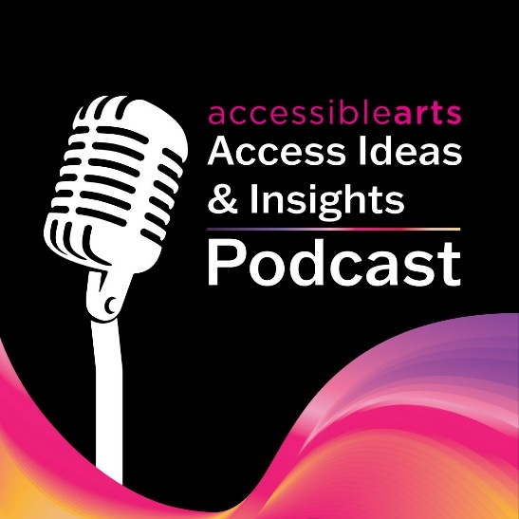

Image 2: Headshot Bedelia Lowrenčev
Video Timestamp: 00:44:0 – 01:22:0
Image Description: A person with long wavy brown hair and hazel eyes smiles at the camera. They are wearing a sheer green long-sleeve top. Their head tilts slightly as their hand rests against her neck. The background is softly blurred, bringing the focus to their face.
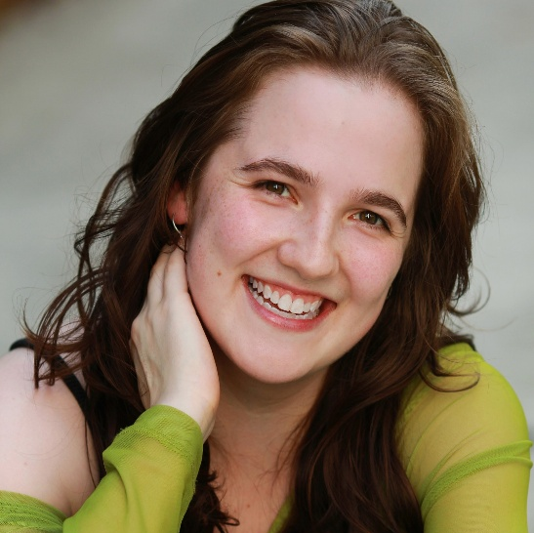

Image 3: Access Ideas & Insights Podcast Logo Graphic
Video Timestamp: 01:22:0 – 02:54:3
Image Description: A white vintage microphone stands out against a solid black background. To its right, bold text reads: “accessible arts Access Ideas & Insights Podcast.” The words “accessible arts” appear in magenta lowercase, while the rest of the text is white. The word “Podcast” is larger and set below by a thin gradient line shifting from magenta to yellow. Along the bottom edge, a vivid wave of magenta, purple, orange, and yellow adds movement to the design.

Image 4: Headshot Riana Head-Toussaint
Video Timestamp: 02:54:3 - 03:45:7
Image Description: A close-up colour portrait of Riana Head-Toussaint shows her facing the camera with a serious, confident expression. She has light brown, shoulder-length hair styled in a side part and light brown skin. She wears a small nose stud, gold earrings, and a blue top with thin straps. The background is a plain, off-white textured wall.
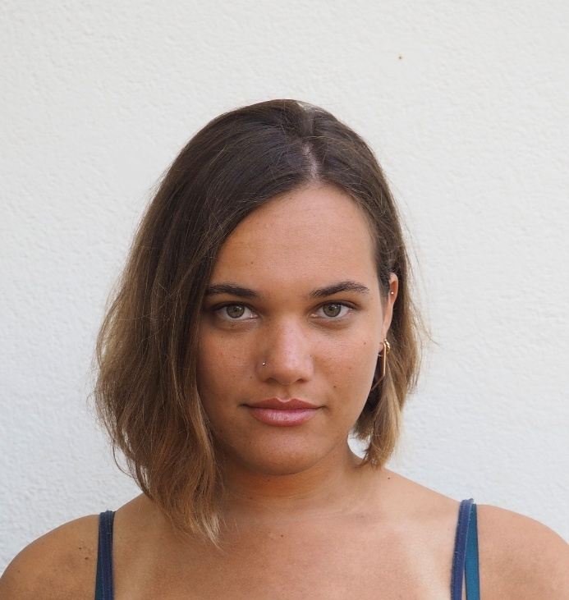

Image 5: Crip Rave Theory, Vol 1
Video Timestamp: 03:45:7 - 06:01:8
Image Description: A performer crouches low at the centre of a theatre space, illuminated by deep magenta and red lighting. They are dressed in heels and a translucent costume, their body held in a grounded, deliberate pose. Audience members stand and sit in a ring around the performer, some clapping, others holding phones or watching intently. Discarded costume pieces lie across the floor, reinforcing the raw, intimate atmosphere of a live performance moment.
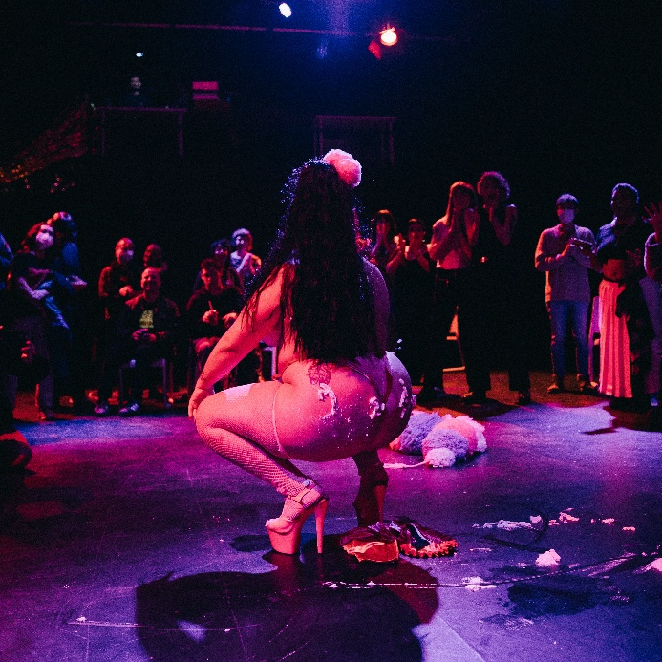

Image 6: Crip Rave Theory x Body Place
Video Timestamp: 06:01:8 – 07:55:8
Image Description: A group of people gather on a small, raised outdoor stage at night, immersed in an energetic, club scene. At the centre, a person in a wheelchair moves across the stage, wearing a green patterned dress. Their wheelchair wheels glow with bright purple lights, creating vivid trails of colour against the dark stage floor. Their head is tilted back slightly, eyes closed. Around them, other people stand, dance, or move in blurred motion. One person lies on the stage floor nearby, resting on their back. The lighting is saturated, mixing reds, greens, and yellows.
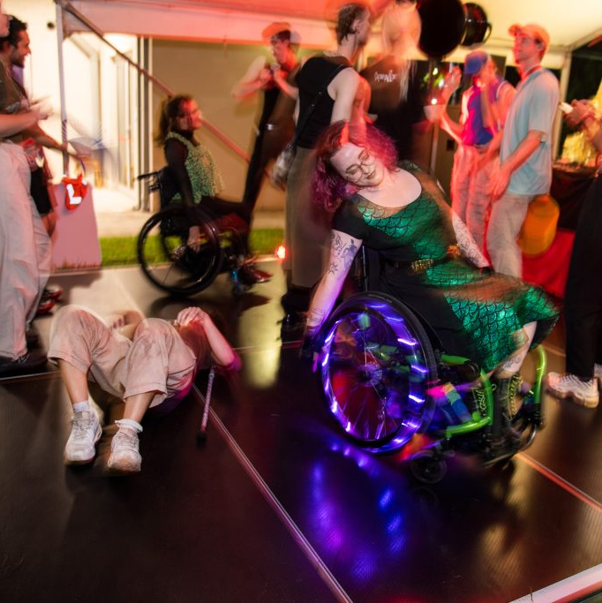

Image 7: Crip Rave Theory for Rising Festival
Video Timestamp: 07:55:8 – 10:41:3
Image Description: A warm, intimate indoor social gathering for Crip Rave Theory at Rising Festival, lit with soft, ambient lighting. In the foreground, the scene is viewed through a doorway framed by hanging artificial vines intertwined with fairy lights. Inside the room, several people relax on large beanbags scattered across a wooden floor. In the background, a shimmering, multicoloured tinsel curtain covers a doorway.
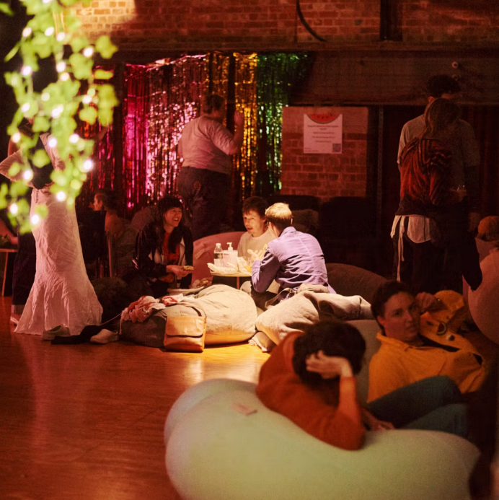

Image 8: Very Excellent Disabled Dancing by Riana Head-Toussaint
Video Timestamp: 10:41:3 – 12:01:7
Image Description: Riana Head-Toussaint is centre stage in a wheelchair, wearing a black sleeveless top and dark pants. One arm is lifted high, palm open and facing outward, while the other rests on the right wheel, grounding the pose. Their expression is focused eyes directed forward. Warm, theatrical lighting illuminates their body, casting a soft glow across their face and arms and creating long shadows on the floor. The dark, minimal stage setting draws attention to the strength, stillness, and intention of Riana’s gestures.
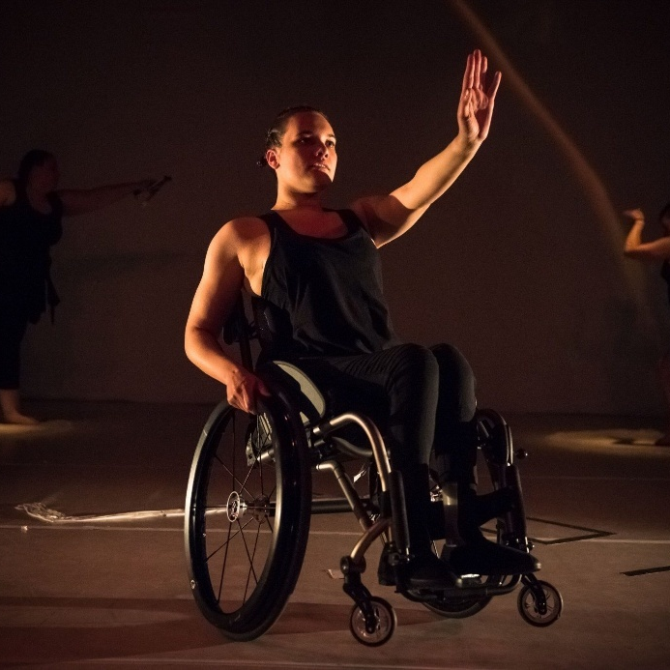

Image 9: Animate Loading at the AGNSW
Video Timestamp: 12:01:7 – 13:10:9
Image Description: In a bright, open atrium, a group of performers are spread out across the floor mid-movement, bodies stretched, inverted, rolling, and resting in varied poses. One performer balances upside down on their shoulders while others lie, twist, or reach along the ground. The expansive glass walls and sweeping staircase behind them frame the scene, amplifying the sense of scale, motion, and collective choreography within the AGNSW.
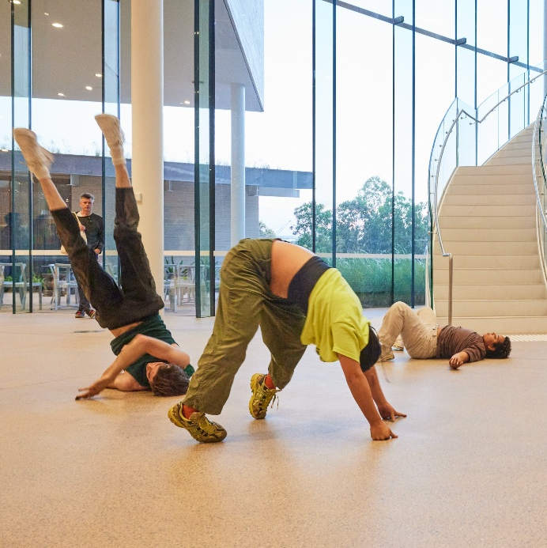

Image 10: Animate Loading 2
Video Timestamp: 13:10:9 – 15:16:5
Image Description: A concrete wall runs diagonally through the scene, illuminated by intense orange light. One performer lies upside down on the grass at the base of the wall, legs bent and feet pressed against the concrete. Another performer stands above on the wall, leaning forward and holding a handheld light focused downward. Below, a third performer crouches close to the wall, gripping a light their body angled forward. In the foreground, a fourth person stands in shadow, partially out of focus, watching.
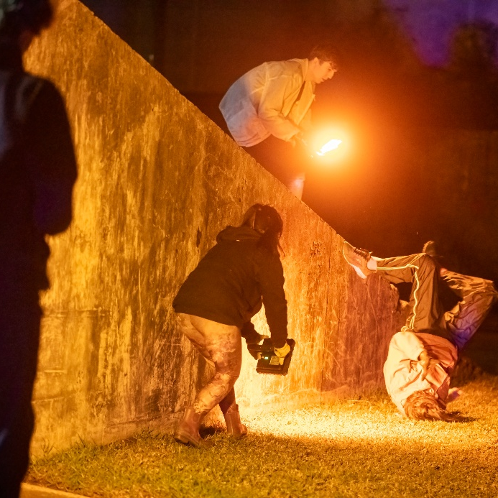

Image 11: Riana and collaborators
Video Timestamp: 15:16:5 – 17:27:9
Image Description: Three performers stand closely together their bodies intertwined in a moment of shared movement. The performer on the left reaches forward, their arm extended across the others, while the central performer looks downward, focused. On the right, a performer tilts their head slightly, eyes closed. Warm, directional lighting highlights the contours of their arms and faces, casting soft shadows that emphasise the connection between the trio.
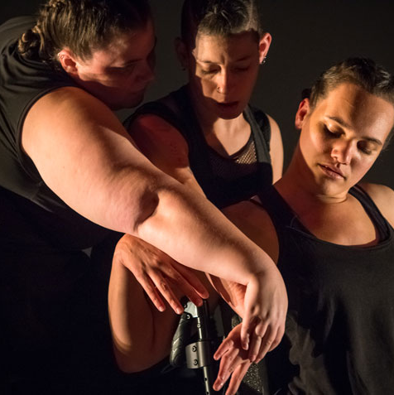

Image 12: Keir Choreographic Award Semi-Final Dancehouse
Video Timestamp: 17:27:9 – 18:54:6
Image Description: The interior of a studio space with white backdrops and a lighting rig suspended overhead. Three performers sit in a row facing away from the camera, showing only their backs. All wear black tops layered with loose white garments. The performer at the centre sits in a wheelchair, with the other two seated on either side. Each has their hair tied up in braids or buns. The lighting is bright and even, creating a clean, neutral studio setting.
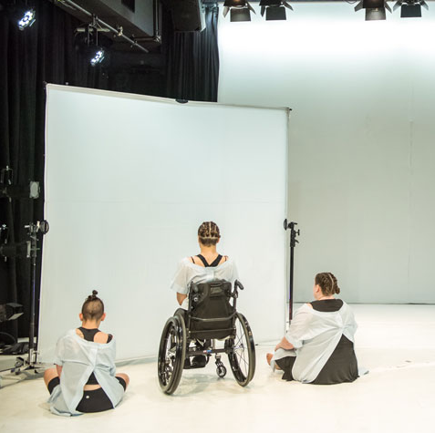

Image 13: Crip Rave Theory x Body Place at UTP
Video Timestamp: 18:54:6 – 19:58:5
Image Description: An outdoor dance party at night during Crip Rave Theory x Body Place, captured with motion blur that suggests continuous movement and music. In the foreground on the left, the corner of a DJ deck is visible. At the centre of the frame, a person in a wheelchair smiles as they dance, surrounded by other dancers standing nearby. Red and green party lights wash over the scene, while strings of festoon lights hang in the background near a white building, creating a lively, communal atmosphere.
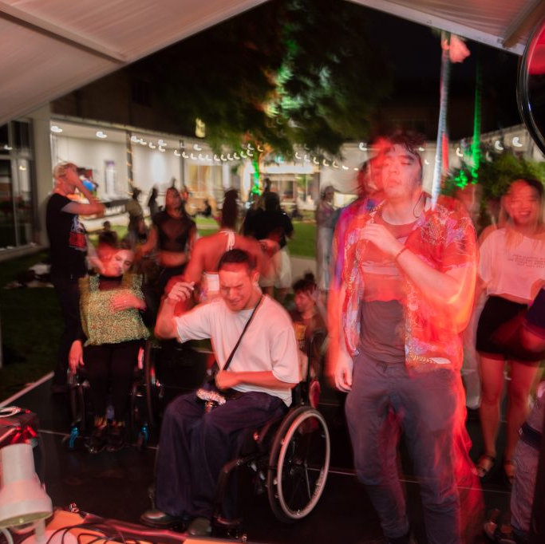

Image 14: Access Ideas & Insights Podcast Logo Graphic
Video Timestamp: 19:58:5 – 20:08:9
Image Description: A white vintage microphone stands out against a solid black background. To its right, bold text reads: “accessible arts Access Ideas & Insights Podcast.” The words “accessible arts” appear in magenta lowercase, while the rest of the text is white. The word “Podcast” is larger and set below by a thin gradient line shifting from magenta to yellow. Along the bottom edge, a vivid wave of magenta, purple, orange, and yellow adds movement to the design.

Image 15: Headshot Joshua Pether
Video Timestamp: 20:08:9 – 20:58:0
Image Description: A black-and-white headshot of Joshua Pether shows him facing the camera directly with a calm, neutral expression. He has a shaved head and light stubble and wears a dark zip-up hoodie, partially unzipped, with the drawstrings hanging loose. The background is a white painted brick wall, providing a clean, simple backdrop.

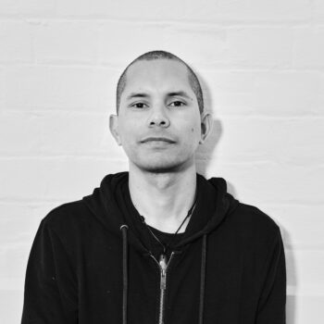

Image 16: Joshua Pether’s performance work
Video Timestamp: 20:58:0 – 21:47:8
Image Description: A side-profile portrait of Joshua Pether shows him standing with his arms crossed, facing to the right. He has short, shaved hair, and his face and neck are marked with visible streaks of white clay. He wears a long-sleeved black shirt. The setting appears to be an industrial interior, with a brick wall behind him lit by warm yellow light.

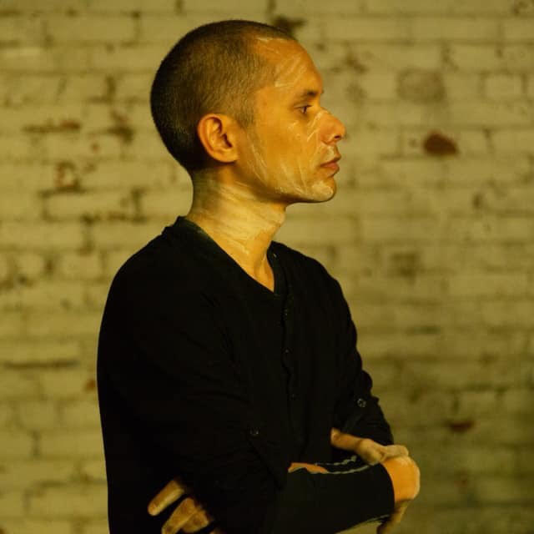

Image 17: Arts Access Victoria – 50th Anniversary Celebration
Video Timestamp: 21:47:8 – 23:12:6
Image Description: A photo of a panel discussion featuring three people seated on stage. On the left, an older woman with short grey hair and glasses wears an orange top and listens attentively. Beside her in the centre, a man with glasses and a shiny black jacket sits, looking downward. On the right, a woman with dark hair and glasses, wearing a patterned floral dress, speaks into a microphone while gesturing. Behind them is a black backdrop featuring a repeated logo that reads "Arts Access Victoria".
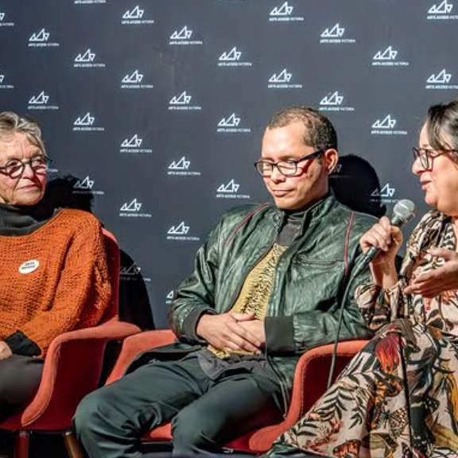

Image 18: The Reckoning by Joshua Pether
Video Timestamp: 23:12:6 – 25:23:8
Image Description: Joshua Pether crouches low on a dark stage, balanced on the balls of his feet with knees bent. They wear a loose white shirt and dark trousers. One hand reaches down to brush the stage floor. Their head is turned to the side, gaze downward. Behind them, a tall vertical projection glows in shades of green, displaying an abstracted textured surface. The projection frames the performer, casting a soft green light across the stage. A small bowl sits on the floor in front of the performer, suggesting a ritualistic or symbolic element within the performance.
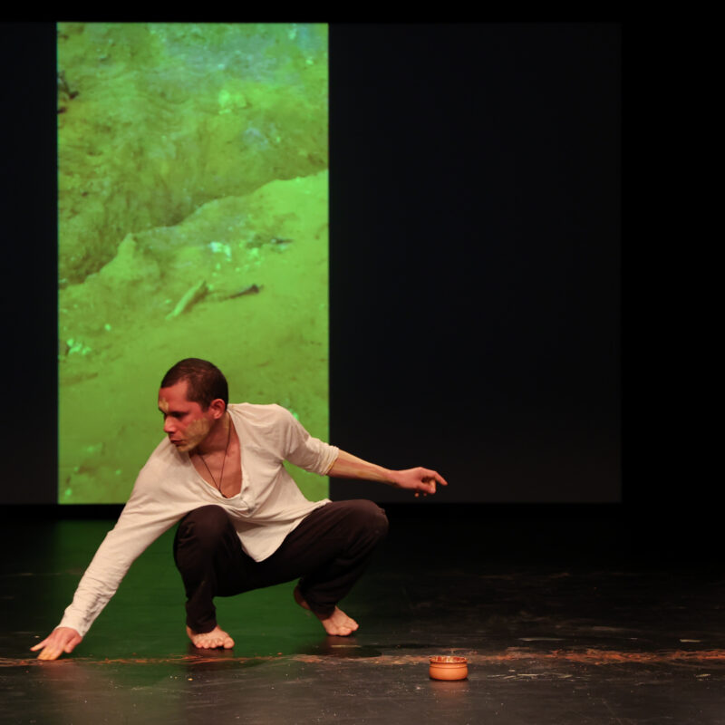

Image 19: As Below, So Above by Joshua Pether
Video Timestamp: 25:23:8 – 28:28:2
Image Description: Seen from behind, Joshua Pether stands with both arms raised overhead, elbows slightly bent, palms open and facing inward. They are wearing a black top, and a thin cord necklace. Their closely cropped hair and the line of their shoulders are softly illuminated by warm, low lighting. In front of them, slightly out of focus, another figure mirrors the gesture creating a layered composition of overlapping hands and forearms.
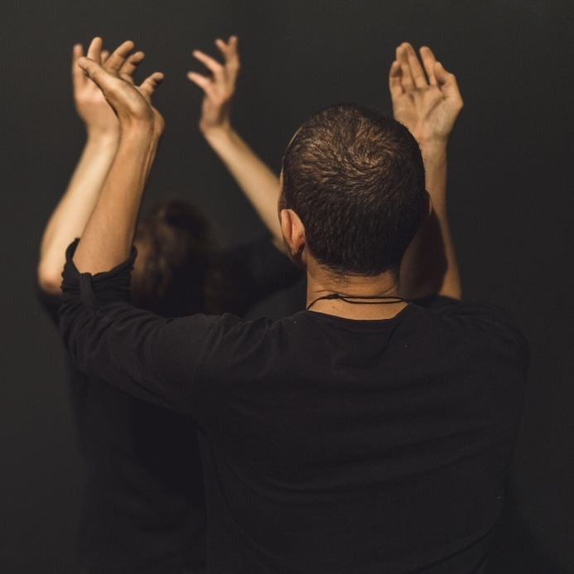

Image 20: Access Arts Victoria - The Collective
Video Timestamp: 28:28:2 – 30:31:4
Image Description: A panel discussion held during The Collective exhibition celebrating the 50th Anniversary for Arts Access Victoria. A bright red carpet runs down the centre of the room, dividing audience members seated on chairs and beanbags on either side. In the background, a stage glows with blue lighting. Five panellists are seated in a row facing the audience, with the panellist on the far left holding a microphone. Behind them, a large black backdrop displays a repeated white logo.
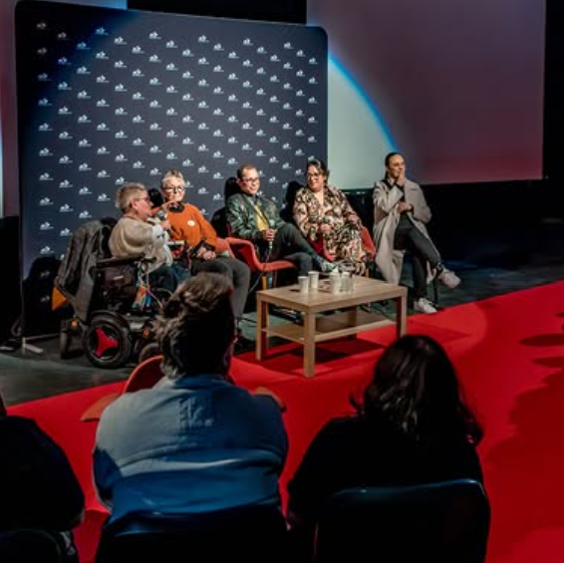

Image 21: Performance Jupiter Orbiting
Video Timestamp: 30:31:4 – 31:34:0
Image Description: A performance scene shows a person wearing a white horse-head mask standing in profile. The performer wears a white T-shirt, with their lower body bare, and is captured mid-action as they pull a white sheet off a table. Behind them, a large projection screen displays a vivid blue-and-white, cloud-like abstract pattern. The bright projection light casts a sharp, clearly defined shadow of the performer and the horse head onto the screen, amplifying the dramatic contrast of the scene.
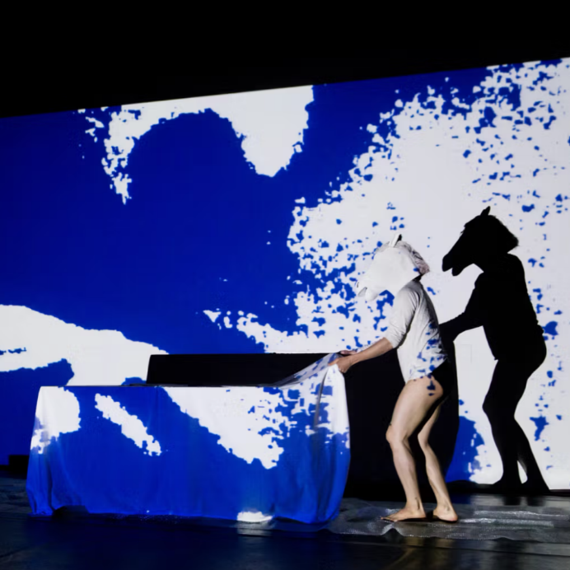

Image 22: Image 1 - Jupiter Orbiting by Joshua Pether
Video Timestamp: 31:34:0 – 33:34:8
Image Description: Two human figures sit facing one another. Both wear full-body suits that cover their heads and faces, obscuring all facial features. The figure on the left is dressed in white, while the figure on the right is dressed in black. Both figures are covered in white fabric draped around their waists and legs. They lean slightly forward toward each other, arms extended, with hands reaching out as if about to embrace. Their mirrored postures create a sense of symmetry and quiet tension.
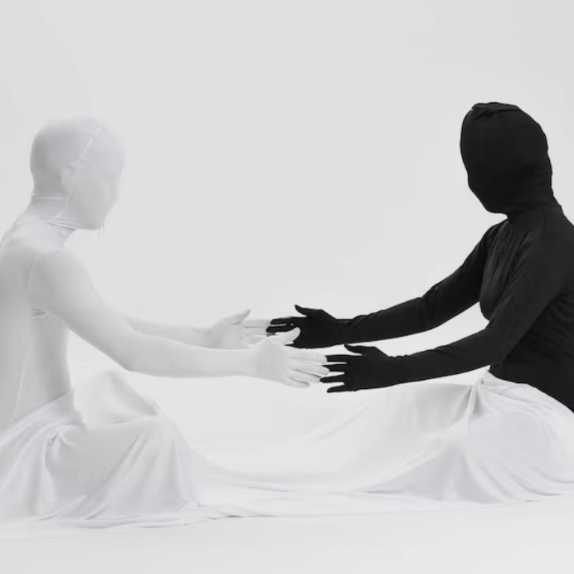

Image 23: Image 2 - Jupiter Orbiting by Joshua Pether
Video Timestamp: 33:34:8 – 35:00:3
Image Description: A surreal, brightly lit studio portrait set against a white background features two performers in elaborate costumes. On the left, a performer sits on a white block wearing a black bodysuit layered with a gold top and pink wig. They hold a large, half-inflated pink inflatable flamingo around their waist. On the right, a second performer sits on the floor wearing a full-body white suit and a shiny gold face mask. They face the first performer, holding a handful of colourful confetti.
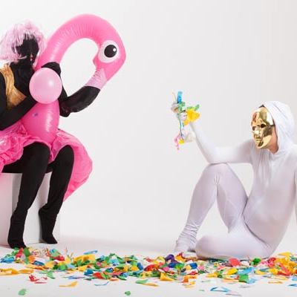

Image 24: Phases
Video Timestamp: 35:00:3 – 37:12:3
Image Description: Four performers stand among piles of crumpled white fabric scattered across the floor. On the left, a performer in a mustard-yellow shirt leans inward, using both hands to stabilise a second performer whose body tilts heavily toward them. Directly behind, a third performer in supports, their hands placed on the leaning performer’s shoulders to help keep them upright. On the right, a fourth performer in a beige dress stands slightly apart from the group, observing the exchange.
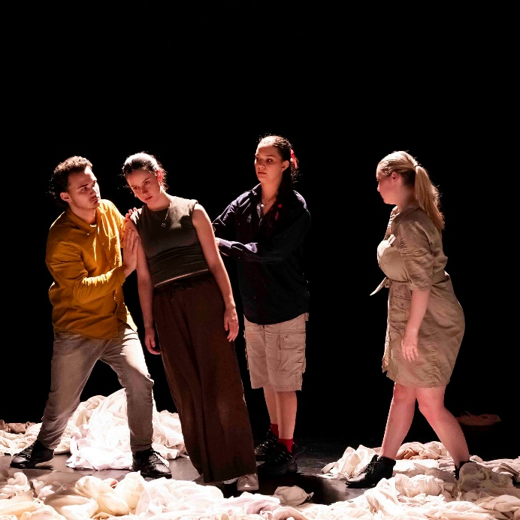

Image 25: Access Ideas & Insights Podcast Logo Graphic
Video Timestamp: 37:12:3 – 37:46:5
Image Description: A white vintage microphone stands out against a solid black background. To its right, bold text reads: “accessible arts Access Ideas & Insights Podcast.” The words “accessible arts” appear in magenta lowercase, while the rest of the text is white. The word “Podcast” is larger and set below by a thin gradient line shifting from magenta to yellow. Along the bottom edge, a vivid wave of magenta, purple, orange, and yellow adds movement to the design.

Image 26: Access Ideas & Insights Podcast Partnerships
Video Timestamp: 37:46:5 – 38:02:4
Image Description: A black background with white text and three logos at the bottom. The text reads: "This podcast was proudly produced by Accessible Arts and Kiera Brew Kurec, with sound design by Tralala Blip. Access consulting was provided by Macro Impact Consulting and our Advisory Group. Special thanks to our Auslan interpreters from Sweeney Interpreting. This podcast series is proudly supported by the City of Sydney and Create NSW, the principal funding partner of Accessible Arts."
At the bottom are three logos. On the left: A black circle with a white outline of a hand in Auslan signing, with the text "MACRO Impact Consulting." In the centre: The words "CITY OF SYDNEY" in bold white capital letters, with a small circular anchor emblem beside it. On the right: A white waratah flower symbol above the words "NSW GOVERNMENT."
