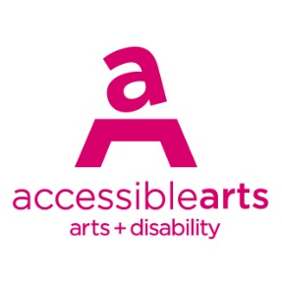

Access Ideas & Insights Podcast

Image Description Guide

Introduction: Episode 5 – Creative Partnerships & Pathways
This document contains written Image Descriptions for the images featured in the Auslan version of the Accessible Arts: Access Ideas & Insights podcast video Creative Partnerships & Pathways. Each episode of the podcast includes the following accessible features: Auslan video, transcript, and an image description guide. Where available, time stamps are included to assist with navigation.

Table of Contents
Introduction: Episode 5 – Creative Partnerships & Pathways 1
Table of Contents 1
Image 1: Access Ideas & Insights Podcast Logo Graphic 2
Image 2: Headshot Bedelia Lowrenčev 2
Image 3: Access Ideas & Insights Podcast Logo Graphic 3
Video: Alex Jones welcome video 4
Image 4: Alex Jones opening speech at the Access Ideas & Insights: Disability Leadership event. 4
Image 5: Access Ideas & Insights: Disability Leadership event 5
Image 6: Alex Jones asking at audience question at Access Ideas & Insights 5
Image 7: Alex Jones giving a presentation in Auslan 6
Image 8: Alex Jones, Jennifer Moon & Shane Carroll 7
Image 9: Alex Jones presenting at the Workplace Readiness Program 7
Image 10: Alex Jones gives the opening address at Access Ideas & Insights 8
Image 11: Access Ideas & Insights: Disability Leadership panel 8
Image 12: Access Ideas & Insights Podcast Logo Graphic 9
Image 13: Utp Co-Artistic Directors Dr Jessica Olivieri 10
Image 14: Utp Co-Artistic Directors Jessica Olivieri & Hannah Donnelly. 10
Image 15: Crip Rave Theory x Body Place 11
Image 16: Crip Rave Theory at Utp 11
Image 17: Utp Team 12
Image 18: Seasons of Care development at Utp 12
Image 19: Crip Rave Theory x Body Place 13
Image 20: Seasons of Care - Artists in residence 14
Image 21: DJ Riana Head-Toussaint 14
Image 22: Access Ideas & Insights Podcast Logo Graphic 15
Image 23: Access Ideas & Insights Podcast Partnerships 16

Image Descriptions

Image 1: Access Ideas & Insights Podcast Logo Graphic
Video Timestamp: 00:01:0 – 00:45:4
Image Description: A white vintage microphone stands out against a solid black background. To its right, bold text reads: “accessible arts Access Ideas & Insights Podcast.” The words “accessible arts” appear in magenta lowercase, while the rest of the text is white. The word “Podcast” is larger and set below by a thin gradient line shifting from magenta to yellow. Along the bottom edge, a vivid wave of magenta, purple, orange, and yellow adds movement to the design.
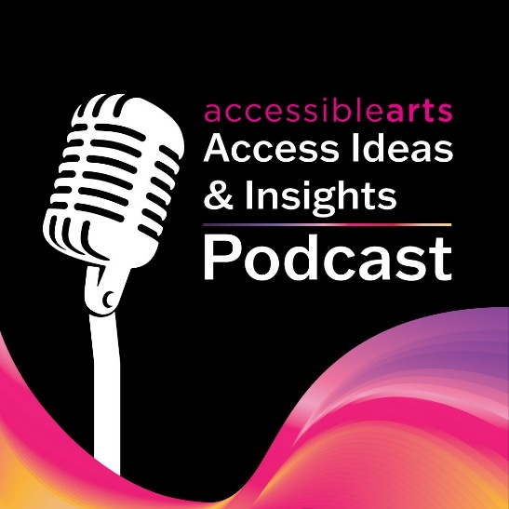

Image 2: Headshot Bedelia Lowrenčev
Video Timestamp: 00:45:4 – 01:21:3
Image Description: A person with long wavy brown hair and hazel eyes smiles at the camera. They are wearing a sheer green long-sleeve top. Their head tilts slightly as their hand rests against her neck. The background is softly blurred, bringing the focus to their face.
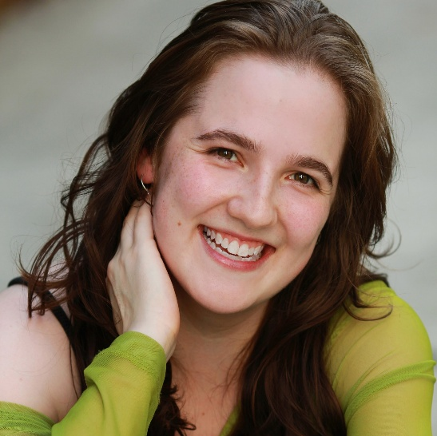

Image 3: Access Ideas & Insights Podcast Logo Graphic
Video Timestamp: 1:21:3 - 2:59:9
Image Description: A white vintage microphone stands out against a solid black background. To its right, bold text reads: “accessible arts Access Ideas & Insights Podcast.” The words “accessible arts” appear in magenta lowercase, while the rest of the text is white. The word “Podcast” is larger and set below by a thin gradient line shifting from magenta to yellow. Along the bottom edge, a vivid wave of magenta, purple, orange, and yellow adds movement to the design.

Video: Alex Jones welcome video
Video Timestamp: 2:59:9 - 3:36:8
Video Description: Alex Jones introduces himself and his role at the Sydney Opera House, communicating in Auslan. In the video, he is seated at a table, wearing a grey shirt and glasses, with a kitchen visible in the background. He explains that during the podcast recording, he will be voiced by Auslan Interpreter David McQuinggin.
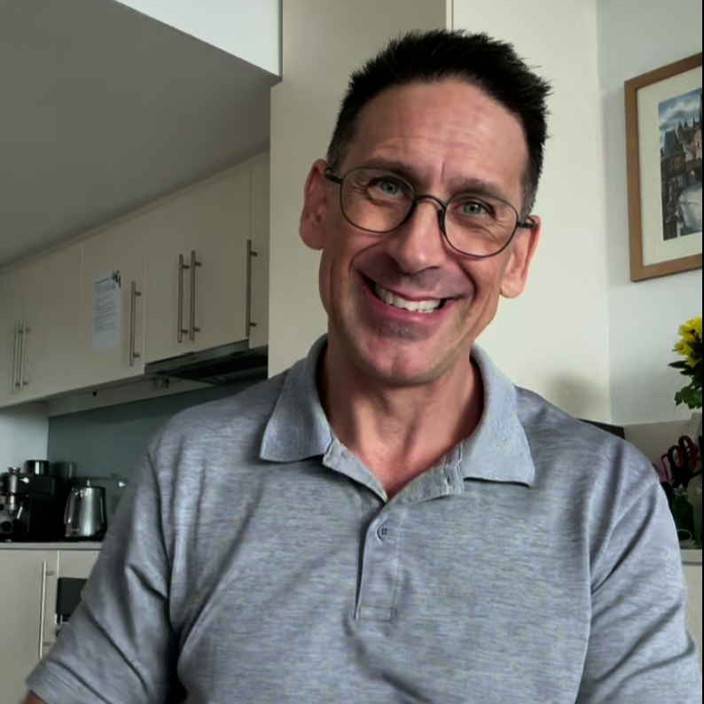

Image 4: Alex Jones opening speech at the Access Ideas & Insights: Disability Leadership event.
Video Timestamp: 3:36:8 - 5:51:3
Image Description: A mid-shot of Alex Jones standing behind a black lectern, addressing an audience. They are wearing a short-sleeved, dark floral button-up shirt and a lanyard with an ID badge. Their expression is animated and engaged, with a broad smile, as they gesture with both hands communicating in Auslan. Behind them is a large screen displaying bright yellow live captioning text on a dark background. The lighting is warm and even, clearly illuminating the speaker’s face and hand gestures.
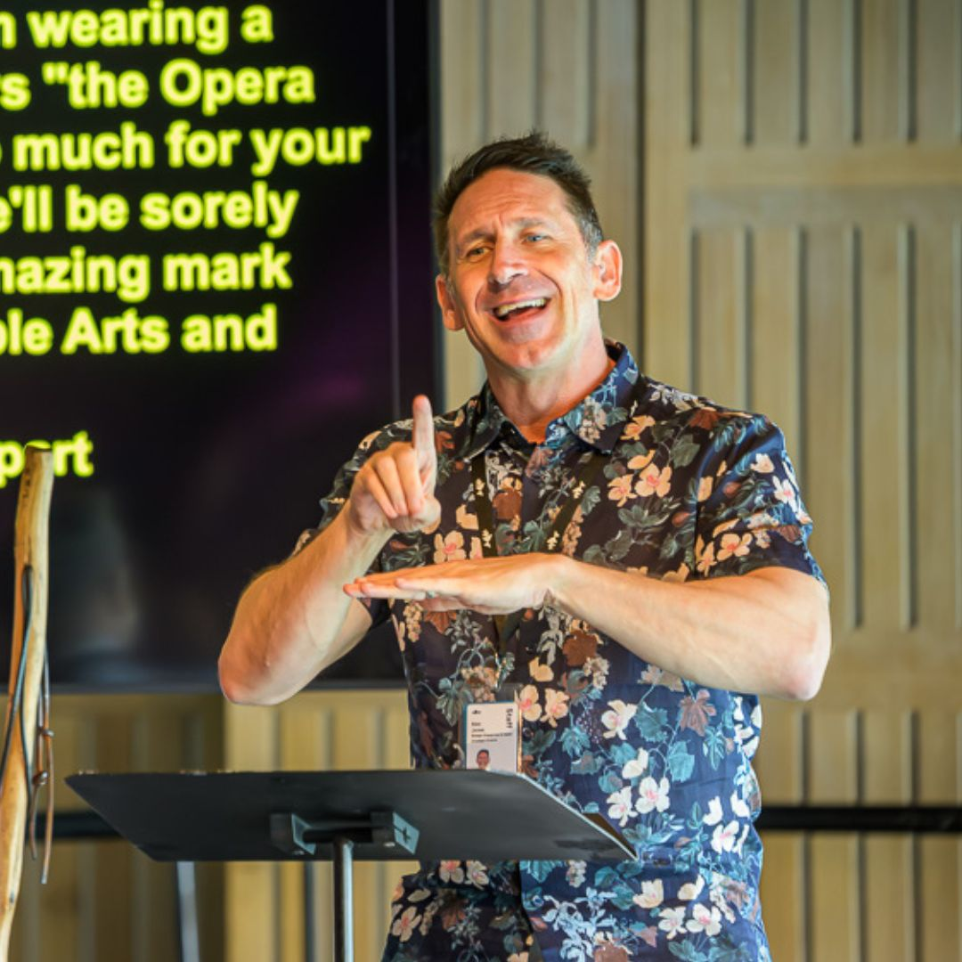

Image 5: Access Ideas & Insights: Disability Leadership event
Video Timestamp: 5:51:3 - 8:40:4
Image Description: A group portrait of seven people posed in front of a large, colourful abstract tapestry made up of bold, organic shapes in yellow, purple, green, black, and white. The group is arranged in a loose line, standing close together, with one person seated in a wheelchair at the right side of the image. Several people have their arms around one another’s shoulders, suggesting a sense of connection and camaraderie. The group includes from left to right: Janelle Ryan, Alex Jones, Liz Martin, Sarah-Mace Dennis, Eliza Hull, Daniel McDonald & Uncle Paul Calcott. The group is dressed in a mix of smart-casual and semi-formal clothing, including patterned dresses, jackets, button-up shirts, and layered outfits. Their expressions are relaxed and happy.
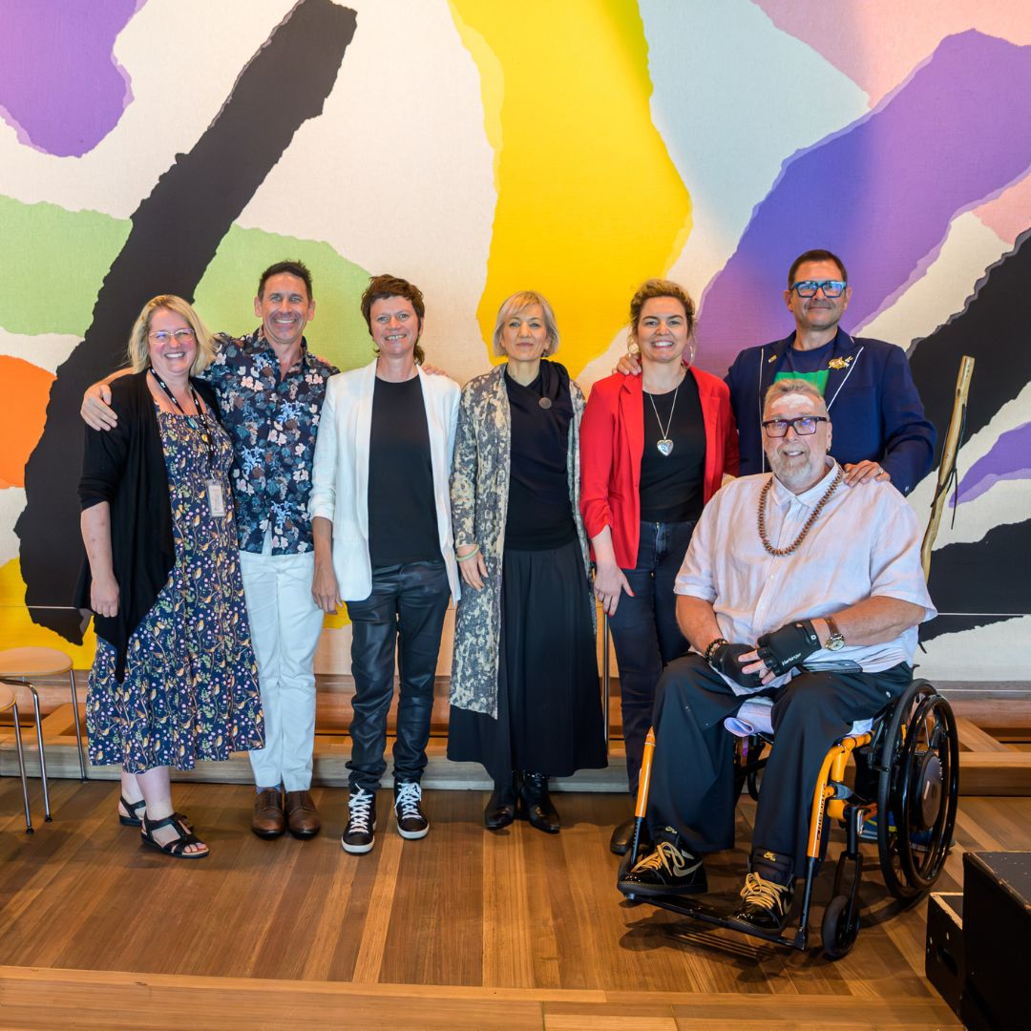

Image 6: Alex Jones asking at audience question at Access Ideas & Insights
Video Timestamp: 8:40:4 - 12:18:0
Image Description: A wide shot captures an audience seated in a darkened auditorium during a live Q&A session. In the foreground, a person with curly, shoulder-length blonde hair speaks into a handheld microphone, she is an Auslan interpreter. As she speaks, she turns toward the man seated beside her. Next to them, Alex Jones responds in Auslan, one hand raised with fingers clearly shaped in a signing gesture. He wears a dark, patterned button-up shirt and faces the speaker with focused attention, actively engaged in the exchange. The moment reflects a dialogue between spoken English and Auslan. Behind them, rows of audience members sit closely together in theatre chairs, watching attentively.
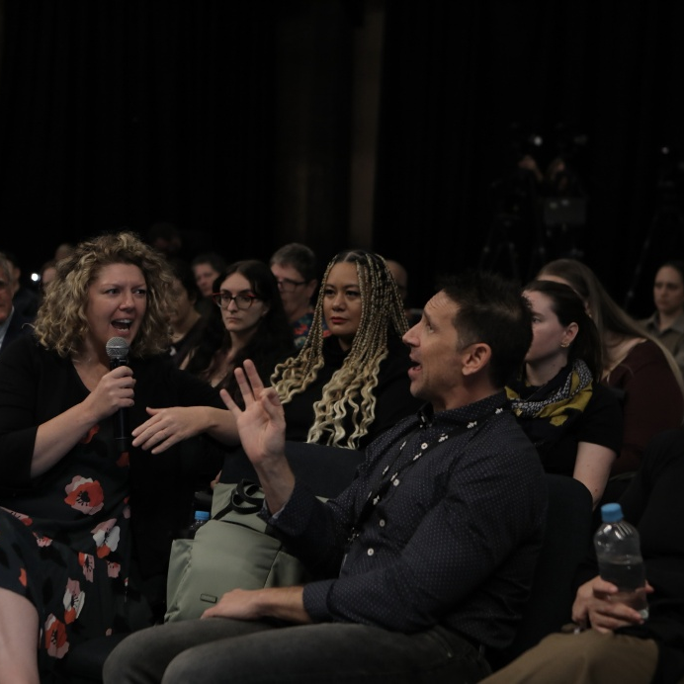

Image 7: Alex Jones giving a presentation in Auslan
Video Timestamp: 12:18:0 - 14:28:2
Image Description: Photograph of Alex Jones, wearing a dark blue shirt. He has light skin, blue eyes and short brown hair. Alex is delivering a speech in Auslan - Australian Sign Language. With expressive hand movements and focused facial expression.
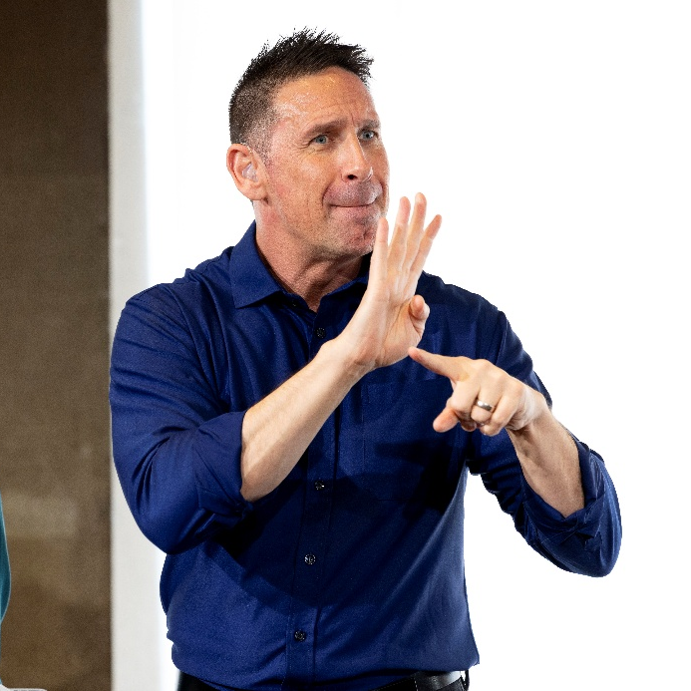

Image 8: Alex Jones, Jennifer Moon & Shane Carroll
Video Timestamp: 14:28:2 - 16:09:6
Image Description: A photograph of Alex Jones, Jennifer Mooney and Shane Carroll standing side by side. On the left, Alex wears a blue shirt and a lanyard with a pass around his neck featuring the Sydney Opera House logo in white. In the centre, Jennifer wears a bright purple shirt and a black crossbody bag. On the right, Shane wears a sage green jumper layered under a knitted coat. All three face the camera, smiling warmly.

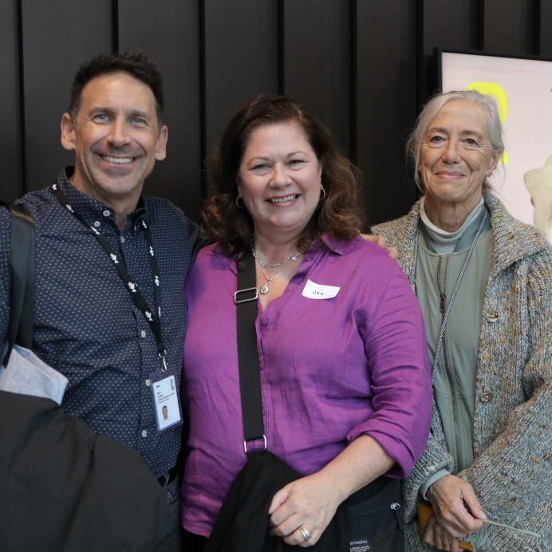

Image 9: Alex Jones presenting at the Workplace Readiness Program
Video Timestamp: 16:09:6 - 19:46:0
Image Description: Photograph of a presentation in progress, with three speakers standing behind a clear lectern on stage, addressing a seated audience. A large screen behind them displays the slide title, “Inclusive Career Pathways: Celebrating Diversity in the Arts.” One of the presenters, Alex Jones, communicates in Auslan. An audience member holds a handheld microphone, appearing to ask a question.
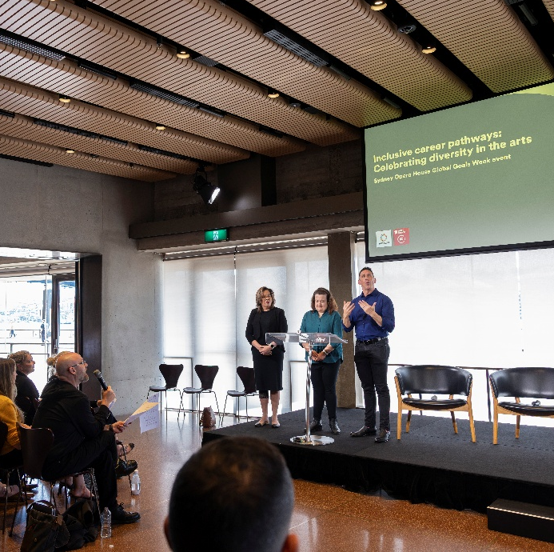

Image 10: Alex Jones gives the opening address at Access Ideas & Insights
Video Timestamp: 19:46:0 - 21:28:3
Image Description: A wide photograph of a large audience gathered at the Utzon Room in the Sydney Opera House for a panel discussion. In the foreground, rows of audience members sit facing a stage; several attendees are seated in wheelchairs, and others sit on light wooden chairs arranged in neat rows. At the front of the room, four panellists are positioned on stage. On the far right, Alex Jones stands beside a lectern, mid-presentation, wearing a dark patterned short-sleeve shirt. His hands are raised as he communicates in Auslan, addressing the audience with an engaged, expressive posture. Seated to his left are three panellists, Eliza Hull, Sarah-Mace Dennis, & Uncle Paul Calcott.
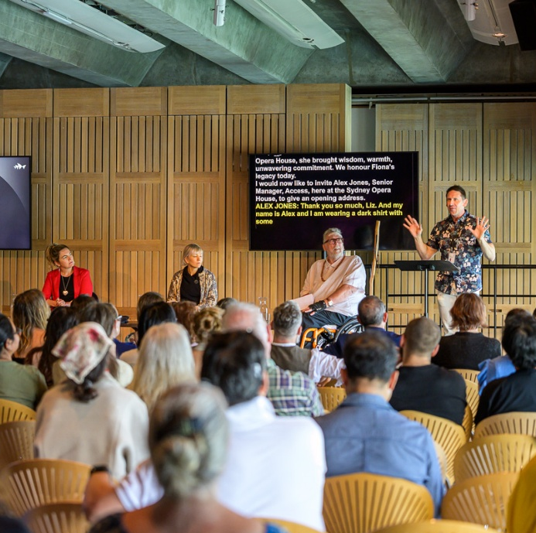

Image 11: Access Ideas & Insights: Disability Leadership panel
Video Timestamp: 21:38:3 - 23:47:7
Image Description: A wide photograph of a large audience gathered at the Utzon Room in the Sydney Opera House for a panel discussion. Rows of seated attendees face a stage at the front of the room including several wheelchair users located throughout the audience. At the front, four speakers sit on stage beneath two large screens. One screen displays the words “Disability Leadership” against a dark background with colourful graphic elements, while the other shows live captions in yellow text on black. An Auslan interpreter stands to one side of the stage. To the left, a large, vibrant abstract tapestry in bold shapes and colours covers the wall. Natural light streams in from tall windows along the right-hand side, illuminating the audience.
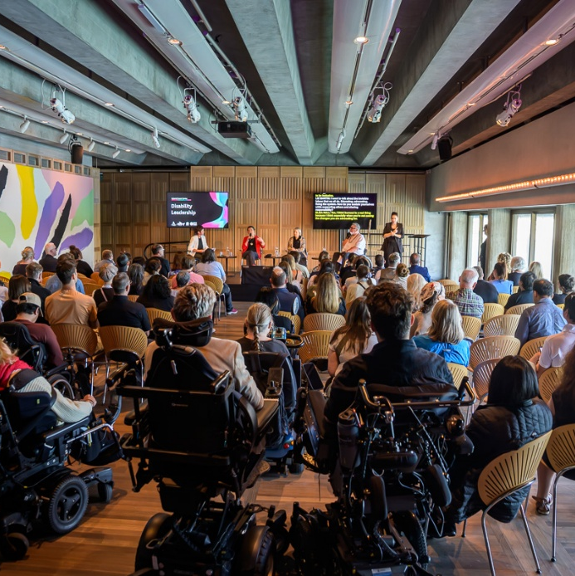

Image 12: Access Ideas & Insights Podcast Logo Graphic
Video Timestamp: 23:47:7 - 23:54:0
Image Description: A white vintage microphone stands out against a solid black background. To its right, bold text reads: “accessible arts Access Ideas & Insights Podcast.” The words “accessible arts” appear in magenta lowercase, while the rest of the text is white. The word “Podcast” is larger and set below by a thin gradient line shifting from magenta to yellow. Along the bottom edge, a vivid wave of magenta, purple, orange, and yellow adds movement to the design.

Image 13: Utp Co-Artistic Directors Dr Jessica Olivieri
Video Timestamp: 23:54:0 - 27:13:0
Image Description: A studio portrait of a Dr Jessica Olivieri standing against a black backdrop. They face the camera with a calm, self-assured expression, their body turned slightly to the side with one hand resting on their hip. Jessica has short, dark hair and light skin, and is wearing a bright orange button-up shirt with the sleeves rolled up, paired with blue jeans. The shirt is loosely styled, gathered slightly at the waist, and their fingernails are painted a matching orange-red tone.
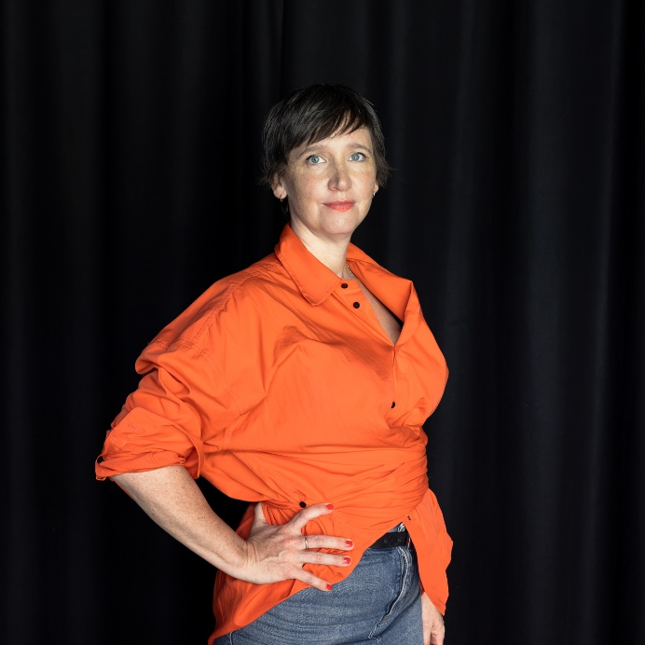

Image 14: Utp Co-Artistic Directors Jessica Olivieri & Hannah Donnelly.
Video Timestamp: 27:13:0 - 30:49:5
Image Description: Utp Co-Artistic Directors Jessica Olivieri & Hannah Donnelly stand together against a dark background. On the right, Hannah has curly hair and glasses and wears a loose, peach-orange button-up shirt. They are mid-gesture, raising one hand near their face while holding a small green booklet in the other. To the right stands Jessica with short dark hair dressed in an all-black outfit facing Hannah, smiling warmly.
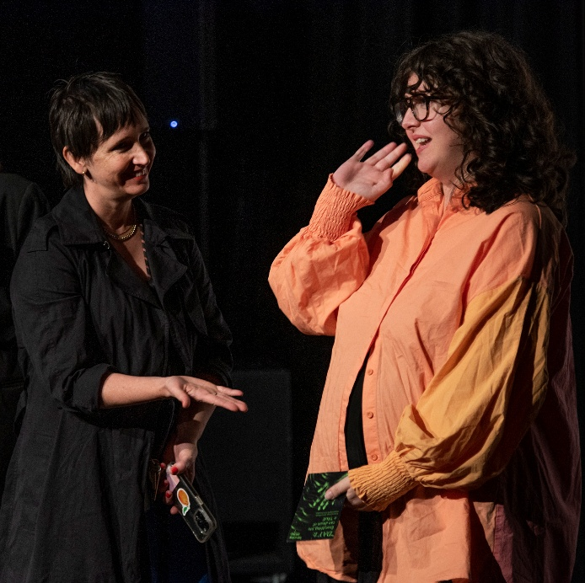

Image 15: Crip Rave Theory x Body Place
Video Timestamp: 30:49:5 - 32:12:9
Image Description: A group of people gather on a small, raised outdoor stage at night, immersed in rave. At the centre, a person in a wheelchair moves across the stage, wearing a green dress. Their wheelchair wheels glow with bright purple lights, creating vivid trails of colour against the dark stage floor. Their head is tilted back slightly, eyes closed. Around them, other people stand, dance, or move in blurred motion. The lighting is saturated, mixing reds, greens, and yellows.
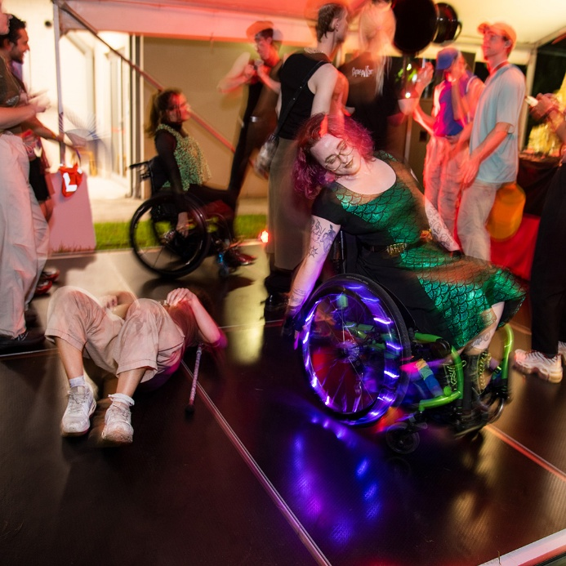

Image 16: Crip Rave Theory at Utp
Video Timestamp: 32:12:9 - 34:11:7
Image Description: An outdoor nighttime gathering on a grassy lawn for Crip Ray Theory. In the foreground, a group of people sit together on a large, patterned rug, talking, eating, and relaxing. Some sit cross-legged while others lean back on their hands. Beyond the rug people are spread across the lawn, sitting on the grass or standing in small groups. The space is softly lit with green and red uplighting on trees and palms, and warm light spills from the building in the background.
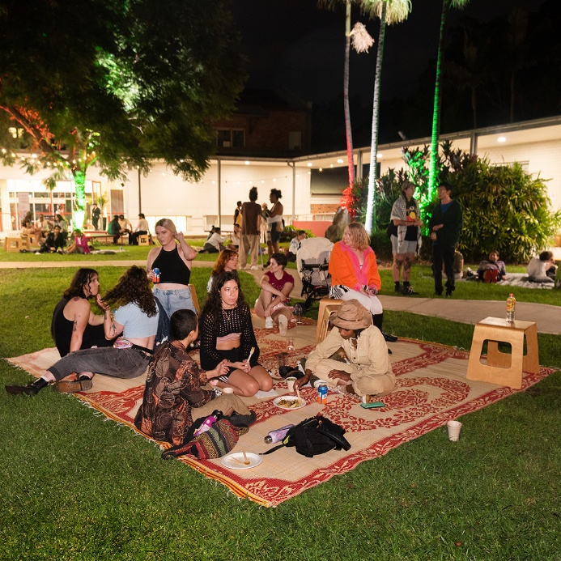

Image 17: Utp Team
Video Timestamp: 34:11:7 - 35:27:3
Image Description: On the left, a person with short, dark curly hair sits casually on a stack of large black speakers. They wear a black top, grey jeans, and black boots, with an olive-green jacket layered over their shoulders. One arm rests confidently on the top speaker. In the centre, a person with dark hair pulled back and wearing glasses sits on the speakers beside them. They wear a sleeveless white top and a dark skirt with a sheer overlay featuring a large purple floral design. On the right, a third person sits on a low stool. They have short brown hair and wear a denim button-up shirt decorated with a floral appliqué on one shoulder.
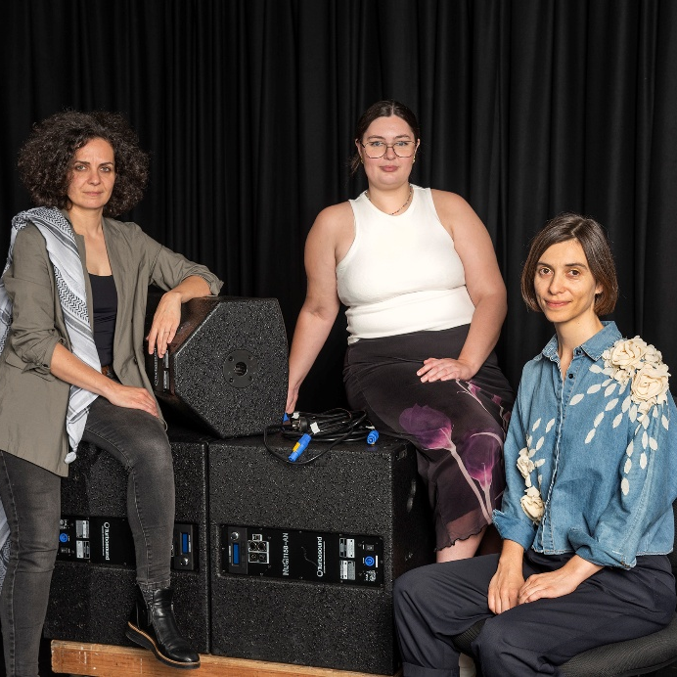

Image 18: Seasons of Care development at Utp
Video Timestamp: 35:27:3 - 38:06:7
Image Description: Several people sit and lounge across tiered black seating in a studio space with black curtains and metal railings in the background. Bright green cushions are scattered across the steps, adding soft colour to the otherwise dark setting. In the foreground, a person dressed in black sits on the floor, holding a plate of food and smiling toward the group. At the centre, a person in a sleeveless cream top sits cross-legged on the seating, laughing openly, their body turned slightly toward others nearby. Behind them, two people sit side by side on the next tier, mid-conversation, holding plates and gesturing as they talk.
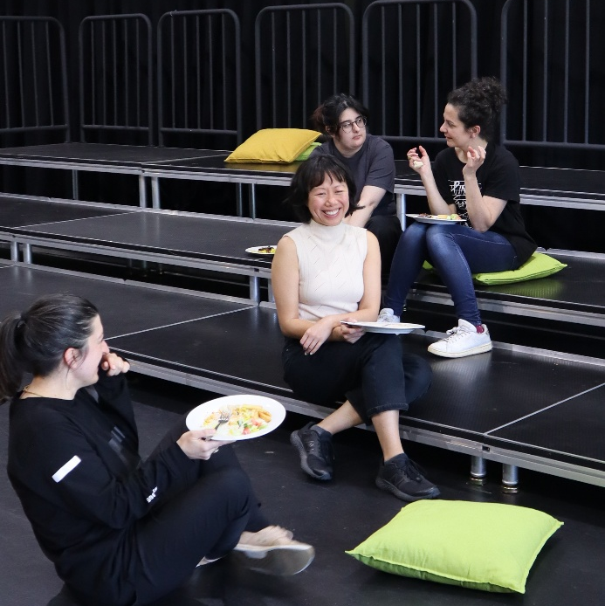

Image 19: Crip Rave Theory x Body Place
Video Timestamp: 38:06:7 - 39:46:9
Image Description: A nighttime outdoor dance party during Crip Rave Theory x Body Place. Captured with motion blur that suggests continuous movement and music. In the foreground on the left, the corner of a DJ deck is visible. At the centre of the frame, a person in a wheelchair smile as they dance, surrounded by other dancers standing nearby. Red and green party lights wash over the scene, while strings of festoon lights hang in the background near a white building, creating a lively, communal atmosphere.
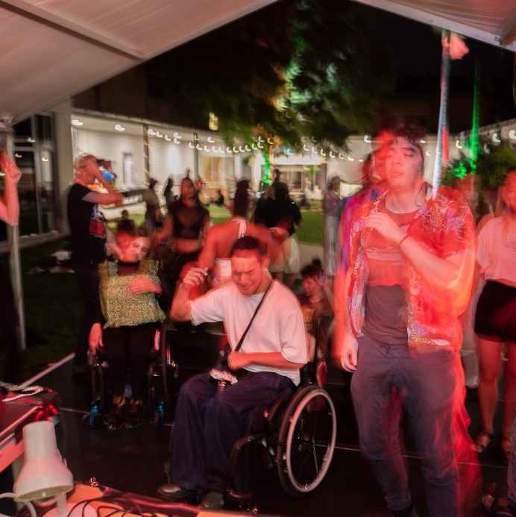

Image 20: Seasons of Care - Artists in residence
Video Timestamp: 39:46:9 - 44:10:4
Image Description: A group of 13 people stand together in a loose semi-circle against a black studio backdrop. They face inward toward one another rather than the camera, sharing smiles, laughter, and conversation. Clothing is varied and colourful, with layered textures like knits, button-up shirts, and patterned jackets. At the centre of the group, a person sits in a wheelchair, wearing a dark outfit with a soft, pale green textured vest. The overall vibe is joyful and relaxed, as if the group has just shared a moment or joke together.
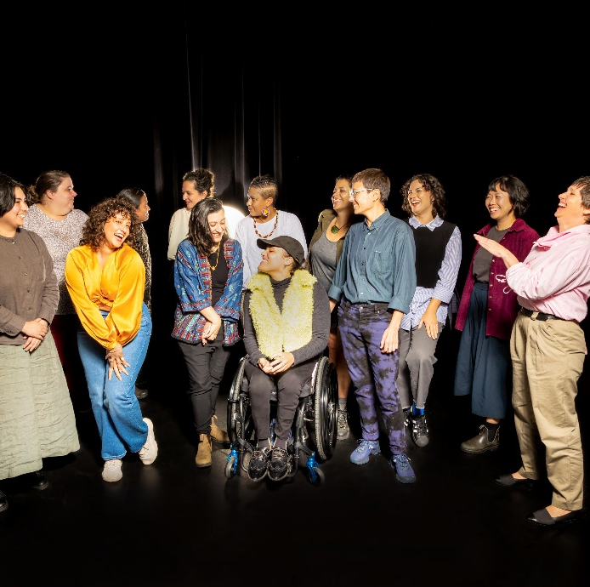

Image 21: DJ Riana Head-Toussaint
Video Timestamp: 44:10:4 - 47:00:7
Image Description: Two people share a joyful, intimate moment beside a DJ deck at an outdoor event. In the foreground, the DJ deck fills the lower half of the frame, on the left, a brown-skinned person with curly hair styled up wears’ glasses and a short-sleeved patterned shirt. They lean forward, smiling, gently cupping the other person’s face with one hand. On the right, Riana Head-Toussaint leans back slightly, smiling up at them, reaching up to hold the other person’s face in return.
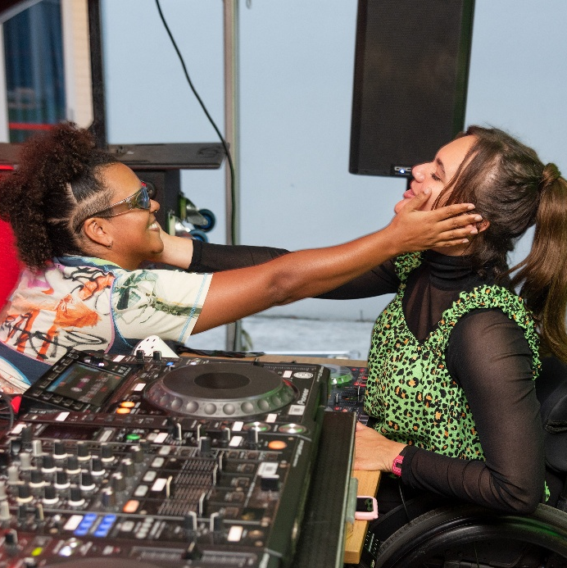

Image 22: Access Ideas & Insights Podcast Logo Graphic
Video Timestamp: 47:00:7 - 47:31:2
Image Description: A white vintage microphone stands out against a solid black background. To its right, bold text reads: “accessible arts Access Ideas & Insights Podcast.” The words “accessible arts” appear in magenta lowercase, while the rest of the text is white. The word “Podcast” is larger and set below by a thin gradient line shifting from magenta to yellow. Along the bottom edge, a vivid wave of magenta, purple, orange, and yellow adds movement to the design.

Image 23: Access Ideas & Insights Podcast Partnerships
Video Timestamp: 47:31:2 - 47:50:4
Image Description: A black background with white text and three logos at the bottom. The text reads: "This podcast was proudly produced by Accessible Arts and Kiera Brew Kurec, with sound design by Tralala Blip. Access consulting was provided by Macro Impact Consulting and our Advisory Group. Special thanks to our Auslan interpreters from Sweeney Interpreting. This podcast series is proudly supported by the City of Sydney and Create NSW, the principal funding partner of Accessible Arts." At the bottom are three logos. On the left: A black circle with a white outline of a hand in Auslan signing, with the text "MACRO Impact Consulting." In the centre: The words "CITY OF SYDNEY" in bold white capital letters, with a small circular anchor emblem beside it. On the right: A white waratah flower symbol above the words "NSW GOVERNMENT."
