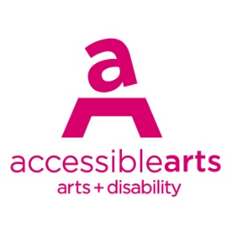

Access Ideas & Insights Podcast

Image Description Guide

Introduction: Episode 6 – Reclaiming Words
This document contains written Image Descriptions for the images featured in the Auslan version of the Accessible Arts: Access Ideas & Insights podcast video Reclaiming Words. Each episode of the podcast includes the following accessible features: Auslan video, transcript, and an image description guide. Where available, time stamps are included to assist with navigation.

Table of Contents
Introduction: Episode 6 – Reclaiming Words 1
Table of Contents 1
Image 1: Access Ideas & Insights Podcast Logo Graphic 2
Image 2: Headshot Bedelia Lowrenčev 2
Image 3: Access Ideas & Insights Podcast Logo Graphic 3
Image 4: Headshot of Daley Rangi 3
Image 5: Access Ideas & Insights Podcast Logo Graphic 4
Image 6: Headshot of Eliza Hull 4
Image 7: Image of Eliza Hull from ‘Running Under Water’ music video 5
Image 8: Eliza and her band at Malthouse Theatre 5
Image 9: Roya the Destroya performing alongside Eliza Hull and her band 6
Image 10: Access Ideas and Insights: Disability Leadership event 7
Image 11: Eliza Hull performing on stage at The Memo 7
Image 12: Screen projection of Eliza Hull on stage at a music festival. 8
Image 13: Eliza Hull reading to group of young children 9
Image 14: Eliza Hull’s children book ‘The World We Can Build’ 9
Image 15: Eliza Hull performing at the Bridge Hotel 9
Image 16: Access Ideas & Insights Podcast Logo Graphic 10
Image 17: Access Ideas & Insights Podcast Partnerships 10

Image Descriptions

Image 1: Access Ideas & Insights Podcast Logo Graphic
Video Timestamp: 00:01:0 – 00:44:0
Image Description: A white vintage microphone stands out against a solid black background. To its right, bold text reads: “accessible arts Access Ideas & Insights Podcast.” The words “accessible arts” appear in magenta lowercase, while the rest of the text is white. The word “Podcast” is larger and set below by a thin gradient line shifting from magenta to yellow. Along the bottom edge, a vivid wave of magenta, purple, orange, and yellow adds movement to the design.
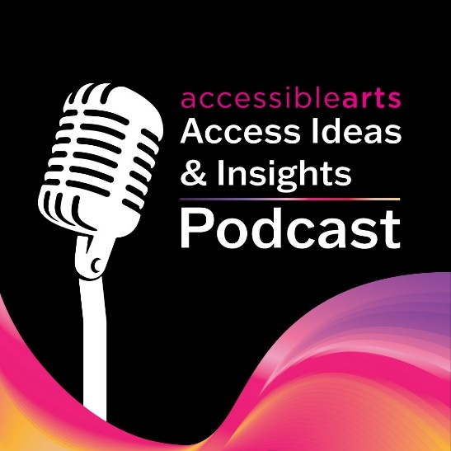

Image 2: Headshot Bedelia Lowrenčev
Video Timestamp: 00:44:0 – 01:22:0
Image Description: A person with long wavy brown hair and hazel eyes smiles at the camera. They are wearing a sheer green long-sleeve top. Their head tilts slightly as their hand rests against her neck. The background is softly blurred, bringing the focus to their face.


Image 3: Access Ideas & Insights Podcast Logo Graphic
Video Timestamp: 1:22:0 - 2:46:1
Image Description: A white vintage microphone stands out against a solid black background. To its right, bold text reads: “accessible arts Access Ideas & Insights Podcast.” The words “accessible arts” appear in magenta lowercase, while the rest of the text is white. The word “Podcast” is larger and set below by a thin gradient line shifting from magenta to yellow. Along the bottom edge, a vivid wave of magenta, purple, orange, and yellow adds movement to the design.

Image 4: Headshot of Daley Rangi
Video Timestamp: 02:46:1 – 21:20:3
Image Description: Headshot photograph of Daley Rangi seated against a wooden panel background. They wear a dark t-shirt and a Pounamu pendant necklace, complemented by matching earrings. Daley has dark brown hair, a dark brown beard, and brown eyes, with a calm, composed expression.
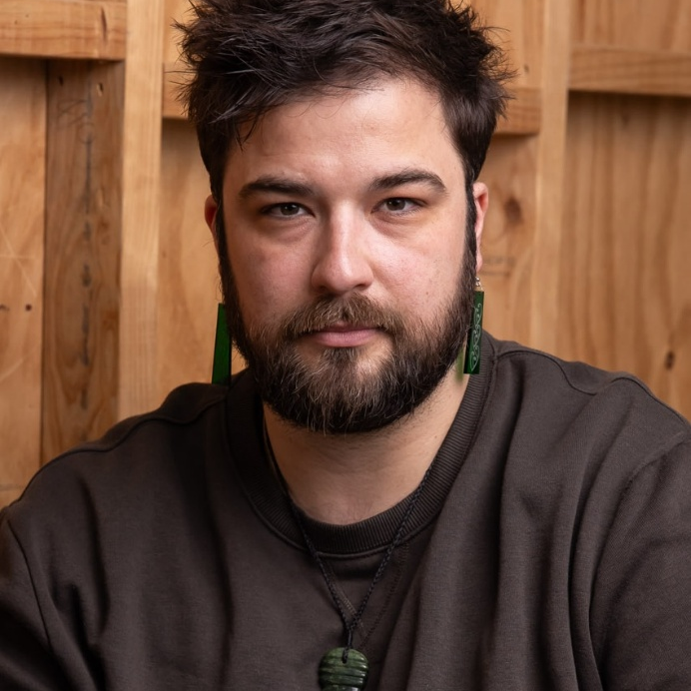

Image 5: Access Ideas & Insights Podcast Logo Graphic
Video Timestamp: 21:20:3 – 21:32:5
Image Description: A white vintage microphone stands out against a solid black background. To its right, bold text reads: “accessible arts Access Ideas & Insights Podcast.” The words “accessible arts” appear in magenta lowercase, while the rest of the text is white. The word “Podcast” is larger and set below by a thin gradient line shifting from magenta to yellow. Along the bottom edge, a vivid wave of magenta, purple, orange, and yellow adds movement to the design.

Image 6: Headshot of Eliza Hull
Video Timestamp: 21:32:5 – 21:58:6
Image Description: Photograph of Eliza Hull sitting inside a vintage train carriage with wooden panelling and large windows showing a blurred outdoor scene. Eliza wears a black long-sleeve top, a red, blue and black plaid skirt, black tights, and a heart-shaped pendant necklace, creating a cozy and nostalgic atmosphere.
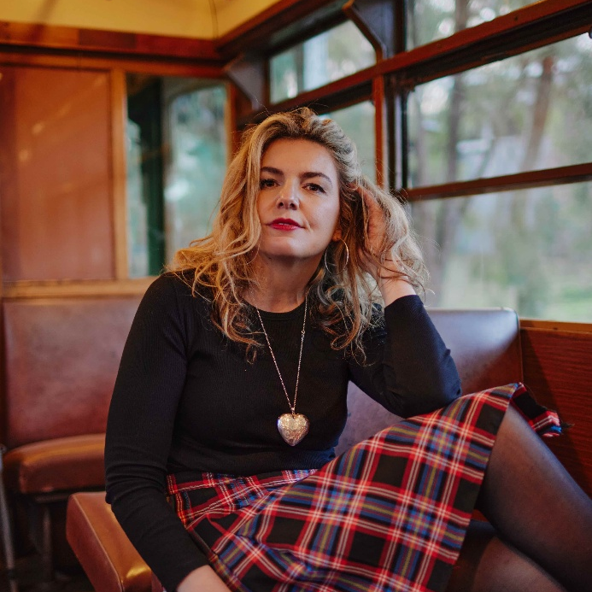

Image 7: Image of Eliza Hull from ‘Running Under Water’ music video
Video Timestamp: 21:58:6 – 23:50:9
Image Description: Photograph from Eliza Hull’s music video ‘Running Under Water’. Eliza’s curly hair rests naturally on her shoulders, and she wears a dark outfit while posing with one arm bent behind her head against a wall. Her eyes are closed, and a gentle smile graces her face. A greenish, circular light pattern illuminates the background, creating a glowing halo effect around Eliza.
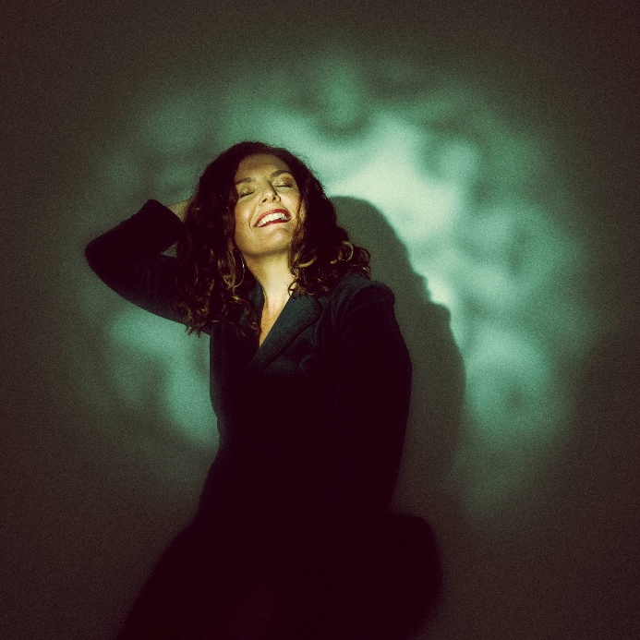

Image 8: Eliza and her band at Malthouse Theatre
Video Timestamp: 23:50:9 – 24:41:2
Image Description: Photograph of an outdoor live music performance at night. Eliza Hull and her band perform on a raised stage framed by a metal truss structure, with colourful stage lights in red, blue, and purple illuminating them. The stage is labelled “Malthouse Outdoor Stage” and is topped with a canopy, with warm string lights hanging above. In the foreground, audience members sit at small round tables, watching the performance.

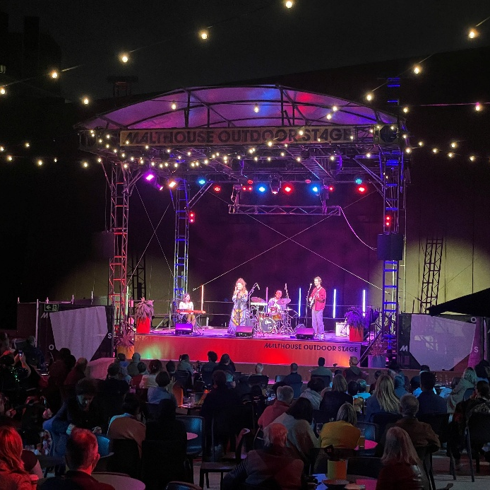

Image 9: Roya the Destroya performing alongside Eliza Hull and her band
Video Timestamp: 24:41:2 – 26:10:9
Image Description: Photograph of a live performance in a theatre setting. At the centre of a circular stage, performer Roya the Destroya balances upside down in a handstand on a wooden chair, one leg extended straight upward. They wear a bright, flowing yellow dress that contrasts vividly against the otherwise darkened space. To the right, Eliza Hull and her band perform live music, positioned to face both the central performer and the audience. The audience is seated in a close circle around the stage.
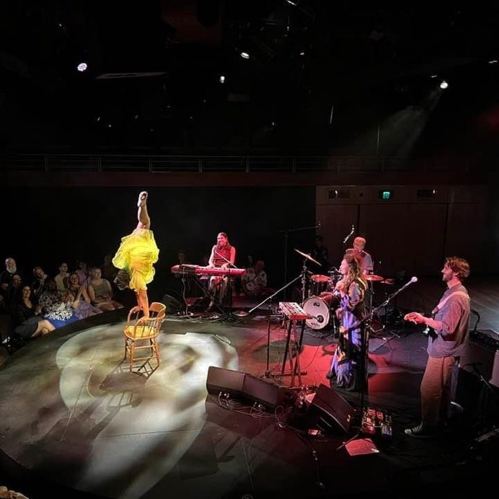

Image 10: Access Ideas and Insights: Disability Leadership event
Video Timestamp: 26:10:9 – 27:02:3
Image Description: Photograph of the Access Ideas and Insights: Disability Leadership event during a live panel discussion. On stage, Liz Martin and Eliza Hull are seated, with a large screen behind them displaying the title “Disability Leadership.” Eliza holds a microphone, engaged in conversation. Audience members sit facing the stage in a wood-panelled room, attentively listening.
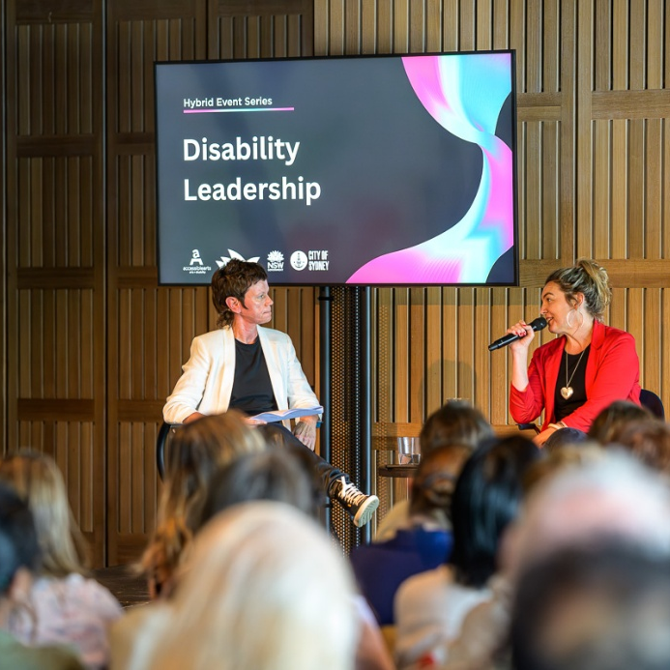

Image 11: Eliza Hull performing on stage at The Memo
Video Timestamp: 27:02:3 – 28:41:8
Image Description: Black and white photograph of Eliza Hull singing on stage with a microphone, surrounded by musical instruments including a drum set, guitars, and keyboards. Stage lighting highlights the performer while the background remains dim, capturing an intimate live music setting.
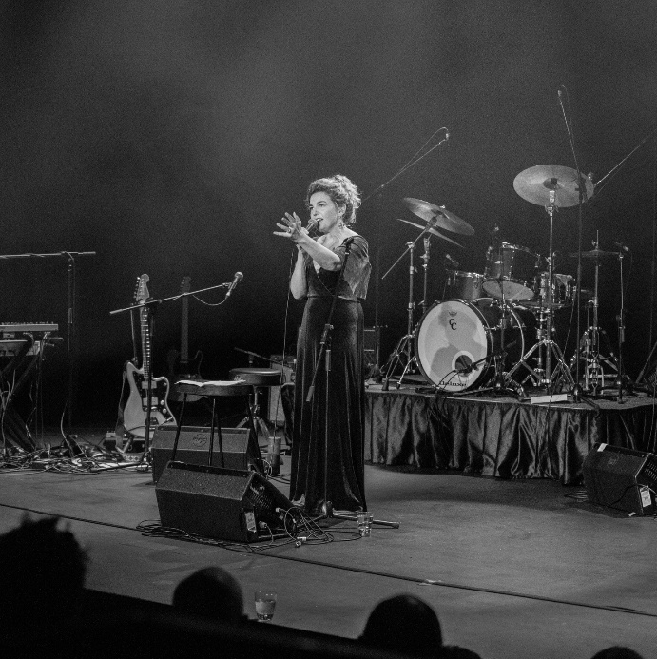

Image 12: Screen projection of Eliza Hull on stage at a music festival.
Video Timestamp: 28:41:8 – 32:10:3
Image Description: Photograph of a circular screen at a concert displaying a live projection of the stage. On the screen, Eliza Hull performs alongside two other musicians, holding a microphone with both hands and wearing a black and yellow dress. Text overlaid on the projection reads “Emmanuel Kelly. No Zodiac EP – Available for Order.” The actual stage and performers are not visible, only their image on the screen.
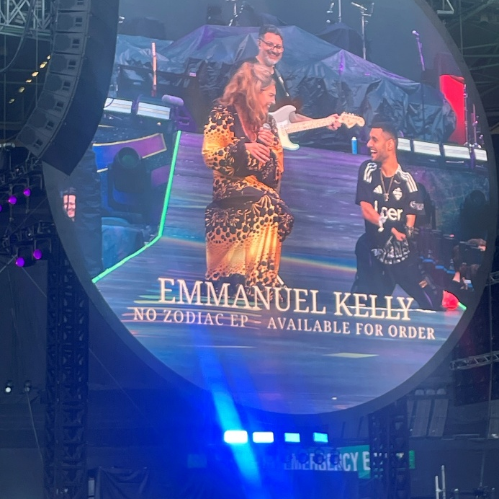

Image 13: Eliza Hull reading to group of young children
Video Timestamp: 32:10:3 – 33:43:2
Image Description: Photograph of a children's Storytime event in a bookstore or library, showing a Eliza Hull reading aloud to an audience of seated children and adults. Warm lighting, colourful bookshelves, and hanging paper lanterns create a cozy atmosphere.
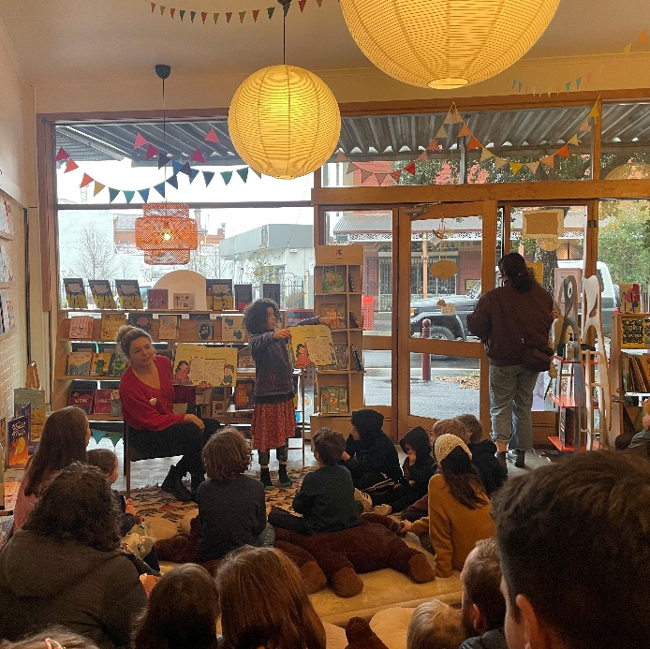

Image 14: Eliza Hull’s children book ‘The World We Can Build’
Video Timestamp: 32:43:2 – 35:41:2
Image Description: Photograph of Eliza Hull holding a colourful children's book titled "The World We Can Build," featuring illustrated characters and playful fonts on a blue and yellow cover. Eliza is sitting outdoors with greenery and a fence in the background; Eliza has her hair down and it wears bright red lipstick and a floral blouse and jeans.
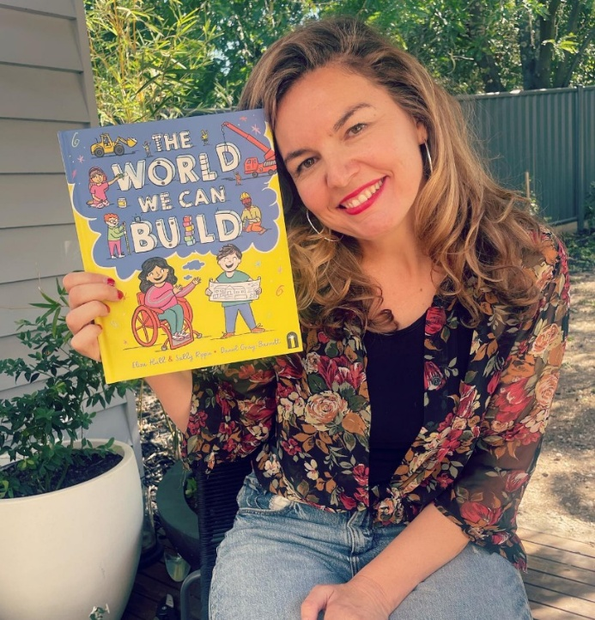

Image 15: Eliza Hull performing at the Bridge Hotel
Video Timestamp: 35:41:2 – 36:47:4
Image Description: Black and white photograph of a live music performance. In the foreground, singer Eliza Hull is shown in side profile, holding a microphone. Her hair and patterned top catch the light, standing out against the darker surroundings. In the foreground a guitarist is partially visible, slightly out of focus. The scene is dimly lit, with a single hanging lamp above casting a soft, intimate glow over the performers.
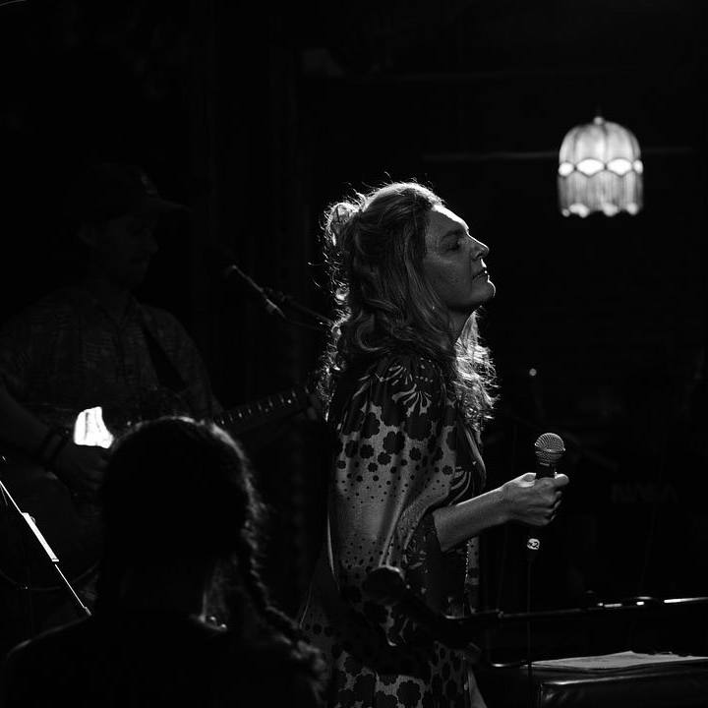

Image 16: Access Ideas & Insights Podcast Logo Graphic
Video Timestamp: 36:47:4 – 37:24:9
Image Description: A white vintage microphone stands out against a solid black background. To its right, bold text reads: “accessible arts Access Ideas & Insights Podcast.” The words “accessible arts” appear in magenta lowercase, while the rest of the text is white. The word “Podcast” is larger and set below by a thin gradient line shifting from magenta to yellow. Along the bottom edge, a vivid wave of magenta, purple, orange, and yellow adds movement to the design.

Image 17: Access Ideas & Insights Podcast Partnerships
Video Timestamp: 37:24:9 – 37:38:3
Image Description: A black background with white text and three logos at the bottom. The text reads: "This podcast was proudly produced by Accessible Arts and Kiera Brew Kurec, with sound design by Tralala Blip. Access consulting was provided by Macro Impact Consulting and our Advisory Group. Special thanks to our Auslan interpreters from Sweeney Interpreting. This podcast series is proudly supported by the City of Sydney and Create NSW, the principal funding partner of Accessible Arts." At the bottom are three logos. On the left: A black circle with a white outline of a hand in Auslan signing, with the text "MACRO Impact Consulting." In the centre: The words "CITY OF SYDNEY" in bold white capital letters, with a small circular anchor emblem beside it. On the right: A white waratah flower symbol above the words "NSW GOVERNMENT."
